COMPUTER SYSTEMS RESEARCH
Code Writeup 2009-2010
- Your name: Mo Lu, Period: 04
- Date of this version of your program: 10/25/2009
- Project title: Coverage Efficiency in Autonomous Robots With Emphasis on Simultaneous Localization and Mapping Algorithms
- Describe how your program runs as of this version.
-- files that may be needed
-- algorithms, specific procedures or methods you wrote
-- kinds of input your program uses
-- screenshots, what kinds of output does your program have
-- does your program handle errors, or does it crash on errors of input?
-- tests: summarize the basic analysis and testing of this version of your program
Pseduo-Code
Inputs: Hard-coded matrix, 0's represent 1's represent obstacles
Robot Class
Knows Location in Matrix
Knows Direction
Scan Method
Map Method
Move Ahead Method
Backtrack Method
Change Facing
Run Method
Scan Method
Scan 4 spaces ahead
Return distance until out-scan encounters a 1
Calculate location of the 1, based off current location
Recur, scan in 180 degree forward direction
Map Method
Creates matrix of 0's
Store 1's in matrix
Move Ahead Method
while location+1!=[1]
move ahead 1 space
if location+1=[1]
backtrack(location)
Backtrack Method(Location)
set robot coordinates to [x-1][y-1]
Change Facing(Location)
if at boundary of environment:
change facing 180 degrees
Run
While Map()!=Environment
Scan()
Move Ahead{}

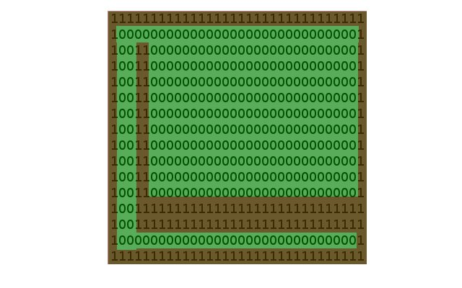
Result

Testing and Errors
These testing categories are dependent on obstacle and boundary recognition, obstacle mapping, location tracking, and unmowable terrain recognition. Current focus is on the testing of obstacle/boundary recognition and obstacle mapping. Testing for the current focus is determined by how accurate the obstacle map is when compared to the environment. Later, the simulation will be adapted for testing in a random matrix environment, and then a non-matrix based environment. The non-matrix based environments will be able to function in a physical environment. Many conditions must be met for success of this project, if the original goal is to be met. Future testing will address the processing aspect of the program, with success determined by coverage and time efficiency.
Current analysis of the project is determined by the correlation of the obstacle map with the environment. When processing works, need to test for 1) Time Efficiency, 2) Coverage Percentage and 3) Backtracking.

