Hybrid Parallel GPU Implementation of HMAX Visual Processing Model
Devraj Mehta, Mentorship in The Laboratory for Computational
Cognitive Neuroscience at Georgetown University

The goal of this project is to speed up the existing implementation of the HMAX, written in MATLAB, by parallelizing it on the GPU.

Introduction
The visual cortex processes images by filtering them through a hierarchal model increasing the complexity of the filters at each step. This is the generally accepted model of visual processing and there have been many different implementations, such as Serre et al [2] and Riesenhuber et al [3]. However, for the purposes of this project we will be examining the widely accepted IEEE version of the model [1]. In the HMAX model an image is first passed through several, four in this case, alternating stages of filtering operations and maximum pooling operations. Then the resulting component vector is passed to a classification stage where the image is associated, via the component vector, to different properties of the image and potentially objects within the image. Both of these two distinct steps can be parallelized by means of the massively parallel architecture of modern GPUs. Using NVIDIA's CUDA standard C language extensions and architecture the model was parallelized on the GPU.

Background
Previous implementations of the HMAX model have improved upon serial methods using parallel techniques such as multi-threading, yet speed has remained a limiting factor. One previous implementation by Chikkerur explored using GPUs to separately parallelize the first four stages of the HMAX model [4]. While speedup of an order of magnitude was shown GPU's have been growing quickly and steadily in their capabilities and we intend to utilize some newer features of GPU's that are currently developing as well as creating a more comprehensive model that combines all of the different stages of the HMAX model.

Procedure
GPU's afford multiple levels of parallelism. On the smallest level each process executes on a scalar processor with limited resources. These are grouped, in groups of eight currently, into multiprocessors. Multiprocessors have a relatively small amount of shared memory. A standard GPU currently has roughly thirty multiprocessors. This creates two levels of parallelism, and then, accounting for the possibility of multiple GPUs there is a total of three levels possible. These levels are of varying sizes on different systems and therefore different methods of parallelism of the model are optimal for different systems. In order to account for these difference we have developed a hybrid model which provides several different methods of parallelizing automatically tuned for the specific system before running the model.
For the first stage of the model, filtering using a simple cell filter which in this model is a Gabor filter, we have developed three distinct methods with varying use of the different levels of parallelism inherent in the GPU. The first uses the convolution theorem to take advantage of the logarithmic cost of the Fast Fourier Transform [9]. Each transform is parallelized across the entire GPU serializing the execution of each convolution. As there needs to be a convolution for each pixel in the image this method could easily become inefficient when the cost of each convolution is small and the image size is large. Therefore we also developed a method which executes all of the convolutions across the image in parallel implementing a straightforward 2-D convolution in each parallel thread. To account for times when the optimal parallelism lies somewhere between these two opposite extremes we developed a third method which uses the first layer of parallelism on the GPU across the multiprocessors to parallelize the different convolutions, and then, the second layer to parallelize each 2-D convolution. Choosing when to run each of these three methods will depend on the specifications of the system and can be determined by a tuning program run separately from the model.
The maximum pooling operations after the filtering operations in the first four stages of the model will be simply parallelized to most fully use every processor in the GPU due to the lighter amount of work required. Then, in the fifth stage of classification matrix operations will be parallelized using existing implementations of linear algebra routines for the GPU such as CUBLAS [10]. Most of the operations required for classification, however, can be simplified to matrix multiplication which has shown two orders of magnitude speed up over the CPU (Fig.1).
In order to allow for the model to be used easily in future research relating to the HMAX model it will be made accessible from MATLAB [11].
The final comprehensive model containing all stages will be timed against the existing IEEE model to achieve a relative speedup.

Figures
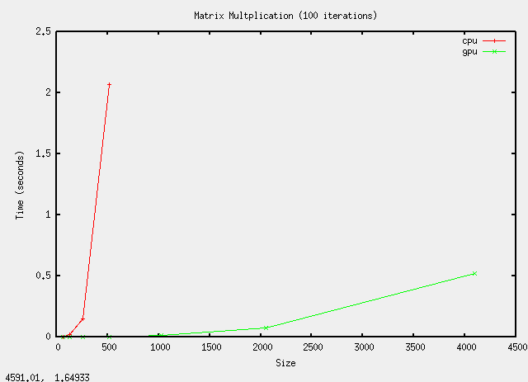Fig. 1: Comparison of run-times between GPU and CPU implementation of matrix multiplication

References
- Serre, T., Wolf, L., Bileschi, S., Riesenhuber, M., & Poggio, T. (2007). Robust Object Recognition with Cortex-like Mechanisms. IEEE Transactions on Pattern Analysis and Machine Intelligence 29(3): 411-426.
- Serre, T., Wolf, L., Poggio, T. (2005). Object Recognition with Features Inspired by Visual Cortex. Center for Biological and Computational Learning, McGovern Institute, Brain and Cognitive Sciences Department, Massachusetts Institute of Technology.
- Riesenhuber M., and Poggio, T. (1999). Hierarchical Models of Object Recognition in Cortex. Nature America Inc.
- Chikkerur, Sharat. (2009). CUDA Implementation of a Biologically Inspired Object Recognition System. Massachusetts Institute of Technology.
- Podlozhynuk, Victor. (June 2007). FFT-based 2D Convolution. NVIDA Corporation.
- Podlozhynuk, Victor. (June 2007). Image Convolution with CUDA. NVIDIA Corporation.
- CUDA Reference Manual Version 2.3. (April 2009). NVIDIA Corporation.
- NVIDIA CUDA Programming Guide Version 2.3. (July 2009). NVIDIA Corporation.
- CUDA CUFFT Library. (June 2009). NVIDIA Corporation.
- CUDA CUBLAS Library. (March 2008). NVIDIA Corporation.
- Accelerating MATLAB with CUDA Using MEX Files. (September 2007). NVIDIA Corporation.

