Running head: Functional connectivity of the thalamus

Using Statistical Parametric Mapping Software to Analyze the Functional Connectivity
of the Thalamus during Sleep
Morgan Pixa
Abstract
The centromedian nucleus of the thalamus is a non-specific relay center in the brain, controlling the passage of arousal signals from the midbrain-pontine reticular formation to the cerebral cortex. However, during sleep, this connection is greatly reduced or cut off, causing humans to exhibit the defining characteristic of sleep of a high arousal threshold. As such, this experiment was expected to show that connectivity between the centromedian nucleus and the neocortex is greater during wake compared to sleep.
For this study, functional magnetic resonance imaging (fMRI) and electroencephalogram (EEG) data were collected simultaneously after 44 hours of sleep deprivation, which was used to facilitate sleep inside the MRI scanner. This data was collected using MRI-compatible EEG equipment. Blood Oxygen Level-Dependent fMRI scans gathered data every three seconds from 25 axial slices, covering most of the brain. In the current study, a single-subject preliminary analysis was performed using the statistical parametric mapping software program AFNI (Analysis of Functional NeuroImaging; National Institutes of Mental Health, Bethesda, USA). Testing for changes in connectivity between the centromedian nucleus and the rest of the brain was performed on periods where the subject was either awake, or in stage three or four sleep.
Comparison of the connectivity images indeed showed decreases in correlation between the subject’s awake state and that of sleep stages three and four over the majority of the brain. In the posterior cingulate and the precuneus region of the brain, for example, there was a large cluster of significant positive correlations during wake, and none during sleep; similarly, in the postcentral gyri and prefrontal cortex there was a positive correlation during wake, but it changed to a negative correlation during sleep. However, during sleep there was a noticeable increase in correlation between the centromedian nucleus and a large part of the cerebellum.
The changes in connectivity from the majority of the brain confirmed the hypothesis of this preliminary analysis, that is, neocortical connectivity from a non-specific thalamic nucleus is greater during wake than during sleep. These results replicate the results from animal experiments on the thalamocortical mechanisms of arousal threshold changes during sleep using a non-invasive imaging technique in humans.

Introduction
During sleep, humans experience a reduced arousal threshold automatically (Rechtschaffen, Hauri, & Zeitlin, 1966); humans may be distracted from everyday activities by something as common as a car driving by or a dog barking, but while asleep humans are likely not aroused by these common occurrences. This increased arousal threshold is achieved by minimizing or disrupting the flow of information through the brain. The centromedian nucleus of the thalamus, or the centromedianum, is a non-specific relay center in the brain that propagates this flow of information. The centromedian nucleus controls the passage of arousal signals from the midbrain-pontine reticular formation, a part of the brain responsible for filtering incoming stimuli, to the cerebral cortex, which processes these stimuli. Experimentation with animals regarding neural mechanisms has shown that inhibition of these non-specific thalamocortical neurons is responsible for the decreased arousal threshold (Steriade, McCormick, & Sejnowski, 1993).
As it is known that humans experience a decrease in their arousal threshold during sleep, this experiment was designed to prove that there is a decrease in correlation between the non-specific relay nuclei in the thalamus, such as the centromedianum, and the neocortex, which is involved in sensory perception. Previous analysis of connectivity to the thalamus in humans has included investigations into the thalamocortical connection while the participants were awake (Zhang et al., 2008), and a study which analyzed connectivity during sleep to the whole thalamus rather than differentiating between the specific and non-specific relay nuclei (Koike, Kan, Misaki, & Miyauchi, 2008). In this study, simultaneous Blood Oxygen Level-Dependent (BOLD) functional magnetic resonance imaging (fMRI) and electroencephalogram (EEG) data were acquired from 18 subjects during sleep. Using statistical parametric mapping software, a single-subject preliminary analysis was performed, testing for changes in connectivity between the centromedian nucleus and the rest of the brain during periods when the participant was either awake, or in stage three or four sleep. It was hypothesized for this experiment that connectivity between the centromedian nucleus and the neocortex is greater during wake as compared to sleep.

Methods
Subjects
Simultaneous BOLD fMRI and EEG data were collected from 18 participants (10 female; mean age, 25.3 years, range, 21-31 years) for this study, all of whom were screened for potentially compounding factors and were also monitored at home with wrist-worn actigraphs (Ambulatory Monitoring, Inc., Ardsley, USA).

EEG Acquisition and Processing
EEG Data were acquired using MRI-compatible hardware and the associated software (Brain Products, GmbH, Gilching, Germany). A total of 14 EEG channels were collected (AC amplifier at 5 kHz, using a 0.016 Hz high-pass filter and 250 Hz low-pass filter) from a wide range across the scalp. Sleep scoring was performed using standard settings, filters, and criteria. Exceptions were using P₃ as the reference rather than A₂ and using 12-second rather than 30-second epochs.

fMRI Acquisition and Pre-Processing
fMRI data were acquired on a 3T scanner (GE, Milwaukee, USA) and for the BOLD fMRI an echo planar imaging acquisition was used, covering most of the brain by means of 25 axial slices (3.45 x 3.45 mm², 4.5 mm thickness, 0.5 mm gap), and collecting data every 3 seconds. Over the course of the few hours that data were collected, there is a large possibility to accrue error from various sources, such as movement of the participant’s head or signals coming from the machinery during the collection. To correct for this error, pre-processing was done on the entire dataset: slice-timing correction, motion correction, distortion correction, physiological signal correction (involving regressing out the signals from cardiac and respiration rates), global signal correction, and low-frequency drift correction (eliminating all frequencies under .005 Hz).

fMRI Analysis
Using the Talairach and Tournoux atlas (1988) and that of DeArmond, Fusco, and Dewey (1989), a Region of Interest (ROI) was created using the AFNI (Analysis of Functional NeuroImaging; National Institutes of Mental Health, Bethesda, USA) software to create a mask to isolate the centromedian nucleus of the thalamus. This ROI’s voxels’ values were then averaged at each time point using ANFI. Volumes were chosen for use for each the two states – wake or stage three or four sleep – using the sleep levels of the participant at each time point over the three hour scanning period (Fig. A1). Having previously spatially smoothed the functional data using a Gaussian Blur to reduce noise (4.0 mm), the connectivity maps for both wake (100 volumes, 5 minutes) and stage three or four sleep (1344 volumes, 67.2 minutes) are then calculated using the average activity in the centromedianum as the seed.

Results
The majority of the brain displayed significant decreases in correlations to the centromedian nucleus during sleep when contrasted to the same sections of the brain while the participant was awake, or else displayed increases in negative correlations. In the posterior cingulate and the precuneus region of the brain, there were correlations during wake, and yet none during sleep (Fig. 2). Slightly higher in the brain, the prefrontal cortex shifts from close to no connectivity during wake to a large amount of negative connectivity during sleep (Fig. 3). Higher still in the brain, during wake the precentral gyri has a positive correlation to the thalamus, though this correlation decreases during the subject’s stage three and four sleep (Fig. 4). Even more strongly, the postcentral gyri displays similar positive correlations to the centromedian nucleus during wake, but it changed to negative correlations during sleep (Fig. 5). One region of the brain showed the opposite trend: during sleep there was a noticeable increase in correlation between the centromedianum and a large part of the cerebellum, compared to practically no correlation in this area while the participant was awake (Fig. 1).

A wake B stage 3/4 sleep
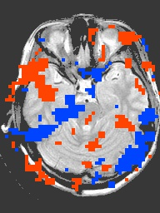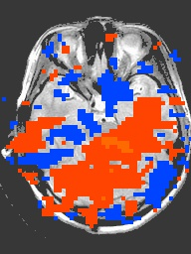
Fig. 1. Cerebellum pictured, during wake and sleep. Images display correlations with centromedian nucleus during (A) wake and (B) stage three or four sleep. Both positive (yellow and red) and negative (blue) correlations are shown.
A wake B stage 3/4 sleep
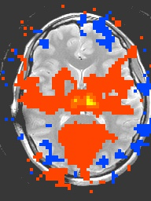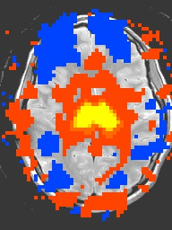
Fig. 2. Posterior cingulate and precuneus pictured, during wake and sleep. Images display correlations with centromedian nucleus during (A) wake and (B) stage three or four sleep. Both positive (yellow and red) and negative (blue) correlations are shown.
A wake B stage 3/4 sleep
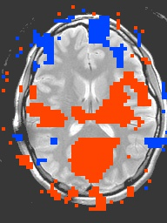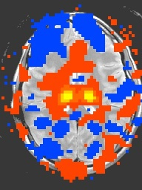
Fig. 3. Prefrontal cortex pictured, during wake and sleep. Images display correlations with centromedian nucleus during (A) wake and (B) stage three or four sleep. Both positive (yellow and red) and negative (blue) correlations are shown.
A wake B stage 3/4 sleep
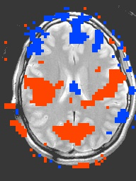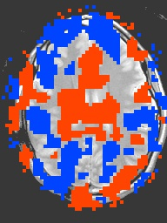
Fig. 4. Precentral gyri pictured, during wake and sleep. Images display correlations with centromedian nucleus during (A) wake and (B) stage three or four sleep. Both positive (yellow and red) and negative (blue) correlations are shown.
A wake B stage 3/4 sleep
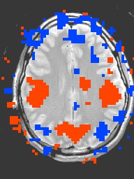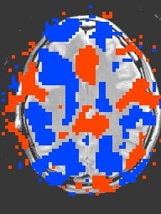
Fig. 5. Postcentral gyri pictured, during wake and sleep. Images display correlations with centromedian nucleus during (A) wake and (B) stage three or four sleep. Both positive (yellow and red) and negative (blue) correlations are shown.

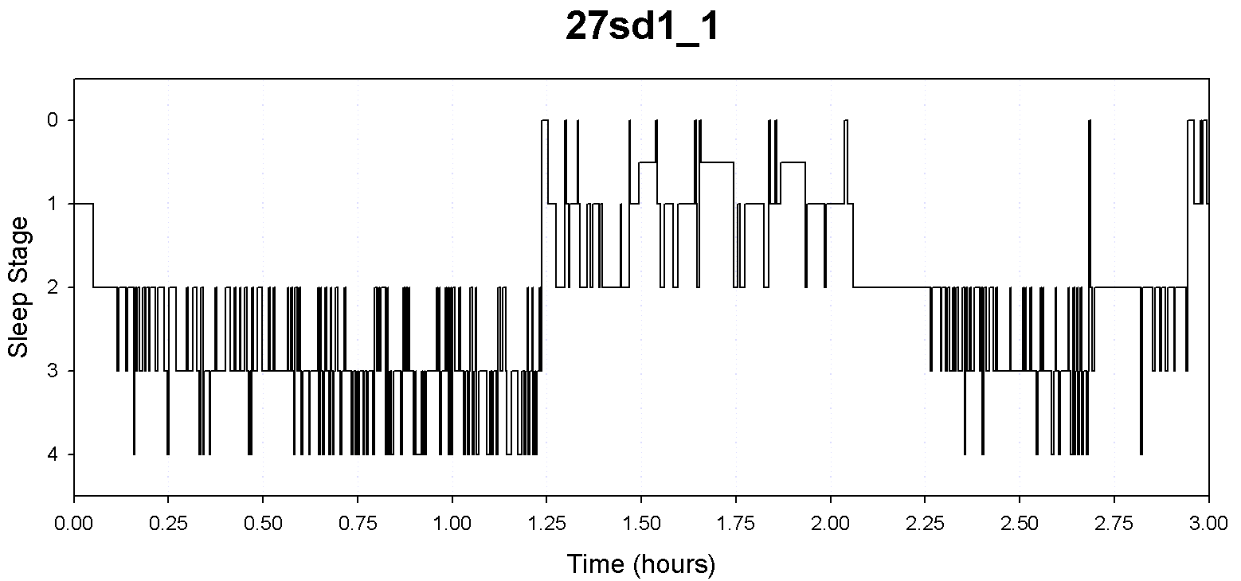Fig. 6. Sleep stages of the subject throughout the three hour scan period are depicted. Slow wave sleep (sleep stages two, three, and four) is established during the beginning and the end of the period, following typical cyclical form; of these, only fMRI volumes of time periods with either stage three or four sleep were used. Wake volumes were used for all time periods that appear as sleep stage zero.
Discussion
In reviewing this experiment and the limitations thereof, error was possible through both the experimental procedure and the quality of the equipment, allowing for the potential for future research that reduces or eliminates the shortcomings of the present study. Use of a multiple comparison correction would increase the statistical significance of the results; similarly, using a direct sleep-wake image comparison (comparing Figs. 1-5 using statistical tests) rather than visually comparing the images would give more specific and significant information about the study. This study would also be improved by using equal amounts of wake and sleep volumes in the correlations, or by creating a better ROI drawing using an anatomical image with better spatial resolution by using standard Talairach coordinates. This study could also be furthered and expanded upon by assessing other nonspecific nuclei in the thalamus.

Conclusions
This experiment was hypothesized to show that connectivity between the centromedian nucleus of the thalamus and the neocortex is greater during wake as compared to sleep. The neocortex indeed showed greater connectivity to the centromedian nucleus during wake than during sleep. However, one region of the brain showed the opposite trend: during sleep there was a noticeable increase in correlation between the centromedianum and a large part of the cerebellum, compared to practically no correlation in this area while the participant was awake (Fig. 1). The results found in this experiment replicate the results from animal experiments on the thalamocortical mechanisms of arousal threshold changes during sleep using a non-invasive imaging technique in humans.
References
DeArmond, S. J., Fusco, M. M., & Dewey, M. M., (Eds.). (1989). Structure of the human brain:
A photographic atlas. New York: Oxford University Press.
Koike, T., Kan, S., Misaki, M., & Miyauchi, S. (2008, June). Dynamic switching of
thalamocortical network with transition of human states between NREM and REM sleep. Poster presentation at the Organization for Human Brain Mapping meeting, Melbourne, Australia.
Rechtschaffen, A., Hauri. P., & Zeitlin, M. (1966). Auditory awakening thresholds in REM and
NREM sleep stages. Perceptual and Motor Skills, 22, 927-942.
Steriade, M., McCormick, D. A., & Sejnowski, T. J. (1993). Thalamocortical oscillations in the
sleeping and aroused brain. Science, 262, 679-685.
Talairach, J., & Tournoux, P. (1988). Co-planar stereotaxic atlas of the human brain: 3-
Dimensional proportional system - an approach to cerebral imaging. New York: Thieme Medical.
Zhang, D., Snyder, A. Z., Fox, M. D., Sansbury, M. W., Shimony, J. S., & Raichle, M. E. (2008).
Intrinsic functional relations between human cerebral cortex and thalamus. Journal of
Neurophysiology, 100, 1740-1748.

