COMPUTER SYSTEMS RESEARCH

Code Writeup of your program, example report form 2009-2010
- Your name: Neal Milstein, Period 3
- Date of this version of your program: October 28, 2009
- Project title: Developing a Physics Problem Simulation Engine
- Describe how your program runs as of this version. Include
-- files that may be needed
-- algorithms, specific procedures or methods you wrote
-- kinds of input your program uses
-- screenshots, what kinds of output does your program have
-- does your program handle errors, or does it crash on errors of input?
-- tests: summarize the basic analysis and testing of this version of your program

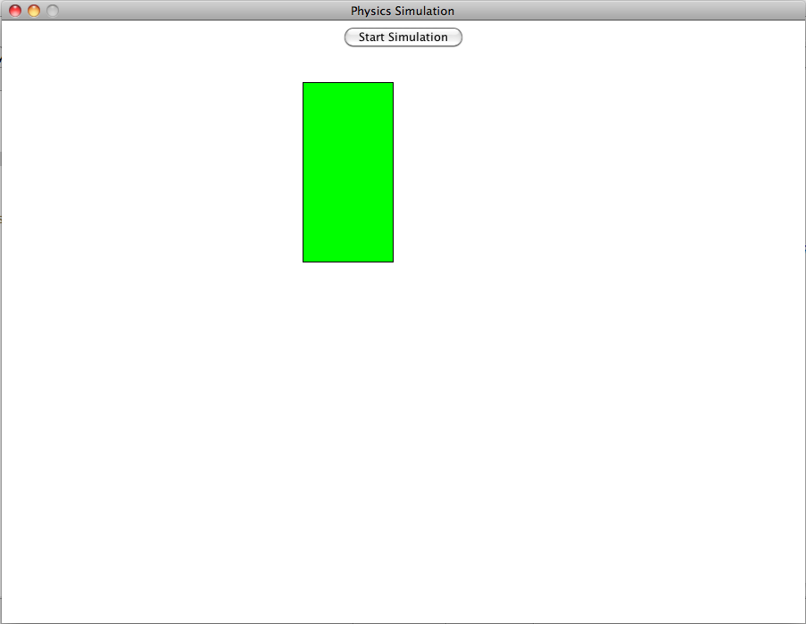

Driver.java

import java.awt.*;
import java.io.*;

public class Driver
{
private static Map map;

public static void main(String[] args)
{
map = new Map(new Dimension(900, 675), 15);
map.addMapObject(new Box());

map.start();
}

public static Map getMap()
{
return map;
}
}

Map.java

import javax.swing.*;
import java.awt.*;
import java.awt.event.*;
import java.awt.geom.Ellipse2D;
import java.awt.geom.PathIterator;
import java.util.*;
import javax.swing.Timer;

public class Map
{
private JFrame mainFrame;
private MainPanel mainPanel;
private Dimension mainDimension;

private Timer mainTimer;

private ArrayList<MapObject> mapObjects = new ArrayList<MapObject>();
private ArrayList<MapObject> removalObjects = new ArrayList<MapObject>();
private ArrayList<MapObject> addObjects = new ArrayList<MapObject>();

public Map(Dimension dimension, int frameRate)
{
mainDimension = dimension;

createMainFrame();

mainTimer = new Timer(frameRate, new MainListener());
mainTimer.start();
}

public void createMainFrame()
{
mainFrame = new JFrame("Physics Simulation");
mainPanel = new MainPanel(mainDimension);

mainFrame.setLocationRelativeTo(null);
mainFrame.setDefaultCloseOperation(JFrame.EXIT_ON_CLOSE);
mainFrame.setResizable(false);
mainFrame.setContentPane(mainPanel);
mainFrame.pack();
mainFrame.setLocationRelativeTo(null);
mainFrame.setVisible(true);
}

public void disposeMainFrame()
{
mainFrame.dispose();
}

public void addMapObject(MapObject mo)
{
addObjects.add(mo);
}

public void removeMapObject(MapObject mo)
{
removalObjects.add(mo);
}

public void clearMap()
{
for (MapObject mo : mapObjects) {
removeMapObject(mo);
}
}

public void stop()
{
mainTimer.stop();
}

public void start()
{
mainTimer.start();
}

public boolean isStopped()
{
return !mainTimer.isRunning();
}

public Dimension getDimension()
{
return mainDimension;
}

public void addMouseListener(MouseListener mouseListener)
{
mainPanel.addMouseListener(mouseListener);
}

public void removeMouseListener(MouseListener mouseListener)
{
mainPanel.removeMouseListener(mouseListener);
}

public void addKeyListener(KeyListener keyListener)
{
mainPanel.addKeyListener(keyListener);
}

public void removeKeyListener(KeyListener keyListener)
{
mainPanel.removeKeyListener(keyListener);
}

private class MainListener implements ActionListener
{
public void actionPerformed(ActionEvent e)
{
Graphics2D buffer = mainPanel.getBuffer();

buffer.setColor(Color.WHITE);
buffer.fillRect(0, 0, (int)mainDimension.getWidth(), (int)mainDimension.getHeight());

for (MapObject mo : mapObjects) {
mo.act();
}

for (MapObject ro : removalObjects) {
ro.removeFromMap();
mapObjects.remove(ro);
}
removalObjects.clear();

for (MapObject ao : addObjects) {
mapObjects.add(ao);
ao.addToMap(Map.this);
}
addObjects.clear();

for (MapObject mo : mapObjects) {
mo.draw(buffer);
}

mainPanel.repaint();
}
}
}

MapObject.java

import java.awt.*;
import java.util.*;

public abstract class MapObject
{
protected Map map;
protected int x, y, prevX, prevY;
protected Shape shape;

public void addToMap(Map map)
{
this.map = map;
}

public void removeFromMap()
{
this.map = null;
}

public abstract void act();

public abstract void draw(Graphics2D buffer);

public int getX()
{
return x;
}

public int getY()
{
return y;
}

public int getPrevX()
{
return prevX;
}

public int getPrevY()
{
return prevY;
}

public void setX(int x)
{
this.x = x;
}

public void setY(int y)
{
this.y = y;
}

public Map getMap()
{
return map;
}

public void setMap(Map map)
{
this.map = map;
}
}

Box.java

import java.awt.Color;
import java.awt.Graphics2D;

public class Box extends MapObject
{
private double a = -9.81;
private double vy = 0;
private double vx = 4;
private int bounce = 1;

public Box()
{
setX(300);
setY(100);
}

public void draw(Graphics2D buffer)
{
buffer.setColor(Color.BLACK);
buffer.fillRect(x - 51, y - 101, 102, 202);
buffer.setColor(Color.GREEN);
buffer.fillRect(x - 50, y - 100, 100, 200);
}

public void act()
{
vy += a / 30;
y -= vy;
if (y >= 575) {
vy = 10.0 / bounce;
bounce++;
}
x += vx;
}
}

MainPanel.java

import javax.swing.*;

import java.awt.*;
import java.awt.image.*;

public class MainPanel extends JPanel
{
private Dimension dimension;

private BufferedImage myImage;
private Graphics2D buffer;

public MainPanel(Dimension dimension)
{
this.dimension = dimension;

myImage = new BufferedImage((int)dimension.getWidth(), (int)dimension.getHeight(), BufferedImage.TYPE_INT_RGB);
buffer = (Graphics2D)myImage.getGraphics();

setFocusable(true);

setPreferredSize(dimension);

add(new JButton("Start Simulation"));
}

public Graphics2D getBuffer()
{
return buffer;
}

public void paintComponent(Graphics g)
{
g.drawImage(myImage, 0, 0, (int)dimension.getWidth(), (int)dimension.getHeight(), null);
}
}

- What do you expect to work on next quarter, in relation to the goal of your project for the year?

Thus far, I have primarily developed the basic structure (the model, and parts of the view and controller) of my program. By next quarter, I expect to have finished these parts, in addition to programming in and testing the specific physical interactions between objects. At this point, I will be able to use my program similar to the way a student would, thereby allowing me to evaluate the success of my engine and interface.

