COMPUTER SYSTEMS RESEARCH
Code Writeup First Quarter 2009-2010
- Your name: Deniz Oran, Period: 5
Date of this version of your program: 10/22/2009
Project title: Implementation of Least Significant Bit Steganography and its Steganalysis
Thus far, there are several files that do separate parts of the program. In order to facilitate detection, knowing the file extension of the file and confirming that it's an image is necessary. It is denoted as "protected" because different operating systems have various security features that may interfere with a key variable that I want to be static. The code confirming that the file can be inputted into the program is as follows:
protected boolean isImageFile(String ext)
{
return (ext.equals("jpg")||ext.equals("png")||ext.equals("gif")||ext.equals("doc")||ext.equals("odt");
}
In addition a GUI attempts to integrate the separate aspects of the program with a drop down menu to encode or decode and the option to input the image into the blank space as a preview.

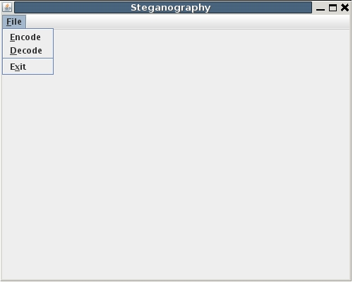

A key element of the program is inputting binary code and interpreting how the pixel values are configured. The binary code of either an image or text message is inputted into an array called byte. The values of 0, 8, and 16 represent the contrast and opacity of the pixels. The following is an example of the code the analyzes the arrays pixels.
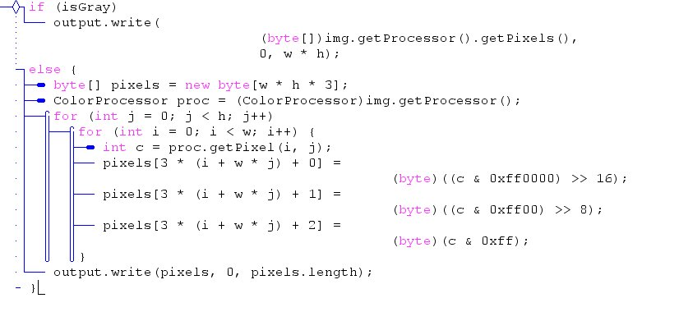

- What do you expect to work on next quarter, in relation to the goal of your project for the year?

I new class defining the binary code associated with each ASCII character will need to be coded. For next quarter, the program will be able to manipulate the binary as opposed to simply analyzing the carrier image's ability to be used by the program and displaying a GUI. As for detection, since the program can already determine file types. It will be easier to convert the program to hexadecimal and analyze the hex code in accordance to the tags. By the next quarter, at least one image format will be capable of being manipulated with Least Significant Bit encoding and detected using steganalysis.

