COMPUTER SYSTEMS RESEARCH
Code Writeup of your program, example report form 2009-2010
- Your name: Tara Naughton, Period: 2
- Date of this version of your program: 10/27/09
- Project title: Enhancing the Enlargement of Images
- Describe how your program runs as of this version. Include
-- files that may be needed
-- algorithms, specific procedures or methods you wrote
-- kinds of input your program uses
-- screenshots, what kinds of output does your program have
-- does your program handle errors, or does it crash on errors of input?
-- tests: summarize the basic analysis and testing of this version of your program
I totally completed the two typically used methods of image resizing: the pixel replication method, and the interpolation method. Both programs take black and white .pgm inputs. This is the finished version of my pixel replication method:
def main():
scale=2
fname=raw_input('Filename: ')
outfile=open('output.pgm','w')
s=open(fname).read().split()
outfile.write(s[0])
outfile.write('\n')
width = int(s[9])
height = int(s[10])
outfile.write('%d '%(width*scale))
outfile.write('%d'%(height*scale))
outfile.write('\n')
outfile.write(s[11])
outfile.write('\n')
result = []
for k in range((width*scale)*(height*scale)):
result.append(0)
w=0
while w < height*scale:
l = 0
while l < width*scale:
sample = s[(w/scale) * width + (l/scale)+12]
result[w * width*scale + l] = sample
l += 1
w += 1
for k in range((width*scale)*(height*scale)):
outfile.write('%s '%result[k])
if k%(width*scale) == 0:
outfile.write('\n')
outfile.close()

This is what it produces:


From the original input:


This is my interpolation code:
def main(): #reads in the image file and calls on the interpolation method
fname=raw_input('Filename: ')
s=open(fname).read().split()
test = []
che = 0
k= 0
while che < 50:
try: #this try blockinsures that any image comments in the .pgm file do not get read into the array, which would cause huge errors of input.
k = che
x = int(s[k])
if x > 3:
break
else:
che = che + 1
except ValueError:
che = che + 1
width = int(s[k])
length = int(s[k+1])
k = k+3
while k < len(s):
test.append(s[k])
k += 1
scale=2
new=interpolate(test,width,length,scale)
outfile=open('thumbnailedge.pgm','w')
outfile.write('P2 ')
outfile.write('%s '%(width*scale))
outfile.write('%s '%(length*scale))
outfile.write('255 ')
for m in range(len(new)):
outfile.write('%s '%new[m])
if m%(width*scale) == 0:
outfile.write('\n')
outfile.close()

def gradline(start,end,scale,src): #takes two neighboring pixels and returns an enlarged array with a gradient filling in the points in between the pixels
result = []
for k in range(2*scale):
result.append(0)
result[0] = start
result[2*scale-1] = end
if start==end:
grad= 0
elif start > end:
grad = (end-start+1)/(2*(scale-1))
else:
grad = (end-start-1)/(2*(scale-1))
k=1
while k < (2*scale)-1:
temp = int(k*grad+start)
result[k] = temp
k += 1
return result

def putpoint(point, x, y, width, bitmap): #places new points into the image
bitmap [(y * width) + x] = point

def getpoint(x, y, width, src_bitmap): #returns intensity value of a pixel in the image
return int(src_bitmap[(y * width) + x])

def interpolate(src,origw,origh,scale): #uses the three methods above to interpolate the image
newh = origw * scale
neww = origh * scale
result = []
for r in range(neww*newh):
result.append(0)

if scale==1:
for r in range(origh*oriw):
result[r] = src[r]
return result

i=0
while i < origh-1:
j=0
while j < origw-1:
line = gradline(getpoint(j, i, origw, src), getpoint(j+1, i, origw, src),scale,src)
for k in range(scale+1):
putpoint(line[k],j*scale+k,i*scale,neww,result)
line = gradline(getpoint(j, i, origw, src), getpoint(j, i+1, origw, src),scale,src)
for k in range(scale+1):
putpoint(line[k],j*scale,i*scale+k,neww,result)
line = gradline(getpoint(j+1, i, origw, src), getpoint(j+1, i+1, origw, src),scale,src)
for k in range(scale+1):
putpoint(line[k],(j+1)*scale,i*scale+k,neww,result)
k=1
while k <= scale:
line = gradline(getpoint(j*scale,i*scale+k,neww,result),getpoint((j+1)*scale,i*scale+k,neww,result),scale,src)
for l in range(scale+1):
putpoint(line[l],j*scale+l,i*scale+k,neww,result)
k += 1
j += 1
i += 1
return result

This is the image it produces:
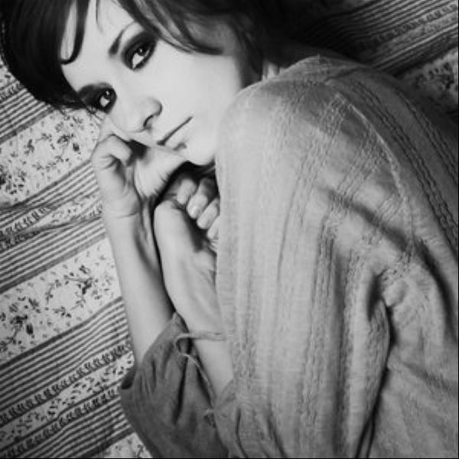
As of now, they don't crash on errors of input. My analysis of whether the algorithms succeed or fail is determined by sight; I can look at the output image produced and see if it really resizes the image to the appropriate scale factor and the results match up with what is expected from each method. The pixel replication method and interpolation method have both worked for the inputs I've given them.

I spent much of this quarter working on an edge detection method.

def edge(val,array): #takes a pixel and calculates its edge value based on the values of its neighbors
width = int(array[1])
if val-(width+1) < 4 or val+(width+1)>(len(array)-1) or (val-1-4)%width==0 or (val+1-4)%width==0:
return 0
h1 = int(array[val-(width+1)]) * (-1)
h2 = int(array[val-(width-1)])
h3 = int(array[val-1]) * (-2)
h4 = int(array[val+1]) * (2)
h5 = int(array[val+(width-1)]) * (-1)
h6 = int(array[val+(width+1)])
gx = h1 + h2+ h3+h4+h5+h6
v1 = int(array[val-(width+1)])
v2 = int(array[val-width]) * (2)
v3 = int(array[val-(width-1)])
v4 = int(array[val+(width+1)]) * (-1)
v5 = int(array[val+width]) * (-2)
v6 = int(array[val+(width-1)]) * (-1)
gy = v1 + v2+ v3+v4+v5+v6
return math.sqrt(gx * gx + gy * gy)

The part of my code that is still undergoing heavy modification at the end of my project was the putpoint method; I was trying to utilize my edge value method there, finding an equation that would calculate a stronger intensity for pixels with a stronger edge value.

def putpoint(point, x, y, width, bitmap, src):
n=edge(point,src) #gets the edge value of the point being placed in the image
point = point – int(2.91985*.0001*n*n+.002402*n+.769511) #playing with different equations to change the intensity; I may need to find a different way to approach this
if point < 0: #makes sure there are no negative values
point = 0
bitmap [(y * width) + x] = point:

I kept making modification after modification to it, but eventually realized there was a mismatch of input. However, when I tried to fix that, I only ran into more problems.

At one point, I tried to fix this problem with global variables in the getpoint method, but kept getting errors and didn't have enough time to sit back, look through my code, and figure out what was wrong with it at that point.

def getpoint(x, y, width, src_bitmap):
global derp
derp = (y*width) + x
return int(src_bitmap[(y * width) + x])
#return (y * width) + x

I don't have a whole ton of finished code to show for fourth quarter, because much of it was spent troubleshooting, and I didn't really keep the failed code I worked with.

- What do you expect to work on next quarter, in relation to the goal of your project for the year?
My project didn't get as far as I hoped it would. I had all the parts in place, but ran into troubles incorporating all the parts together. I was able to slightly modify the interpolation method, but ran into trouble with a mismatch of data input. There were many things I wanted to do with this project that I did not quite get to accomplish. Of course, given more time I would continue to work on my project until it yielded the results I was aiming for, but there are additional steps that could be taken in future research. One aspect I would modify about my project in the future is the input. While the .pgm image format is a convenient one to use to get the basic algorithm running, it is not the most commonly used image format. I would like to expand my project to take additional image inputs, such as .jpgs and .gifs. Additionally, the project could be expanded to include color rather than just working in grayscale.

