COMPUTER SYSTEMS RESEARCH
Code Writeup of your program, example report form 2009-2010
- Your name: Jacob Dominy , Period: 2
- Date of this version of your program: 01/19/2010
- Project title:
- Describe how your program runs as of this version. Include
-- files that may be needed
-- algorithms, specific procedures or methods you wrote
-- kinds of input your program uses
-- screenshots, what kinds of output does your program have
-- does your program handle errors, or does it crash on errors of input?
-- tests: summarize the basic analysis and testing of this version of your program
To run properly, my program requires the GLT ZPR libraries be accessible and that it be compiled using OpenGL. In my program, I use algorithms for calculating water acceleration (the Navier-Stokes equations), velocity, and displacement. All of these equations come from my knowledge of physics. My current implementations:
double displace(double Vi, double a, double t){
double d=(Vi*t)+(0.5)*(a*pow(t, 2));
return d;}
double velocity(double Vi, double a, double t){
double v=Vi+(a*t);
return v;}
void NSLine(){
double grid[11][11][3];
for(int x=1; x<10; x++){
for(int y=0; y<11; y++){
double curh=temp[x][y][0];
double curv=temp[x][y][1];
double cura=temp[x][y][2];
double curd=curh-depth;
double prevh=temp[x-1][y][0];
double prevd=prevh-depth;
double nexth=temp[x+1][y][0];
double nextd=nexth-depth;
double a;
a=(-g)*((prevd+curd)/(2*pow(xstep,2)))*(curh-prevh)+(g)*((curd+nextd)/(2*pow(xstep,2)))*(nexth-curh);
grid[x][y][2]=a;
grid[x][y][1]=velocity(curv, a, tstep);
grid[x][y][0]=curh+displace(curv, a, tstep);
cout << grid[x][y][0] << ", " << grid[x][y][1] << ", " << grid[x][y][2] << endl;
}
}
for(int x=0; x<11; x++){
for(int y=0; y<11; y++){
for(int z=0; z<3; z++){
temp[x][y][z]=grid[x][y][z];
}
cout << temp[x][y][0] << ", " << temp[x][y][1] << ", " << temp[x][y][2] << endl;
}
}
}
Here is the code that displays the height field from values stored in an array:
for(int xx=0; xx<10; xx++){

for(int yy=0; yy<10; yy++){

glBegin(GL_LINE_LOOP);

glVertex3f(-0.5+(xx*0.1), temp[xx][yy][0], -0.5+(yy*0.1));

glVertex3f(-0.5+(xx*0.1)+0.1, temp[xx+1][yy][0], -0.5+(yy*0.1));

glVertex3f(-0.5+(xx*0.1)+0.1, temp[xx+1][yy+1][0], -0.5+(yy*0.1)+0.1);

glVertex3f(-0.5+(xx*0.1), temp[xx][yy+1][0], -0.5+(yy*0.1)+0.1);

glEnd();

}

}

It should be noted that my NS code does not work yet. The program does not accept any real input yet, and only automatically generates the motion. When I run the program as it is now, this is what I see:
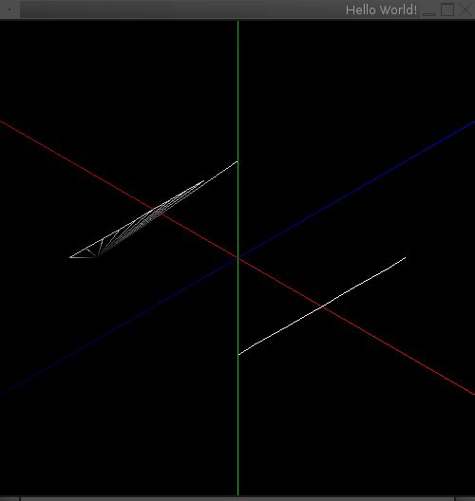

This is a result of the NS code outputting values that are close to infinity, causing the map to go totally off the visible area. This is one of the two errors that always happens. Sometimes the program goes to infinity and then quits because of a “Segmentation Fault”. However, this only happens every once in a while and I do not know if I can replicate the circumstances that cause it. Without the NS code in my program, the height map, which was my original goal for this quarter, is displayed as expected.
- What do you expect to work on next quarter, in relation to the goal of your project for the year?
In the next quarter, I plan on getting my Navier-Stokes code to calculate properly, and if I accomplish that, then I will use it to animate my height field. After that, all I will need to do is animate my program in 3 dimensions. This will be relatively simple, seeing as to use the Navier-Stokes equation in 3D, all you have to do is repeat the equation for both the X and Y axes. Once this is all finished, I will put more finishing touches on the program, such as more diverse user input and more variability.

