COMPUTER SYSTEMS RESEARCH
Code Writeup of your program, example report form 2009-2010
- Your name: Tara Naughton, Period: 2
- Date of this version of your program: 10/27/09
- Project title: Enhancing the Enlargement of Images
- Describe how your program runs as of this version. Include
-- files that may be needed
-- algorithms, specific procedures or methods you wrote
-- kinds of input your program uses
-- screenshots, what kinds of output does your program have
-- does your program handle errors, or does it crash on errors of input?
-- tests: summarize the basic analysis and testing of this version of your program
As of now, I have the two typically used methods of image resizing: the pixel replication method, and the interpolation method. Both programs take black and white .pgm inputs. This is the finished version of my pixel replication method:
def main():
scale=2
fname=raw_input('Filename: ')
outfile=open('output.pgm','w')
s=open(fname).read().split()
outfile.write(s[0])
outfile.write('\n')
width = int(s[9])
height = int(s[10])
outfile.write('%d '%(width*scale))
outfile.write('%d'%(height*scale))
outfile.write('\n')
outfile.write(s[11])
outfile.write('\n')
result = []
for k in range((width*scale)*(height*scale)):
result.append(0)
w=0
while w < height*scale:
l = 0
while l < width*scale:
sample = s[(w/scale) * width + (l/scale)+12]
result[w * width*scale + l] = sample
l += 1
w += 1
for k in range((width*scale)*(height*scale)):
outfile.write('%s '%result[k])
if k%(width*scale) == 0:
outfile.write('\n')
outfile.close()

This is what it produces:
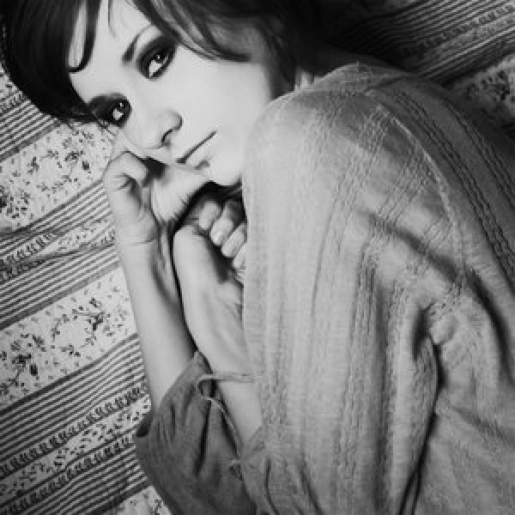
From the original input:
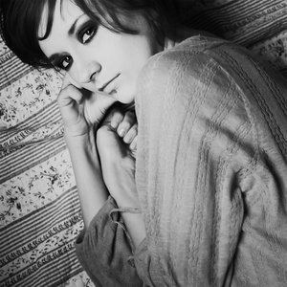

This is my interpolation code:
def main():
fname=raw_input('Filename: ')
print time.time()
s=open(fname).read().split()
test = []
k=12
while k < len(s):
test.append(s[k])
k += 1
scale=2
new=interpolate(test,int(s[9]),int(s[10]),scale)
outfile=open('output.pgm','w')
outfile.write('P2 ')
outfile.write('%s '%(int(s[9])*scale))
outfile.write('%s '%(int(s[10])*scale))
outfile.write('255 ')
for m in range(len(new)):
outfile.write('%s '%new[m])
if m%(int(s[9])*scale) == 0:
outfile.write('\n')
outfile.close()

def gradline(start,end,scale,src):
result = []
for k in range(2*scale):
result.append(0)
result[0] = start
result[2*scale-1] = end
if start==end:
grad= 0
elif start > end:
grad = (end-start+1)/(2*(scale-1))
else:
grad = (end-start-1)/(2*(scale-1))
k=1
while k < (2*scale)-1:
temp = int(k*grad+start)
result[k] = temp
k += 1
return result

def putpoint(point, x, y, width, bitmap):
bitmap [(y * width) + x] = point

def getpoint(x, y, width, src_bitmap):
return int(src_bitmap[(y * width) + x])

def interpolate(src,origw,origh,scale):
newh = origw * scale
neww = origh * scale
result = []
for r in range(neww*newh):
result.append(0)

if scale==1:
for r in range(origh*oriw):
result[r] = src[r]
return result

i=0
while i < origh-1:
j=0
while j < origw-1:
line = gradline(getpoint(j, i, origw, src), getpoint(j+1, i, origw, src),scale,src)
for k in range(scale+1):
putpoint(line[k],j*scale+k,i*scale,neww,result)
line = gradline(getpoint(j, i, origw, src), getpoint(j, i+1, origw, src),scale,src)
for k in range(scale+1):
putpoint(line[k],j*scale,i*scale+k,neww,result)
line = gradline(getpoint(j+1, i, origw, src), getpoint(j+1, i+1, origw, src),scale,src)
for k in range(scale+1):
putpoint(line[k],(j+1)*scale,i*scale+k,neww,result)
k=1
while k <= scale:
line = gradline(getpoint(j*scale,i*scale+k,neww,result),getpoint((j+1)*scale,i*scale+k,neww,result),scale,src)
for l in range(scale+1):
putpoint(line[l],j*scale+l,i*scale+k,neww,result)
k += 1
j += 1
i += 1
return result

This is the image it produces:
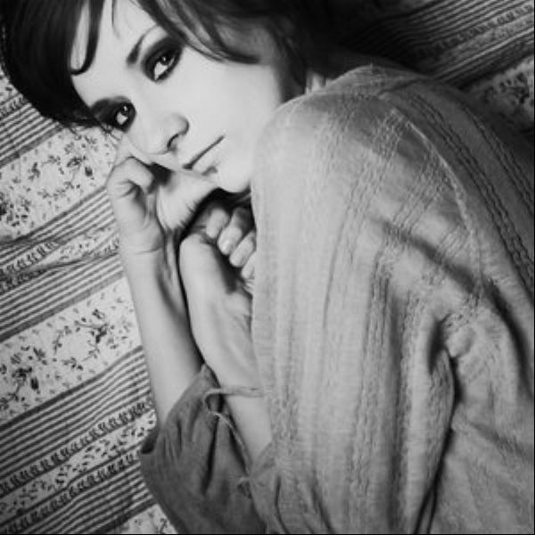

Right now, they both crash on errors of input. My analysis of whether the algorithms succeed or fail is determined by sight; I can look at the output image produced and see if it really resizes the image to the appropriate scale factor and the results match up with what is expected from each method. The pixel replication method and interpolation method have both worked for the inputs I've given them.
- What do you expect to work on next quarter, in relation to the goal of your project for the year?
I expect to finish adding an edge detection method to the interpolation algorithm so that it will be able to separate edges from the rest of the image and resize them with a different intensity. I'm also considering how to add something to the program that will eliminate any noise from the image, as I noticed that even in the interpolated image, it was still present (if there was enough of it in the original image.)

