COMPUTER SYSTEMS RESEARCH
Code Writeup of your program, example report form 2009-2010
- Your name: Jacob Dominy , Period: 2
Date of this version of your program: April 8, 2010
Project title: Methods of Simulating Fluid Motion in a Shallow Context in 3 Dimensions
Describe how your program runs as of this version. Include
-- files that may be needed
-- algorithms, specific procedures or methods you wrote
-- kinds of input your program uses
-- screenshots, what kinds of output does your program have
-- does your program handle errors, or does it crash on errors of input?
-- tests: summarize the basic analysis and testing of this version of your program
In order for my program to run correctly, it needs to utilize the OpenGL graphics libraries, as well as a library called GLTZPR, which stands for GLuT Zoom, Pan, and Rotate. As of now, the only input accepted by the program is mouse input, which is used to handle the GLTZPR methods to do what they are named for. For the time being, I removed the dropdown menus that were part of my program previously for two reasons: one, they didn't actually do anything, and two, they conflicted with the mouse commands that GLTZPR uses.
The backbone of my program is the fluid dynamics equations. At the heart of this is the equation to calculate vertical acceleration at points in the height field. In mathematical terms, the equation looks like this:
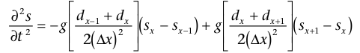
where “g” is the acceleration of gravity, “d” equals the depth at a certain point, and “s” equals the height at that point. In code, this equation looks like this:
a=(-g)*((prevd+curd)/(2*pow(xstep,2)))*(curh-prevh)+(g)*((curd+nextd)/(2*pow(xstep,2)))*(nexth-curh);
In previous versions of my program, I only used this and had methods to derive displacement and velocity from is.
double displace(double Vi, double a, double t){

double d=(Vi*t)+(0.5)*(a*pow(t, 2));

return d;}

double velocity(double Vi, double a, double t){

double v=Vi+(a*t);

return v;}
However, upon further analysis, I realized that I didn't need these methods because I was missing a step in the process. I needed to add in one more thing into it, and it was this equation, which derives the height from the heights of the previous two points:

where A is a matrix that looks like this:
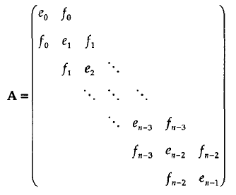
All of the numbers in the matrix are found using a variant of the vertical velocity shown above, which is already coded. The matrix also stays the same, meaning it is found before the Navier-Stokes line method loops. Also, the vertical velocity equation doesn't conserve volume, so we needed to add in checks to manually keep the volume of the water body equal at all times. It was because I didn't have these checks that my program wound up with heights near infinity.
double find_volume(){

double temp_vol;

for(x=1; x<11; x++){

double d1=height_field[x-1][0]-bottom;

double d2=height_field[x][0]-bottom;

double area=(d1+d2)/2;

temp_vol+=area;}

temp_vol=temp_vol*10;

return temp_vol;

}
This returns the volume of an 11x11 field.
double g = 9.8; //meters/seconds^2

double bottom=-1; //meters

int tstep=1; //seconds

double xstep=1; //meters

double volume=100 //meters^3

double height_field[11][11];

int iter=0;
These are the set variables for the program. Because I realized I didn't need to keep track of the acceleration and velocity of each point, I cut the height field array down to 2D from 3D.
for(int xx=0; xx<10; xx++){

for(int yy=0; yy<10; yy++){

glBegin(GL_LINE_LOOP);

glVertex3f(-.5+(xx*0.1), height_field[xx][yy], -.5+(yy*0.1));

glVertex3f(-.5+(xx*0.1)+0.1, height_field[xx+1][yy], -.5+(yy*0.1));

glVertex3f(-.5+(xx*0.1)+0.1, height_field[xx+1][yy+1], -.5+(yy*0.1)+0.1);

glVertex3f(-.5+(xx*0.1), height_field[xx][yy+1], -.5+(yy*0.1)+0.1);

glEnd();

}

}
This is the code that draws the line loops that make up the height field to the screen, specifically an 11x11 grid for now.

void keyboard(unsigned char key, int x, int y){

cout << key << " button pressed" << endl;

if(key==32){

NSLine();

glutPostRedisplay();

glutSwapBuffers();

if(iter==0){

for(int y=0; y<51; y++){

height_field[0][y]=0;}

}

iter+=1;

cout << iter << endl;

}

}
This function runs a single iteration of the Navier-Stokes method on a press of the space bar.

The program after a few iterations looks something like this:
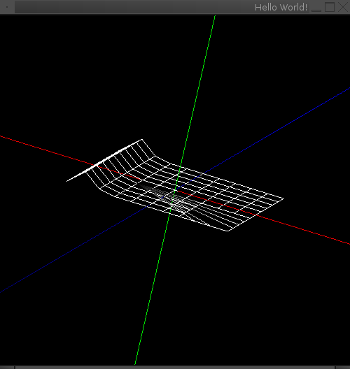

- What do you expect to work on next quarter, in relation to the goal of your project for the year?
In the next quarter, there will be a few things I will do. I will complete the coding of the correct procedure, which will not take much time, and work to have motion moving in two directions rather than only one. After this, I will try to add in some more user interactivity, with the changing of certain variables possible. These will be the last things I will do for my project.

