COMPUTER SYSTEMS RESEARCH
Code Writeup of your program, example report form 2009-2010
- Your name: Tara Naughton, Period: 2
- Date of this version of your program: 10/27/09
- Project title: Enhancing the Enlargement of Images
- Describe how your program runs as of this version. Include
-- files that may be needed
-- algorithms, specific procedures or methods you wrote
-- kinds of input your program uses
-- screenshots, what kinds of output does your program have
-- does your program handle errors, or does it crash on errors of input?
-- tests: summarize the basic analysis and testing of this version of your program
As of now, I have the two typically used methods of image resizing: the pixel replication method, and the interpolation method. Both programs take black and white .pgm inputs. This is the finished version of my pixel replication method:
def main():
scale=2
fname=raw_input('Filename: ')
outfile=open('output.pgm','w')
s=open(fname).read().split()
outfile.write(s[0])
outfile.write('\n')
width = int(s[9])
height = int(s[10])
outfile.write('%d '%(width*scale))
outfile.write('%d'%(height*scale))
outfile.write('\n')
outfile.write(s[11])
outfile.write('\n')
result = []
for k in range((width*scale)*(height*scale)):
result.append(0)
w=0
while w < height*scale:
l = 0
while l < width*scale:
sample = s[(w/scale) * width + (l/scale)+12]
result[w * width*scale + l] = sample
l += 1
w += 1
for k in range((width*scale)*(height*scale)):
outfile.write('%s '%result[k])
if k%(width*scale) == 0:
outfile.write('\n')
outfile.close()

This is what it produces:


From the original input:


This is my interpolation code:
def main(): #reads in the image file and calls on the interpolation method
fname=raw_input('Filename: ')
s=open(fname).read().split()
test = []
che = 0
k= 0
while che < 50:
try: #this try blockinsures that any image comments in the .pgm file do not get read into the array, which would cause huge errors of input.
k = che
x = int(s[k])
if x > 3:
break
else:
che = che + 1
except ValueError:
che = che + 1
width = int(s[k])
length = int(s[k+1])
k = k+3
while k < len(s):
test.append(s[k])
k += 1
scale=2
new=interpolate(test,width,length,scale)
outfile=open('thumbnailedge.pgm','w')
outfile.write('P2 ')
outfile.write('%s '%(width*scale))
outfile.write('%s '%(length*scale))
outfile.write('255 ')
for m in range(len(new)):
outfile.write('%s '%new[m])
if m%(width*scale) == 0:
outfile.write('\n')
outfile.close()

def gradline(start,end,scale,src): #takes two neighboring pixels and returns an enlarged array with a gradient filling in the points in between the pixels
result = []
for k in range(2*scale):
result.append(0)
result[0] = start
result[2*scale-1] = end
if start==end:
grad= 0
elif start > end:
grad = (end-start+1)/(2*(scale-1))
else:
grad = (end-start-1)/(2*(scale-1))
k=1
while k < (2*scale)-1:
temp = int(k*grad+start)
result[k] = temp
k += 1
return result

def putpoint(point, x, y, width, bitmap): #places new points into the image
bitmap [(y * width) + x] = point

def getpoint(x, y, width, src_bitmap): #returns intensity value of a pixel in the image
return int(src_bitmap[(y * width) + x])

def interpolate(src,origw,origh,scale): #uses the three methods above to interpolate the image
newh = origw * scale
neww = origh * scale
result = []
for r in range(neww*newh):
result.append(0)

if scale==1:
for r in range(origh*oriw):
result[r] = src[r]
return result

i=0
while i < origh-1:
j=0
while j < origw-1:
line = gradline(getpoint(j, i, origw, src), getpoint(j+1, i, origw, src),scale,src)
for k in range(scale+1):
putpoint(line[k],j*scale+k,i*scale,neww,result)
line = gradline(getpoint(j, i, origw, src), getpoint(j, i+1, origw, src),scale,src)
for k in range(scale+1):
putpoint(line[k],j*scale,i*scale+k,neww,result)
line = gradline(getpoint(j+1, i, origw, src), getpoint(j+1, i+1, origw, src),scale,src)
for k in range(scale+1):
putpoint(line[k],(j+1)*scale,i*scale+k,neww,result)
k=1
while k <= scale:
line = gradline(getpoint(j*scale,i*scale+k,neww,result),getpoint((j+1)*scale,i*scale+k,neww,result),scale,src)
for l in range(scale+1):
putpoint(line[l],j*scale+l,i*scale+k,neww,result)
k += 1
j += 1
i += 1
return result

This is the image it produces:
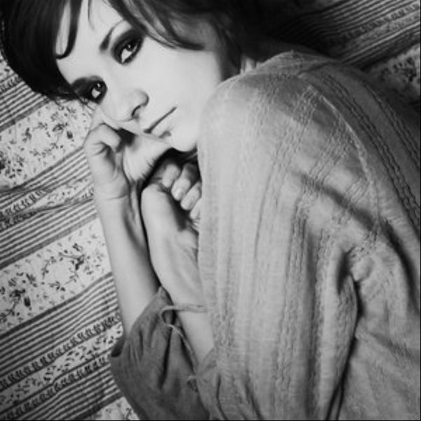
Right now, they both crash on errors of input. My analysis of whether the algorithms succeed or fail is determined by sight; I can look at the output image produced and see if it really resizes the image to the appropriate scale factor and the results match up with what is expected from each method. The pixel replication method and interpolation method have both worked for the inputs I've given them.

I spent much of this quarter working on an edge detection method.

def edge(val,array): #takes a pixel and calculates its edge value based on the values of its neighbors
width = int(array[1])
if val-(width+1) < 4 or val+(width+1)>(len(array)-1) or (val-1-4)%width==0 or (val+1-4)%width==0:
return 0
h1 = int(array[val-(width+1)]) * (-1)
h2 = int(array[val-(width-1)])
h3 = int(array[val-1]) * (-2)
h4 = int(array[val+1]) * (2)
h5 = int(array[val+(width-1)]) * (-1)
h6 = int(array[val+(width+1)])
gx = h1 + h2+ h3+h4+h5+h6
v1 = int(array[val-(width+1)])
v2 = int(array[val-width]) * (2)
v3 = int(array[val-(width-1)])
v4 = int(array[val+(width+1)]) * (-1)
v5 = int(array[val+width]) * (-2)
v6 = int(array[val+(width-1)]) * (-1)
gy = v1 + v2+ v3+v4+v5+v6
return math.sqrt(gx * gx + gy * gy)

The part of my code that is still undergoing heavy modification is the putpoint method; I'm currently trying to utilize my edge value method there, finding an equation that will calculate a stronger intensity for pixels with a stronger edge value. This section isn't where I want it to be at the moment and I need to experiment a lot with it.

def putpoint(point, x, y, width, bitmap, src):
n=edge(point,src) #gets the edge value of the point being placed in the image
point = point – int(2.91985*.0001*n*n+.002402*n+.769511) #playing with different equations to change the intensity; I may need to find a different way to approach this
if point < 0: #makes sure there are no negative values
point = 0
bitmap [(y * width) + x] = point:

- What do you expect to work on next quarter, in relation to the goal of your project for the year?
I expect to be perfecting the code section above and finding some method of incorporating edge enhancement without making the image discontinuous. I may have to completely redo my approach, working with other parts of the code instead of the putpoint method, or simply modify my method so it takes more variables into account in determining the intensity value of an edge pixel.

