COMPUTER SYSTEMS RESEARCH
Code Writeup of your program, report form 2009-2010
- Your name: Dan Johnson Period: 3
- Date of this version of your program: 2010/04/07
- Project title: A Distributed Multicast DNS System
- Describe how your program runs as of this version. Include
-- files that may be needed
-- algorithms, specific procedures or methods you wrote
-- kinds of input your program uses
-- screenshots, what kinds of output does your program have
-- does your program handle errors, or does it crash on errors of input?
-- tests: summarize the basic analysis and testing of this version of your program
Program is a server which can run on lots of nodes which will automatically detect each other and create a list of all nodes on the network. They can then join “interest” groups, lookup DNS records, and share them with other members of their interest groups.
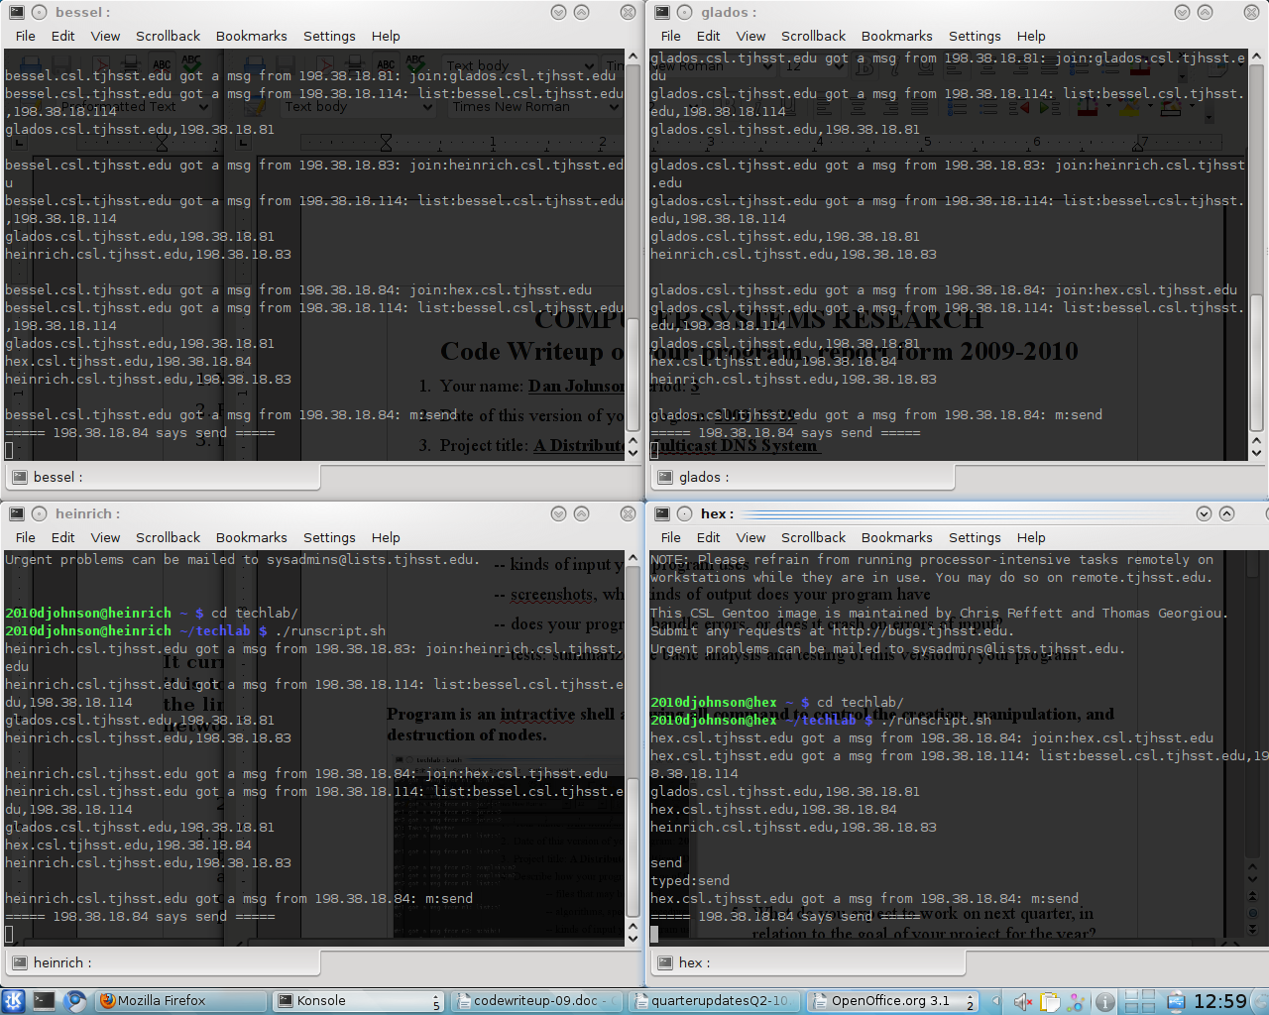
It handles text input on the console, can detect errors in the input and results, and asynchronously does lookups. It logs information to a logfile for each host so that the performance can be analyzed.
