COMPUTER SYSTEMS RESEARCH
Code Writeup of your program, report form 2009-2010
- Your name: Dan Johnson Period: 3
- Date of this version of your program: 2009/10/29
- Project title: A Distributed Multicast DNS System
- Describe how your program runs as of this version. Include
-- files that may be needed
-- algorithms, specific procedures or methods you wrote
-- kinds of input your program uses
-- screenshots, what kinds of output does your program have
-- does your program handle errors, or does it crash on errors of input?
-- tests: summarize the basic analysis and testing of this version of your program
Program is a server which can run on lots of nodes which will automatically detect each other and create a list of all nodes on the network.
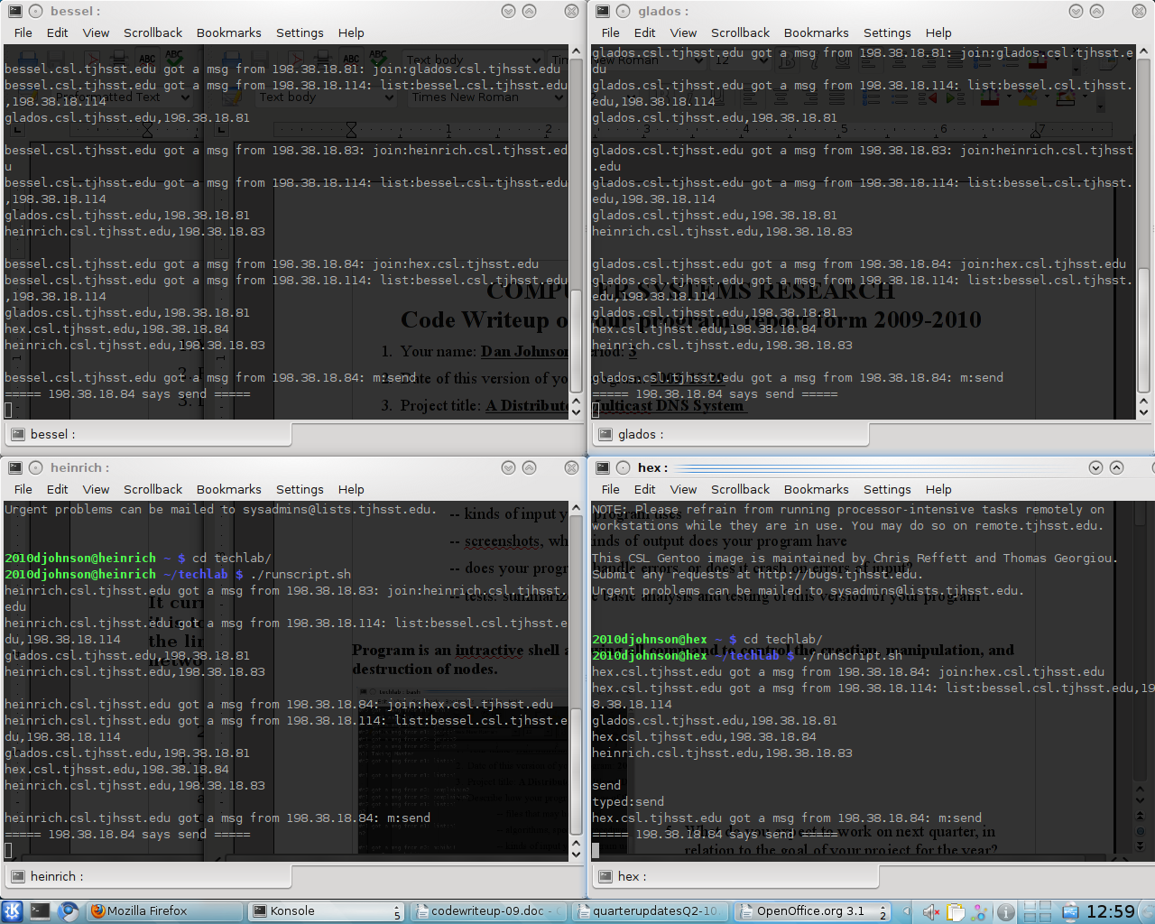
- What do you expect to work on next quarter, in relation to the goal of your project for the year?

I expect to test this on real-life data, as determined from a workstation. If I have spare time, I might work on visualizations of this.

