COMPUTER SYSTEMS RESEARCH
Code Writeup of your program, report form 2009-2010
- Your name: __Mendel Chen__________________________, Period: __3__
- Date of this version of your program: ____January 21st, 2010__________
- Project title: ____Simulation of Marketing Mix - Placement of Business________________
- Describe how your program runs as of this version. Include
-- files that may be needed
-- algorithms, specific procedures or methods you wrote
-- kinds of input your program uses
-- screenshots, what kinds of output does your program have
-- does your program handle errors, or does it crash on errors of input?
-- tests: summarize the basic analysis and testing of this version of your program
Currently, the raw data is just the population density map. I also include a map that displays roads for my GUI. With the raw data, I have an image recognition program in Python which converts the population density map (which is in PPM format) and reads pixel by pixel and prints out in a 780 x 780 text file the density at each point. My program in Java then reads in the data and stores it into a matrix grid. My program then goes over the entire grid and evaluates the heuristic value of each point. The heuristic is below:
for(int row = point_row-48; row < point_row+48; row++)
135 {
136 if(row > 0 && row < 779)
137 {
138 for(int column = point_column-16; column < point_column + 16; column++)
139 {
140 if(column > 0 && column < 779)
141 {
142 int distance = (int)Math.sqrt((row-point_row)*(row-point_row)+(column-point_column)*(column-point_column));
143 int data_value = stored_data[row * 780 + column][0];
144 heur += data_value * distance;
145 }
146 }
147 }
148 }
The heuristic essentially looks at the 48 pixels around each point and based on distance, adds on to the heuristic value of that center point. I then find the optimum point and I mark this point in blue in a new PPM file. So currently, the marked point essentially shows the most clustered part of Fairfax.

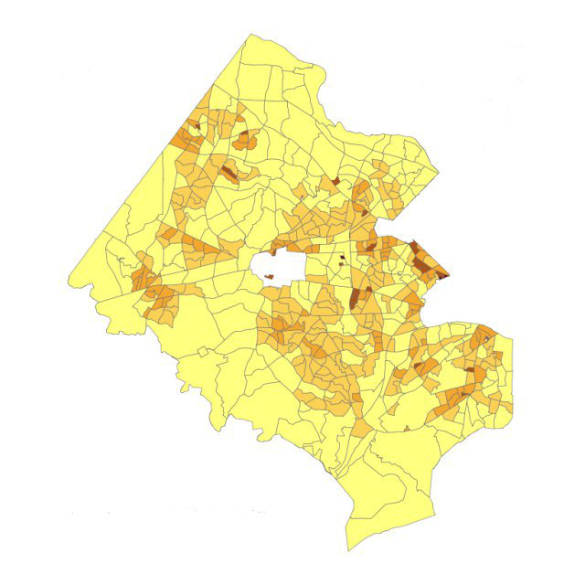
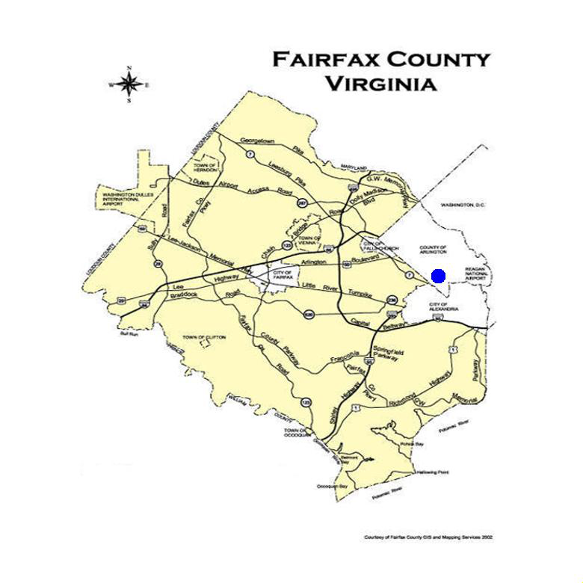
Fairfax Map w/ roads and marked points Raw population density map (darker = more populous)
My program can handle most errors as the run() method will just cancel out. Once it does cancel out, my program can be rerun with the run() button. Lastly, the run time of my project is O(n^3), as I have to loop through the 780 x 780 map three times nested. The run time right now is around 30 seconds.

- What do you expect to work on next quarter, in relation to the goal of your project for the year?
For the next quarter, I want to make my optimization more accurate by including an additional variable in the heuristic. This variable will be the location of competition. I hope to use Google Maps to locate the competition of a specific business and using an image recognition file from Python to convert this graphical data into textual data that can be stored an used. With additional variables, the predicted location will be a lot more accurate instead of simply finding the most crowded clusters.

