COMPUTER SYSTEMS RESEARCH
Code Writeup of your program, example report form 2009-2010
- Your name: Neal Milstein, Period: 3
- Date of this version of your program: January 24, 2009
- Project title: Developing an Educational Rigid Body Physics Engine
- Describe how your program runs as of this version. Include
-- files that may be needed
-- algorithms, specific procedures or methods you wrote
-- kinds of input your program uses
-- screenshots, what kinds of output does your program have
-- does your program handle errors, or does it crash on errors of input?
-- tests: summarize the basic analysis and testing of this version of your program
My program consists of a physics engine that supports a number of physical interactions, including collision detection (using the separate axis theorem), tension interaction (springs, using Hooke’s Law), and impulse forces (using Runge-Kutta 4 integration methods to integrate the accelerations to velocities). The program allows for any number of bodies, of any size and mass, to be put anywhere on the screen, with any starting velocity or acceleration. The simulation is then run, and the bodies follow the laws of physics as they interact on the screen. The program is divided into a model (stores the current state of the simulation), a view (the graphical user interface), and a controller (manages the time step and causes all of the interactions). The Interaction code is completely separated from the rest of the program, allowing for interactions to easily be added to the application.
My program handles ConcurrentModificationException errors, which occur when an object is drawn to the screen in the middle of iterating over the objects and drawing them. The program catches the exception, adds the added objects to a queue, and adds them to the actual simulation once the iterations and drawings are complete.
I have tested my program using conservation of energy laws – the velocity of the center of mass remains constant, for example – and against textbook problems. It is very accurate, most likely because I used Runge-Kutta 4 integration instead of Euler’s method.
The main algorithms my program uses are the Separating Axis Theorem and the Runge-Kutta 4 integration methods. The Separate Axis Theorem states that two convex objects are only colliding if all of their separating axes (projections of the objects onto the line drawn between the center of mass of each object) are intersecting. To calculate this, my program projects the vector protruding from each edge of each convex objects into the coordinate system that directly goes between the two objects. Runge-Kutta 4 Integration involves statistically calculating the best estimate for a slope value as a solution to a differential equation at a particular point. The algorithm presents many possibilities for optimization that I am looking into, such as by treating grouped bodies as a single body.

Screenshots:
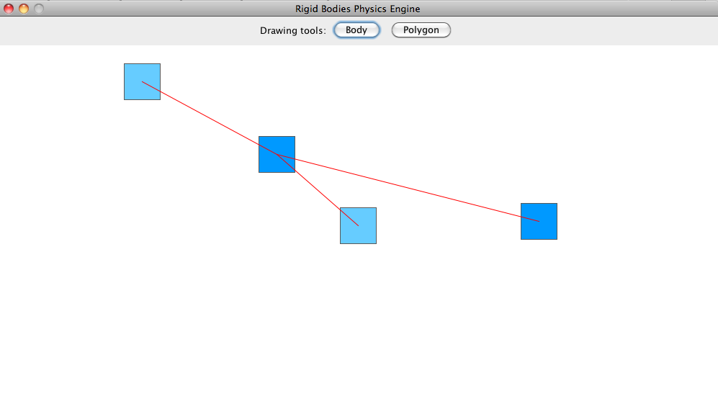
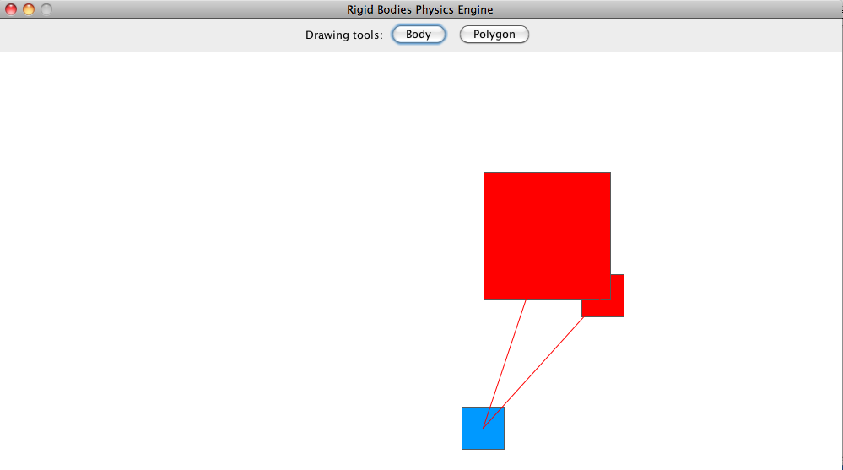

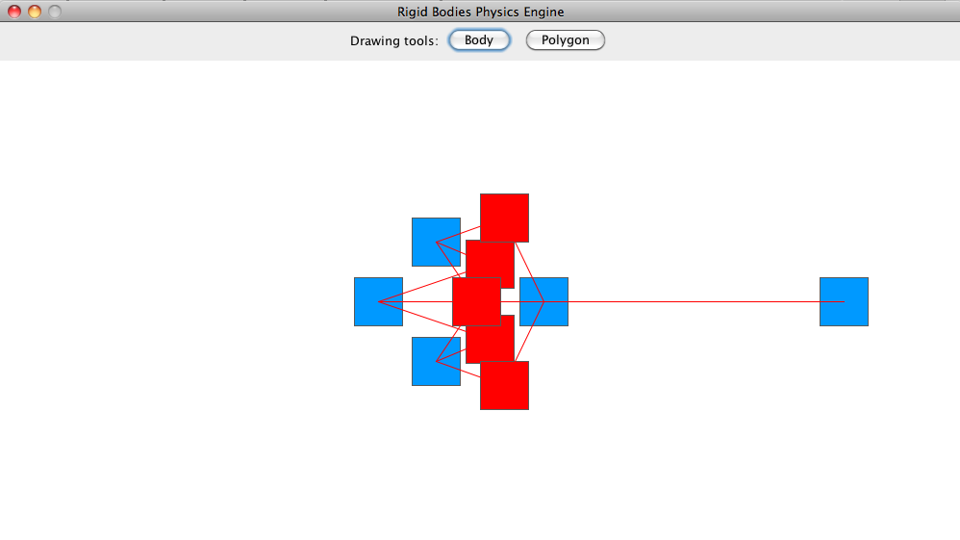

Reduced Code Sample

This class excerpt (from the CollisionInteracter class) detects collisions between objects using the Separating Axis Theorem. Any object that implements the Collideable interface (and thereby implements the getVertices() method) will have its collisions detected by this Interacter class.
public class CollisionInteracter extends Interacter
{
public void interact()
{
HashSet<Collision> collisions = new HashSet<Collision>();
for (Element e : model) {
if (e instanceof Aabb) {
Aabb source = (Aabb)e;
for (Element t : model) {
if (t == e) {
break;
}
if (t instanceof Aabb) {
Aabb target = (Aabb)t;
if (Math.abs(target.getReference().getPosition().getXComp() - source.getReference().getPosition().getXComp()) < (source.getDimension().getXComp() + target.getDimension().getXComp()) / 2 &&
Math.abs(target.getReference().getPosition().getYComp() - source.getReference().getPosition().getYComp()) < (source.getDimension().getYComp() + target.getDimension().getYComp()) / 2) {
collisions.add(new Collision(source, target));
}
}
}
}
}
for (Collision c : collisions) {
c.collide();
}
collisions.clear();
}
}

For every collision that the CollisionInteracter detects, a Collision object is created and added to a HashSet. This prevents duplicate collisions between objects from being created because the HashSet will not allow duplicate objects. After all of the objects have been looped over to test for collisions, the collide() method is called for each collision, which calculates the impulse force and derives the reflection velocities.

class Collision
{
private Body bodyA, bodyB;

public Collision(Body bodyA, Body bodyB)
{
this.bodyA = bodyA;
this.bodyB = bodyB;
}

public boolean equals(Object otherObj)
{
if (otherObj == null) {
return false;
}
Collision other = (Collision)otherObj;
return (other.bodyA == bodyA && other.bodyB == bodyB) || (other.bodyA == bodyB && other.bodyB == bodyA);
}

public int hashCode()
{
return bodyA.hashCode() + bodyB.hashCode();
}

public void collide()
{
Vector pos = bodyA.getPosition();
Vector projection = pos.project(bodyB.getPosition());
if (projection.getIntersection(bodyA.getVelocity()) {
bodyA.addForce(bodyB.getImpulseForceWith(bodyA));
bodyB.addForce(bodyA.getImpulseForceWith(bodyB));
}
}
}
The ReferenceableInteracter Integrates the Accelerations to derive velocities. The Runge-Kutta 4 Integration is performed in a separate class

package controller;
import model.*;

public class ReferenceableInteracter extends Interacter
{
private int frameDelay;

public ReferenceableInteracter(Model model, int frameDelay)
{
super(model);
this.frameDelay = frameDelay;
}

public void interact()
{
for (Element e : model) {
if (e instanceof Referenceable) {
if (!(e instanceof Anchorable && ((Anchorable) e).isAnchored())) {
((Referenceable) e).getReference().addVelocity(((Referenceable) e).getReference().getAcceleration().multiply((frameDelay / 1000.0)));
((Referenceable) e).getReference().addPosition(((Referenceable) e).getReference().getVelocity().multiply((frameDelay / 1000.0)));
((Referenceable) e).getReference().clearAcceleration();
}
}
}
}
}

The SpringInteracter class calculates the tension interactions between objects using Hooke's law. The formula for Hooke's law, f=-kx, is quite simple in itself, but it becomes much more complex when used with Runge-Kutta 4 integration. When solved for the position (by integrating twice), the standard harmonic oscillator equation is obtained.

package controller;
import model.*;

public class SpringInteracter extends Interacter
{
public SpringInteracter(Model model)
{
super(model);
}

public void interact()
{
for (Element e : model) {
if (e instanceof Spring) {
Spring s = (Spring)e;
double forceMag = s.getForce();
Vector direction = s.getBodyA().getReference().getPosition().minus(s.getBodyB().getReference().getPosition());
s.getBodyA().addForce(forceMag, direction);
s.getBodyB().addForce(forceMag, direction.getNegative());
}
}
}
}

The Controller of my project is the interface between the model and the view of the engine. It contains all of the physical interactions of my engine, such as the collision detection and the tension simulation, and it manages the time step.

package controller;

import java.util.Date;
import java.util.LinkedList;
import java.util.Timer;
import java.util.TimerTask;

import model.*;
import view.*;

public class Controller
{
private Model model;
private View view;

private Timer timer;
private int frameDelay;

private LinkedList<Interacter> interacters;

public Controller(int frameDelay)
{
model = new Model();
view = new View(this);

timer = new Timer();
this.frameDelay = frameDelay;

interacters = new LinkedList<Interacter>();
interacters.add(new CollisionInteracter(model));
interacters.add(new SpringInteracter(model));
interacters.add(new ReferenceableInteracter(model, frameDelay));
}

public void start()
{
Aabb body1 = new Aabb(new Reference(new Vector(-1, 1), new Vector(0, 0), new Vector(0, 0)), 0.5, new Vector(0.5, 0.5));
Aabb body2 = new Aabb(new Reference(new Vector(0, 0), new Vector(0, 0), new Vector(0, 0)), 0.5, new Vector(0.5, 0.5), true);
Aabb body3 = new Aabb(new Reference(new Vector(3, 0), new Vector(0, 0), new Vector(0, 0)), 0.5, new Vector(0.5, 0.5), false);
Aabb body4 = new Aabb(new Reference(new Vector(-3, 2), new Vector(0, 0), new Vector(0, 0)), 0.5, new Vector(0.5, 0.5), true);
Spring spring1 = new Spring(body1, body2, 20, 0);
Spring spring2 = new Spring(body1, body3, 20, 0);
Spring spring3 = new Spring(body1, body4, 10, 0);

model.add(body1);
model.add(body2);
model.add(body3);
model.add(body4);
model.add(spring1);
model.add(spring2);
model.add(spring3);

Aabb body1 = new Aabb(new Reference(new Vector(-2, 0), new Vector(0, 0), new Vector(0, 0)), 0.5, new Vector(0.5, 0.5), false);
Aabb body2 = new Aabb(new Reference(new Vector(0, 1), new Vector(0, 0), new Vector(0, 0)), 0.5, new Vector(0.5, 0.5), false);
Aabb body3 = new Aabb(new Reference(new Vector(2, 0), new Vector(0, 0), new Vector(0, 0)), 5, new Vector(1.5, 1.5), false);
Spring spring1 = new Spring(body1, body2, 20, 1.5);
Spring spring2 = new Spring(body2, body3, 40, 2.5);

model.add(body1);
model.add(body2);
model.add(body3);
model.add(spring1);
model.add(spring2);

Aabb body1 = new Aabb(new Reference(new Vector(-1, -1), new Vector(0, 0), new Vector(0, 0)), 0.5, new Vector(0.5, 0.5), false);
Aabb body2 = new Aabb(new Reference(new Vector(-1, 0), new Vector(0, 0), new Vector(0, 0)), 0.5, new Vector(0.5, 0.5), false);
Aabb body3 = new Aabb(new Reference(new Vector(-1, 1), new Vector(0, 0), new Vector(0, 0)), 0.5, new Vector(0.5, 0.5), false);
Aabb body4 = new Aabb(new Reference(new Vector(0, -1), new Vector(0, 0), new Vector(0, 0)), 0.5, new Vector(0.5, 0.5), false);
Aabb body5 = new Aabb(new Reference(new Vector(0, 0), new Vector(0, 0), new Vector(0, 0)), 0.5, new Vector(0.5, 0.5), false);
Aabb body6 = new Aabb(new Reference(new Vector(0, 1), new Vector(0, 0), new Vector(0, 0)), 0.5, new Vector(0.5, 0.5), false);
Aabb body7 = new Aabb(new Reference(new Vector(1, -1), new Vector(0, 0), new Vector(0, 0)), 0.5, new Vector(0.5, 0.5), false);
Aabb body8 = new Aabb(new Reference(new Vector(1, 0), new Vector(0, 0), new Vector(0, 0)), 0.5, new Vector(0.5, 0.5), false);
Aabb body9 = new Aabb(new Reference(new Vector(1, 1), new Vector(0, 0), new Vector(0, 0)), 0.5, new Vector(0.5, 0.5), false);
Aabb body10 = new Aabb(new Reference(new Vector(3, 0), new Vector(0, 0), new Vector(0, 0)), 0.5, new Vector(0.5, 0.5), false);

Spring spring1 = new Spring(body1, body2, 40, 1);
Spring spring2 = new Spring(body2, body3, 40, 1);
Spring spring3 = new Spring(body4, body5, 40, 1);
Spring spring4 = new Spring(body5, body6, 40, 1);
Spring spring5 = new Spring(body7, body8, 40, 1);
Spring spring6 = new Spring(body8, body9, 40, 1);
Spring spring7 = new Spring(body1, body4, 40, 1);
Spring spring8 = new Spring(body2, body5, 40, 1);
Spring spring9 = new Spring(body3, body6, 40, 1);
Spring spring10 = new Spring(body4, body7, 40, 1);
Spring spring11 = new Spring(body5, body8, 40, 1);
Spring spring12 = new Spring(body6, body9, 40, 1);
Spring force13 = new Spring(body8, body10, 40, 3);

model.add(body1);
model.add(body2);
model.add(body3);
model.add(body4);
model.add(body5);
model.add(body6);
model.add(body7);
model.add(body8);
model.add(body9);
model.add(body10);

model.add(spring1);
model.add(spring2);
model.add(spring3);
model.add(spring4);
model.add(spring5);
model.add(spring6);
model.add(spring7);
model.add(spring8);
model.add(spring9);
model.add(spring10);
model.add(spring11);
model.add(spring12);

model.add(force13);

Aabb body1 = new Aabb(new Reference(new Vector(-1, 0), new Vector(-2, 5), new Vector(0, 0)), 0.5, new Vector(0.5, 0.5), false);
Aabb body2 = new Aabb(new Reference(new Vector(0, 2), new Vector(0, -10), new Vector(0, 0)), 0.5, new Vector(0.5, 0.5), false);
Aabb body3 = new Aabb(new Reference(new Vector(2, 0), new Vector(2, 5), new Vector(0, 0)), 0.5, new Vector(0.5, 0.5), false);
Spring spring1 = new Spring(body1, body2, 20, 1);
Spring spring2 = new Spring(body2, body3, 20, 2);

model.add(body1);
model.add(body2);
model.add(body3);
model.add(spring1);
model.add(spring2);

timer.scheduleAtFixedRate(new TimerTask() {
public void run()
{
step();
getView().redraw();
}
}, new Date(), frameDelay);
}

public void step()
{
for(Interacter interacter : interacters) {
interacter.interact();
}
}

public Model getModel()
{
return model;
}

public View getView()
{
return view;
}
}

- What do you expect to work on next quarter, in relation to the goal of your project for the year?

Next quarter, I will first work on creating the responses to the collisions I have detected. This can be very complex, because the responses entail both rotation and translation. I will also move onto simulating friction between resting objects. This can also be complex, because objects will attempt to bounce off of each other instead of experience friction if not setup correctly.

Overall, I plan next quarter to be when I add the remaining features to turn my application into a fully functional physics engine. This requires not only adding a few new physical phenomena, but also implementing drawing methods and algorithms used for optimizing the collision detection between my objects. I also plan to finish the GUI, so that my program can be used in classrooms. I developed the framework for my application primarily in 1st quarter and the beginning of 2nd, and I will spend most of third quarter implementing lower-level physical phenomena that directly involve the interactions between objects.

Building off of what I have coded so far this quarter, I will also optimize the Separating Axis Theorem collision detection and the Runge-Kutta 4 integration of my engine. The Separating Axis Theorem Collision detection currently runs in O(n^2) time, and the Runge-Kutta 4 integration runs in O(n) time. By implementing a bounding box sweep-and-prune model, where bounding-box collisions are looked for before relying on the separate axis theorem, the collision detection can be brought down to constant O(1) time under best-case conditions, with O(n^2) remaining only the worst. Furthermore, the Runge-Kutta 4 integration algorithm can be brought to O(log(n)) time by treating objects as groups.

