COMPUTER SYSTEMS RESEARCH

Code Writeup of your program, example report form 2009-2010
- Your name: Neal Milstein, Period: 3
- Date of this version of your program: April 8, 2010
- Project title: Developing a Rigid-Body Dynamics Physics Engine
- Describe how your program runs as of this version.
Currently, my program accurately simulates a number of common physical phenomena studied in introductory physics classes. It features a GUI that allows for the drawing of bodies, and it can be programmed to run a setup over a time step to give a proper visualization of physical models. The main physical law simulated is collision detection and response. The algorithm used for collision detection is the separating axis theorem, and the process for collision response uses grids of ellipses to simulate collisions between irregular objects. Runge-Kutta 4 integration is also used to simulate acceleration more accurately than comparable integration methods, such as the obsolete Euler’s Method. This quarter, I programmed the interactions for collision response, which use the grids of ellipses. This required new data classes to be added to the model, which are used to create grids representing shapes. I also programmed aerodynamic drag into these shapes to prevent them from moving continuously.

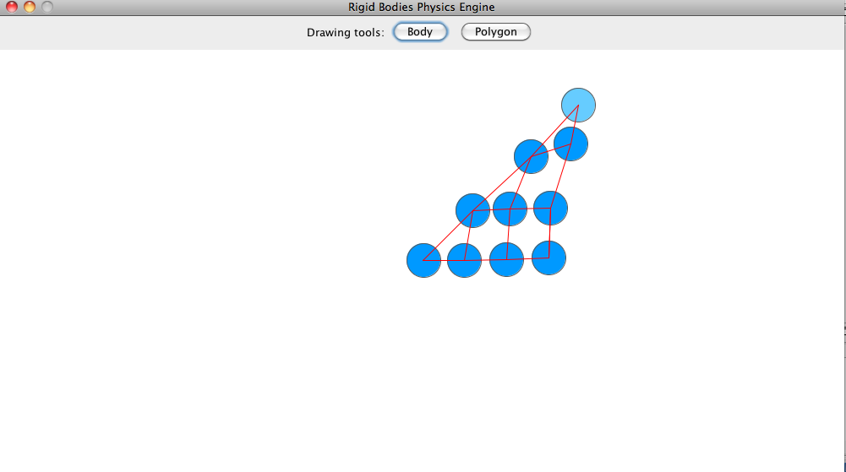
This screenshot shows, on a larger scale, the new elliptical-grid basis used to simulate collision responses. Here, a triangle is represented by a grid of ellipses connected by springs. In the actual simulation, the triangle would be made up of many more ellipses than shown here.

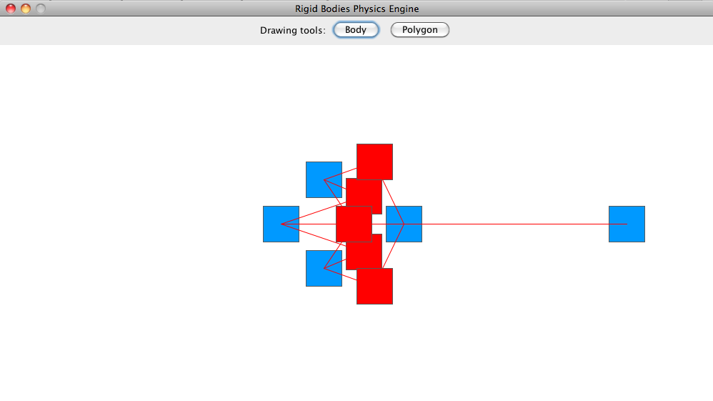
An example of the collision detection interactions, calculated using the Separating Axis Theorem. Colliding objects are shown here in red.
This is my code for the Irregular Shape drawing tool, which is a part of my program's view (GUI). The tool creates matrices of ellipses connected by elastic springs, which represent irregular shapes.

public class IrregularShapeTool extends Tool
{
private IrregularShapeDrawListener IrregularShapeListener;

public IrregularShapeTool(Toolbar parent)
{
super(parent);
}

final String NAME = "Irregular Shape";

public String getName()
{
return NAME;
}

public void select()
{
getParent().getParent().getRender().setCursor(new Cursor(Cursor.CROSSHAIR_CURSOR));
IrregularShapeListener = new IrregularShapeDrawListener(getParent().getParent().getRender());
getParent().getParent().getRender().addMouseListener(IrregularShapeListener);
}

public void deselect()
{
Render render = getParent().getParent().getRender();
render.removeMouseListener(IrregularShapeListener);
}
}

class IrregularShapeDrawListener extends MouseAdapter
{
private Render render;

private boolean IrregularShapeStarted = false;
private double x1 = 0, y1 = 0;

public IrregularShapeDrawListener(Render render)
{
this.render = render;
}

public void mousePressed(MouseEvent e) {
if (e.getButton() == MouseEvent.BUTTON1) {
if (!IrregularShapeStarted) {
IrregularShapeStarted = true;
x1 = e.getX();
y1 = e.getY();
} else {
IrregularShapeStarted = false;
x1 -= render.getDimension().getWidth() / 2;
y1 = render.getDimension().getHeight() - y1;
y1 -= render.getDimension().getHeight() / 2;
double x2 = e.getX() - (render.getDimension().getWidth() / 2);
double y2 = (render.getDimension().getHeight() - e.getY()) - (render.getDimension().getHeight() / 2);
double posX = (x1 + x2) / 2.0;
double posY = (y1 + y2) / 2.0;
double width = Math.abs(x2 - x1);
double height = Math.abs(y2 - y1);
try {
render.getModels().getFirst().add(new IrregularShape(new Reference(new Vector(posX / 100.0, posY / 100.0), new Vector(1.0, 1.0), new Vector(0, 0)), 1, new Vector(width / 100.0, height / 100.0)));
} catch (Exception e1) {

}
}
}
}
}

To fix my issue with ConcurrentModificationExceptions, I am using three array lists (one for the current list of Elements, one for the Elements that need to be added, and one for the Elements that need to be removed) to manage the simulations’s Elements. This prevents Elements from being added or removed in the middle of an iteration, which would throw an Exception. Objects are emptied from the addObjects and removalObjects ArrayLists each frame before the elements are iterated over.

private ArrayList<Element> elements = new ArrayList<Element>();
private ArrayList<Element> removalObjects = new ArrayList<Element>();
private ArrayList<Element> addObjects = new ArrayList<Element>();

public void addElement(Element mo)
{
addObjects.add(mo);
}

public void removeElement(Element mo)
{
removalObjects.add(mo);
}

// The action listener for each frame iteration
public void actionPerformed(ActionEvent e)
{
Graphics2D buffer = mainPanel.getBuffer();

buffer.setColor(Color.WHITE);
buffer.fillRect(0, 0, (int)mainDimension.getWidth(), (int)mainDimension.getHeight());

for (Element mo : Elements) {
mo.act();
}

for (Element ro : removalObjects) {
ro.removeFromMap();
Elements.remove(ro);
}
removalObjects.clear();

for (Element ao : addObjects) {
Elements.add(ao);
ao.addToMap(Map.this);
}
addObjects.clear();

for (Element mo : Elements) {
mo.draw(buffer);
}

mainPanel.repaint();
}

This code, a part of the controller (the engine), calculates the bounds of my IrregularShape elements and overlays a solid-filled shape over them. This does two things: it allows my shapes to be represented by grids of ellipses from the perspective of the physics engine, while showing them to the human user in the form of shapes; and it allows me to easily calculate the bounding box of my irregular shapes, which will speed up collision detection by only detecting collisions between shapes whose bounding boxes are intersecting.

public class OverlayDrawer extends Drawer
{
private Color blue = new Color(0x66ccff);
private Color lightBlue = new Color(0x0099ff);

public OverlayDrawer(LinkedList<Model> models, Graphics2D buffer)
{
super(models, buffer);
}

public void draw()
{
Model model = models.getFirst();
for (Element e : model) {
if (e instanceof IrregularShape) {
double[] bounds = e.getBounds(new Vector(e.rightSide() - e.leftSide()));
Vector[] vertices = e.getVertices();
double[] notations = IrregularShape.notate(bounds, vertices, 4);
for (int i=0; i<notations.length; i++) {
vertices[i] = vertices[i].dot(vertices[i++]);
}
vertices[0].norm();
for(int i=0; i<vertices.length i++) {
buffer.drawLine(vertices[i].getXComp(), vertices[i].getYComp(), vertices[i++].getXComp(), vertices[i++].getYComp())
}
View.redraw();
}
}
}
}

This code adds wind resistance to my irregular shape grids, which is required to prevent them from moving internally forever (like jelly). I used a HashSet for the forces, because I did not want duplicate forces between objects (which would lead to errors where objects are affected by twice as much drag). To properly use the HashSet’s non-duplicate features, I overrode the hashCode() and equals() methods of the DragForce object.

public void interact()
{
HashSet<DragForce> windResistances = new HashSet<DragForce>();
for (Element e : model) {
if (e instanceof Aabb) {
Aabb source = (Aabb)e;
for (Element t : model) {
if (t == e) {
break;
}
if (t instanceof Aabb) {
Aabb target = (Aabb)t;
if (Math.abs(target.getReference().getPosition().getXComp() - source.getReference().getPosition().getXComp()) < (source.getDimension().getXComp() + target.getDimension().getXComp()) / 2 &&
Math.abs(target.getReference().getPosition().getYComp() - source.getReference().getPosition().getYComp()) < (source.getDimension().getYComp() + target.getDimension().getYComp()) / 2) {
windResistances.add(new DragSource(source, target));
}
}
}
}
}

class DragForce
{
private Body bodyA, bodyB;

public DragForce(Body bodyA, Body bodyB)
{
this.bodyA = bodyA;
this.bodyB = bodyB;
}

public boolean equals(Object otherObj)
{
if (otherObj == null) {
return false;
}
DragForce other = (DragForce)otherObj;
return (other.bodyA == bodyA && other.bodyB == bodyB) || (other.bodyA == bodyB && other.bodyB == bodyA);
}

public int hashCode()
{
return bodyA.hashCode() + bodyB.hashCode();
}

public void collide()
{
bodyA.setColliding(true);
bodyB.setColliding(true);
}

- What do you expect to work on next quarter, in relation to the goal of your project for the year?
Next quarter, I will focus on polishing my program into a completed package. Most of the necessary physical interactions have already programmed in, though I still need to work a little more on the collision responses (I have encountered a bug where the object meshes can become entangled, for example). One of the original goals for my project was to make it apt for an educational environment, and this is still my intent. The GUI as of right now contains only a few drawing tools and is designed primarily for testing; I will have to significantly update it for the final product. Once this is done, I would like to add physical interactions to simulate friction and gravity, two very common physics classroom concepts.

