COMPUTER SYSTEMS RESEARCH
Code Writeup of your program, example report form 2009-2010
- Your name: Lenny Li Period: 4
- Date of this version of your program: June 3, 2010
- Project title: Statistical Analysis of Fluctuating Variables on the Stability of Predator Prey Systems
- Describe how your program runs as of this version. Include
-- files that may be needed
none
-- algorithms, specific procedures or methods you wrote
Same as last quarter – using different classes to represent different organisms
-- kinds of input your program uses
The simulation part takes in 6 different inputs – 2 initial populations, 2 reproduction probabilities, kill chance, and gain per kill
-- screenshots, what kinds of output does your program have
I outputted all of the data into a excel table to prepare for regression analysis. The GUI version also allows me to take screenshots of the GUI and a detailed diagram of the graph.
-- does your program handle errors, or does it crash on errors of input?
No. I actually had a lot of trouble getting the program to output the data because there was always a security error with remote. I fixed this problem manually by running the program in pieces.
-- tests: summarize the basic analysis and testing of this version of your program
I used excel's multiple regression analysis to do all the work for me. It gave me the best fit equation, the p-values, and the r^2 value of the system, which was .2289.
Here are the summary statistics.
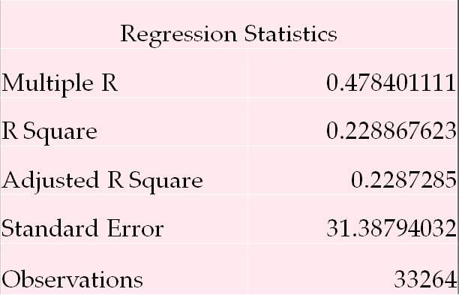
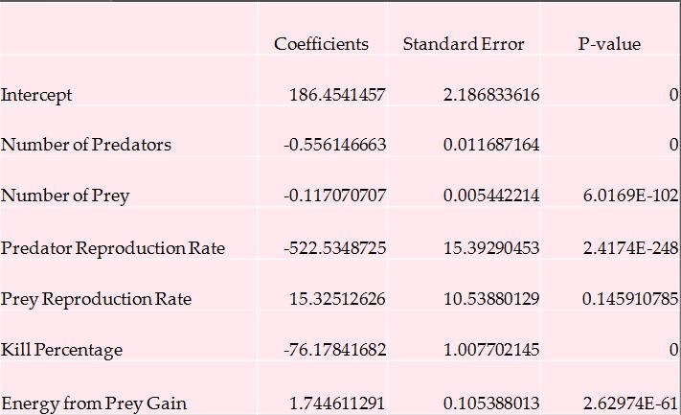
import Tkinter
- from random import *
- from sys import exit
- from copy import copy
- from math import *
- # Making Classes ----------------------------------------------------------------
- class Organism:
- def __init__ (self, lx, ly):
- self.metabolism = 1
- self.locx = lx
- self.locy = ly
- self.energy = randint(5,10)
- self.speed = gauss(1.0,.1) #mean = 1.5, standard deviation = .5
- self.hunger = randint(1,10)
- self.vision = randint(2,5)
- self.target = 0 #for predators only (no target to begin with)
- self.hunters = [] #for prey only (no hunters to begin with)
- self.skill = gauss(.5,.1)
- def calcDistance(self, target):
- x1,y1,x2,y2 = self.locx, self.locy, target.locx, target.locy
- return sqrt((x2-x1)**2 + (y2-y1)**2)
- class Pred(Organism):
- def move(self):
- global LocList
- for i in range(int(self.locx),int(self.locx+2)): #keeps track of where everything is. removes from old location lists
- for j in range(int(self.locy),int(self.locy+2)):
- if j < MapSize and i < MapSize:
- LocList[j*MapSize + i].agentList.remove(self)

- if self.target == 0: #move randomly
- theta = random()*2*pi
- self.locx = self.locx + self.speed*cos(theta)
- self.locy = self.locy + self.speed*sin(theta)
- else: #follow prey
- D = self.calcDistance(self.target)
- if D != 0:
- self.locx = self.locx + self.speed * (self.target.locx - self.locx)/D
- self.locy = self.locy + self.speed * (self.target.locy - self.locy)/D

- if self.locx < 0: #Boundary Check
- self.locx = 0
- if self.locy < 0:
- self.locy = 0
- if self.locx > MapSize-1:
- self.locx = MapSize-1
- if self.locy > MapSize-1:
- self.locy = MapSize-1

- for i in range(int(self.locx),int(self.locx+2)): #keeps track of where everything is. adds to new location lists
- for j in range(int(self.locy),int(self.locy+2)):
- if j < MapSize and i < MapSize:
- LocList[j*MapSize + i].agentList += [self]
- def reproduce(self):
- global NumPred, PredList, canvas, LocList
- lx = self.locx
- ly = self.locy
- new = Pred(lx,ly)
- radius = 5
- NumPred += 1
- self.energy /= 2
- new.energy = self.energy
- PredList += [new]
- for i in range(int(new.locx), int(new.locx+2)):
- for j in range(int(new.locy), int(new.locy+2)):
- if j < MapSize and i < MapSize:
- LocList[j*MapSize+i].agentList += [new]
- def findPrey(self):
- list = []
- r = self.vision
- for lx in range(int(self.locx)-r, int(self.locx)+r): #prey within circle of radius r
- xdif = int(sqrt(r*r - int((lx-self.locx))*int((lx-self.locx))))
- for ly in range(int(self.locy) - xdif, xdif + int(self.locy)):
- if lx >= 0 and ly >= 0 and lx < MapSize and ly <MapSize:
- list += LocList[ly*MapSize + lx].agentList

- ClosestDistance = r
- CurrentPrey = 0
- for l in list: #choosing closest prey
- if isinstance(l, Prey);
- D = self.calcDistance(l)
- if CurrentPrey == 0:
- CurrentPrey = l
- ClosestDistance = D
- elif D < ClosestDistance:
- CurrentPrey = l
- ClosestDistance = D
- if CurrentPrey != 0:
- CurrentPrey.hunters += [self]
- return CurrentPrey # 0 of there is no prey
- def die(self):
- global NumPred, PredList, canvas, LocList
- if self.target != 0: #remove yourself from a prey's hunter list
- self.target.hunters.remove(self)
- PredList.remove(self)
- for i in range(int(self.locx),int(self.locx+2)):
- for j in range(int(self.locy),int(self.locy+2)):
- if j < MapSize and i < MapSize:
- LocList[j*MapSize + i].agentList.remove(self)
- NumPred -= 1
- def kill(self, prey):
- self.energy += GainFromKillRate
- prey.die()
- def calcKill(self, prey):
- return (1-prey.skill)*(self.skill)*KillRate
- def calcReproduce(self):
- if self.energy < 5:
- return 0
- return PredRate * NumPred*(1-NumPred/PredCapacity)/NumPred
- def step(self):
- self.energy -= self.metabolism #subtract energy
- if self.energy <= 0: #check if dead
- self.die()
- else:
- if random() < self.calcReproduce(): #check if it wants to reproduce
- self.reproduce()
- if self.target == 0: #if there is no target, find one
- self.target = self.findPrey()
- self.move() #move randmomly if no target or follow target
- if self.target != 0;
- if self.calcDistance(self.target) < 1:
- if random() < self.calcKill(self.target):
- self.kill(self.target)
- self.target = 0
- class Prey(Organism):
- def move(self):
- global LocList
- for i in range(int(self.locx),int(self.locx+2)): #keeps track of where everything is. removes from old location lists
- for j in range(int(self.locy),int(self.locy+2)):
- if j < MapSize and i < MapSize:
- LocList[j*MapSize + i].agentList.remove(self)
- if len(self.hunters) == 0: #move randomly
- theta = random()*2*pi
- self.locx = self.locx + self.speed*cos(theta)
- self.locy = self.locy + self.speed*sin(theta)
- else: #avoid predators
- xT,yT = 0,0
- for h in self.hunters:
- xT += h.locx
- yT += h.locy
- xT /= len(self.hunters)
- yT /= len(self.hunters)
- D = sqrt((self.locx-xT)*(self.locx-xT) + (self.locy-yT)*(self.locy-yT))
- if D != 0:
- self.locx = self.locx + self.speed * (self.locx - xT)/D
- self.locy = self.locy + self.speed * (self.locy - yT)/D
- if self.locx < 0: #Boundary Check
- self.locx = 0
- if self.locy < 0:
- self.locy = 0
- if self.locx > MapSize-1:
- self.locx = MapSize-1
- if self.locy > MapSize-1:
- self.locy = MapSize-1
- for i in range(int(self.locx),int(self.locx+2)): #keeps track of where everything is. adds to new location lists
- for j in range(int(self.locy),int(self.locy+2)):
- if j < MapSize and i < MapSize:
- LocList[j*MapSize + i].agentList += [self]
- def reproduce(self):
- global NumPrey, PreyList, canvas, LocList
- lx = self.locx
- ly = self.locy
- new = Prey(lx,ly)
- radius = 2
- self.energy /= 2
- new.energy = self.energy
- NumPrey += 1
- PreyList += [new]
- for i in range(int(new.locx), int(new.locx)+2):
- for j in range(int(new.locy), int(new.locy)+2):
- if j < MapSize and i < MapSize:
- LocList[j*MapSize+i].agentList += [new]
- def die(self):
- global NumPrey, PreyList, canvas, LocList
- for l in self.hunters:
- l.target = 0
- PreyList.remove(self)
- for i in range(int(self.locx), int(self.locx)+2):
- for j in range(int(self.locy), int(self.locy)+2):
- if j < MapSize and i < MapSize:
- LocList[j*MapSize+i].agentList.remove(self)
- NumPrey -= 1
- def calcReproduce(self):
- if self.energy < 4:
- return 0
- return PreyRate*NumPrey*(1-NumPrey/PreyCapacity)/NumPrey
- def step(self):
- if self not in PreyList:
- return
- self.energy -= self.metabolism #subtract energy
- if self.energy <= 0: #check if dead
- self.die()
- else:
- if random() < self.calcReproduce(): #check if it wants to reproduce
- self.reproduce()
- self.move() #move randomly
- currentPatch = LocList[int(self.locx+.5)*MapSize + int(self.locy+.5)]
- if currentPatch.amountFood != 0: #get food from current location
- self.energy += GainFromGrassRate
- currentPatch.amountFood = 0
- class Patch:
- def __init__ (self, lx, ly):
- self.color = 0
- self.amountFood = randint(0,1)
- self.foodGrowth = 30
- self.locx = lx
- self.locy = ly
- self.currentCount = randint(0,self.foodGrowth)
- self.character = 0
- self.agentList = []
- def step(self): #grows food
- if self.amountFood == 0:
- self.currentCount += 1
- if self.currentCount >= self.foodGrowth:
- if self.amountFood < 1:
- self.amountFood += 1
- self.currentCount = 0
- # End of Making Classes ---------------------------------------------------------------------------
- # initializing -------------------------------------------------------------------------------------
- def setup():
- global LocList, PredList, PreyList, OrganismList, canvas, NumPred, NumPrey
- PredPopList = []
- PreyPopList = []
- LocList = []
- PredList = []
- PreyList = []
- OrganismList = []
- # Creating Organisms-------------------------------------------------------
- for i in range(0, MapSize): #Initiate map
- for k in range(MapSize):
- LocList += [Patch(i, k)]
- for i in range(NumPred): #Create Predators
- a = Pred(random()*(MapSize - 1), random()*(MapSize - 1))
- PredList += [a]
- for j in range(int(a.locx),int(a.locx + 2)):
- for k in range(int(a.locy),int(a.locy + 2)):
- if k < MapSize and j < MapSize:
- LocList[k*MapSize + j].agentList += [a]
- for i in range(NumPrey): #Create Prey
- a = Prey(random()*(MapSize - 1), random()*(MapSize - 1))
- PreyList += [a]
- for j in range(int(a.locx),int(a.locx + 2)):
- for k in range(int(a.locy), int(a.locy + 2)):
- if k < MapSize and j < MapSize:
- LocList[k*MapSize + j].agentList += [a]
- OrganismList = PredList + PreyList
- # End of Creating Organisms ----------------------------------------------------------------------------------
- # End of Initialize ------------------------------------------------------------------------------------
- def go(number_steps): #step function
- global LocList, PredList, PreyList, OrganismList
- while 1:
- if number_steps > 998:
- return number_steps
- number_steps += 1
- shuffle(OrganismList)
- for a in OrganismList: #Each animal takes turn acting
- if a in PreyList or a in PredList:
- a.step()
- for patch in LocList:
- patch.step()
- OrganismList = PredList + PreyList
- if NumPred * NumPrey == 0:
- return number_steps
- # Global Variables Setup---------------------------------------------------------------
- global MapSize, NumPred,NumPrey,PreyCapacity,PredCapacity,PreyRate,PredRate,KillRate,GainFromKillRate,GainFromGrassRate,LocList,PredList,PreyList,OrganismList
- def GlobalVariables():
- global MapSize, NumPred,NumPrey,PreyCapacity,PredCapacity,PreyRate,PredRate,KillRate,GainFromKillRate,GainFromGrassRate,LocList,PredList,PreyList,OrganismList
- MapSize = MapSize1
- NumPred = NumPred1
- NumPrey = NumPrey1
- PreyCapacity = MapSize*MapSize/3
- PredCapacity = PreyCapacity/2
- PreyRate = PreyRate1
- PredRate = PredRate1
- KillRate = KillRate1
- GainFromKillRate = GainFromKillRate1
- GainFromGrassRate = GainFromGrassRate1
- LocList = []
- PredList = []
- PreyList = []
- OrganismList = []
- # End of Global Variables --------------------------------------------------------
- def drange(start,stop,step):
- r = start
- while r < stop:
- yield r
- r += step
- def mean(list):
- t = 0
- for i in list:
- t += i
- return t*1.0 / len(list)
- def std(list):
- avg = mean(list)
- t = 0
- for i in list:
- t += 1.0*(i - avg)**2/(len(list) - 1)
- return sqrt(t)
- def writeOut(DataLists):
- out = open('data1.3.cvs', 'w')
- out.write('Number of Predators,' + 'Number of Prey,' + 'MapSize,' + 'Predator Reproduction Rate,' + 'Prey Reproduction Rate,' + 'Kill Percentage,' + 'Energy from Prey Gain,' + 'Energy from Grass Gain,' + 'Mean Stability,' + 'Standard Deviation \n')
- for list in DataLists:
- for point in list:
- out.write(str(point) + ',')
- out.write('\n')
- out.close()
- DataLists = [] #list of lists
- Input = [] #[NumPred, NumPrey, MapSize, PredRate, PreyRate, KillRate, GainFromKillRate, GainFromGrassRate, Mean, Standard Deviation]
- for NumPred1 in range(60,65,5):
- for NumPrey1 in range(100,210,10):
- for MapSize1 in range(25,30,5):
- for PredRate1 in drange(.03,.07,.01):
- for PreyRate1 in drange(.06,.12,.02):
- for KillRate1 in drange(.5,1,.1):
- for GainFromKillRate1 in range(10,16,2):
- for GainFromGrassRate1 in range(4,6,2):
- Input = [NumPred1,NumPrey1,MapSize1,PredRate1,PreyRate1,KillRate1,GainFromKillRate1,GainFromGrassRate1]
- trials = []
- for trial in range(5):
- GlobalVariables()
- setup()
- trials += [go(1)]
- Input += [mean(trials)]
- print Input
- DataLists += [Input]
- writeOut(DataLists)

