COMPUTER SYSTEMS RESEARCH
Code Writeup of your program, example report form 2009-2010
- Your name: Mo Lu, Period: 04
- Date of this version of your program: 06/05/2010
- Project title: Coverage Efficiency in an Autonomous Lawnmower
- Describe how your program runs as of this version. Include
-- files that may be needed
-- algorithms, specific procedures or methods you wrote
-- kinds of input your program uses
-- screenshots, what kinds of output does your program have
-- does your program handle errors, or does it crash on errors of input?
-- tests: summarize the basic analysis and testing of this version of your program
Simulation Run-through, key parts of actual code attached
Inputs: Hard-coded randomly generated matrix, 0's represent 1's represent obstacles, 9 Represents Robots, 2 represents unmowable terrain type.
Obstacles
Terrain Types, area input
Horizontal
Vertical
Diagonal
Circular (Problematic, see results)
Robot Class
Knows Location in Matrix
Knows Direction/Angle
Scan Method
Map Method
Move Ahead Method
Backtrack Method
Change Facing
Run Method
Angle Return Method
isBoundary
Scan Method
Scan 2 spaces ahead
Return distance until out-ping scan encounters a 1 or a undefined value (boundary)
Calculate location of the 1, based off current location
Recur, scan in 180 degree forward direction, increments of 0, 45 and 90 degrees
Return spaces that have a value of [1]
Map Method
Creates matrix of 0's
Store 1's in matrix
Move Ahead Method
while location+1!=[1] and isboundary(location)=false:
move ahead 1 space
if location+1=[1]
map(location+1)
newangle=scan(location)
moveahead(location, angle)
Backtrack Method(Location)
set robot coordinates to [x-1][y-1]
Change Facing(Location)
if at boundary of environment:
change facing 180 degrees
isBoundary(location)
if location+1=undefined
map(location+1)
return true
else
return false
Run
While Map()!=Environment
Scan()
Move Ahead{}

Scanning Code for Rangefinder
import time
import serial
import os
import dataconversion.py
Inputs: Physical environment, location on grid
Create a debug list for resulting values
Check ports for rangefinder
for x through 10
test for connection
connect=1
else
connect=0
break
getInput(s):
s=raw_input()
return s
sendSerial Call()
if sent=true
getSerial()
readDevice.inwaiting
print
receive_Data():
strin=getInput(strin)
sendSerial(strin)
time.sleep(.5) #Pause to let the rangefinder update
strout=receiveSerial(strout)
printOutput(strout)
printOutput(input)
dataconvsersion.convert(input) #Converts binary to hex to ACSII
if main = '____'
scan()
sendSerial()
recieve_Data()
for x in range 7 #Scans 7 times
printOutput()
Shape Analysis Code, See attached. Self explanatory.
ShapeAnalysis method
open debug output
readstrings()
def shapeanalysis(olist):
shapecount=0 #Returns most possible shape of the obstacle depending on scanned values
for x in range olist.len():
new=olist[x]
sl=new[2]#Left Side of Scanned values
sr=new[6]#Right Side of Scanned values
sf=new[4]#Front
if (sl+sr+sf%3=0):
shapecount=1 #Square obstacle
return shapecount
if (s1+sr+sf% pi is int):#Integer test for a radius constant
shapecount=2#Circle obstacle
return shapecount
if (sl+sr+sf=sf):
shapecount=3#Line obstacle
return shapecount
else if (sl+sr+sf!=0)
shapecount=4#Traiangular obstacle, since none other exists
return shapecount
Results: GUI w/ Scanner Results

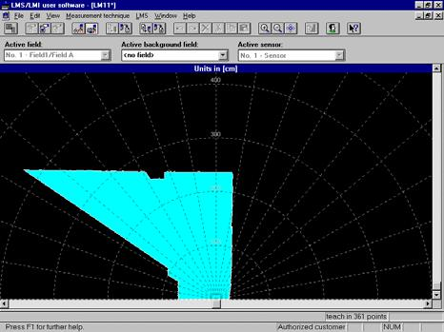

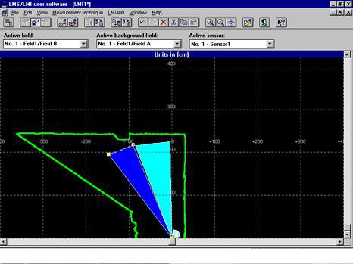

Raw Output Example
0 ['1891', '0', '0', '7', '320', '384', '0']
1 ['1891', '0', '0', '7', '320', '384', '0']
2 ['1891', '0', '0', '7', '320', '384', '0']
3 ['1891', '0', '0', '7', '320', '384', '0']
4 ['1891', '0', '0', '7', '320', '384', '0']
5 ['1891', '0', '0', '7', '320', '384', '0']
6 ['1891', '0', '0', '7', '320', '384', '0']
7 ['1891', '0', '0', '7', '320', '384', '0']
8 ['1891', '0', '0', '7', '320', '384', '0']
With a 270 degree vision, the values of the outputs moves in increments of 45 degrees (270/6). Larger values naturally represent longer distances and 0's represent unseasonable distances (too far.) The 7s in the middle represent the value directly in front of the scanner.

Simulation Results
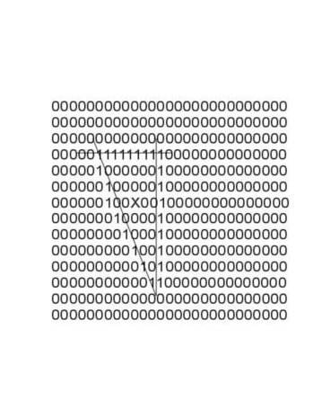

Runtime Analysis
Based off a 8x8 matrix, and a rising level of complication in obstacle construction.

Testing the Rangefinder, Visualizations
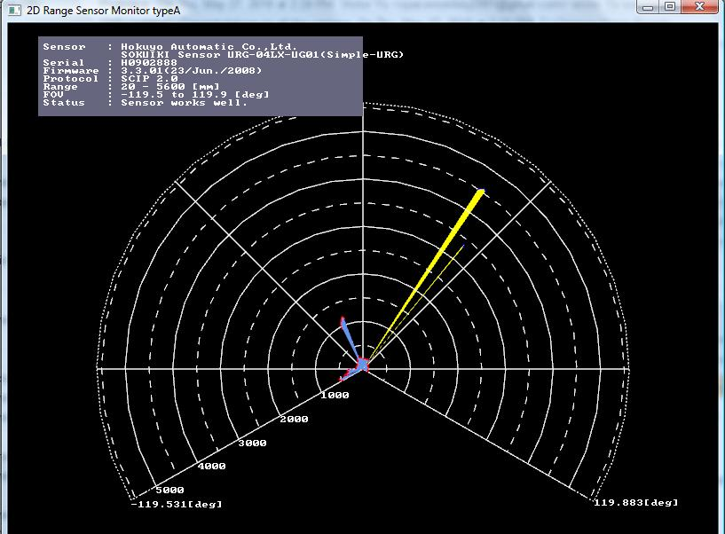

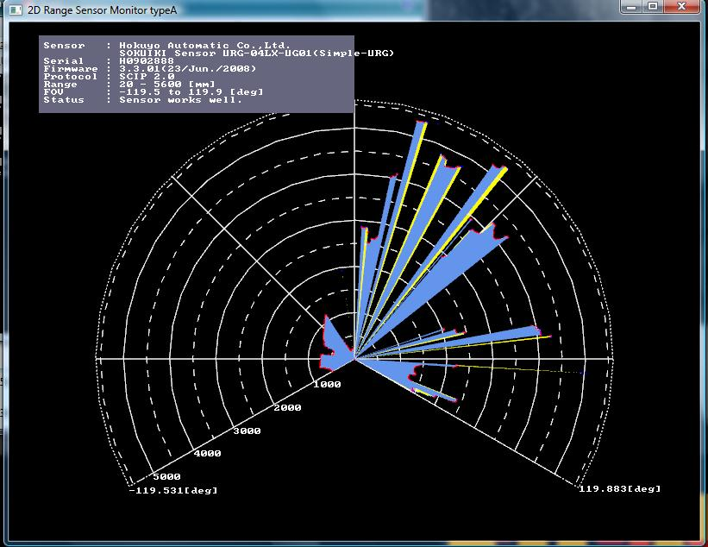

Testing on this version of the program (Final)
1)I have begun to attach the scanner and incorporate my scanning code into the Audrino board. This has not had much impact on the code itself, because the Audrino model we are using is fully compatible with the Python programming language. However, the scanner does not perfectly synch up with the power sources provided, and after a few trial runs, I have been forced to decrease the scan rate to match up with the power consumption of the motors. Using the default baud scanrate of 30 pings/sec I have found a significant discrepancy with the actual environment and the scanner's real time visualization on the computer screen. Essentially, the scanner is always lagging around two seconds behind the robot's movements. I've found the optimal scanrate to be around 27 pings/sec. At this speed, the scan rate and the movement rate match up fairly well without sacrificing much of the scanning-update speed.

2)Using the Vmon visualization, I began to test for the maximum scan range of the device. This involved placing a block directly in front of the scanner in an otherwise completely flat surface and moving it back until the scanner couldn't register the block. I then analyzed the actual distance and the print output for the maximum scan range, and the actual value that each unit in the output was worth. Hokuyo claims the maximum scan distance is 725 hexadecimal units, which translates to around 6.5 meters given my experiments. The maximum range that registered on Vmon was round 5.9 meters away from the scanner, and even then the ping visualization was weak. I have found that the strongest scanning range is from 1-4 meters. At this distance, the update times on the visualization give the clearest and most lag-free correspondence with the adjustments in the environment. At distances less than 1 meter, the points become clumped and it becomes hard to distinguish between curves and straights. At distances greater than 4 meters, the visualization and data recognition lose clarity and straights don't show up consistently. Also, quick motions in the environment do not register as well past the 4 meter mark.

3)This new code does increase the runtime, but the filters prevents the GUI from showing bumps or spikes in the obstacles. In the end, this shows a more accurate picture of the environment than before. This also smooths out the images, giving a more visually accurate picture.
Additionally, I have been playing with pause times between update scans to see if positioning of the robot can change the structure of the GUI visualizations. Usually, I generate the visualizations only after the output has been finalized. This test involves generating them while the robot is still scanning and running, finally implementing the simultaneous section of SLAM.
From my results I have concluded the the mapping and visualization parts of my code remain accurate within a 1 unit space so long as the robot remains around +/- 3 mm within the center. Once the robot passes that working radius that is focused on the obstacle center, the smoothness of the obstacles it sees begin to once again become jagged.
Final conclusion: Robot can see. Great success.
- What do you expect to work on next quarter, in relation to the goal of your project for the year?
Many conditions have been met for success of this project. My original goal was to successfully adapt the mapping program for the navigational use of the LMS rangefinder. While accomplished, the program(s) could stand to be refined. Future versions of the simulation should address the accuracy of the mapping, with more advanced obstacle types, such as terrain types and polygons. Current analysis of the project is determined by the correlation of the obstacle map with the environment, and the results have been accurate. 4th Quarter, I have addressed many of the issues that had been carried over from last quarter, such as obstacle smoothing, output readability, and range-measurement conversions. Unfortunately, the robot could not be built in time, so my scan programs do not have the opportunity to be tested in a live-fire condition.

