COMPUTER SYSTEMS RESEARCH
Code Writeup of your program, example report form 2009-2010
- Your name: Alex Tran Period: 4
- Date of this version of your program: 6/10/10
- Project title: Statistical Analysis of Gut Microbiota In Mouse Fecal Matter
- Describe how your program runs as of this version. Include
-- files that may be needed
-- algorithms, specific procedures or methods you wrote
-- kinds of input your program uses
-- screenshots, what kinds of output does your program have
-- does your program handle errors, or does it crash on errors of input?
-- tests: summarize the basic analysis and testing of this version of your program
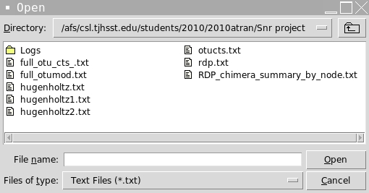
My program requires that the user has at least one or more valid data file to be read as well as a file containing the framework of their desired taxanomic tree if they do not wish to use the built in RDP tree, which the program currently defaults to. The program is also semi-dependent on the 2 files, which it creates to monitor the use of each tree and the recent files opened however if not detected on startup the program will simply create these for the user, which makes them not really necessary. The functionality of the program is that it can read standardized formatted data, and display it to the reader as well as allowing the reader to see some basic statistics of the data such as the mode OTU or the percentage of the observed whole for any OTU. The user can access this information by clicking on any bar in the histogram they desire more information about on the screen below. Another feature that is newer is the implementation of a file browser as seen to the right. This is a file browser very similar to the one used in Microsoft Office or any other comparable program. I also recently included the implementation of multiple file loading and cross file mouse movement comparison. This synchronizes all data files currently open to allow for comparison across two data files as seen in the pictures on the next page.

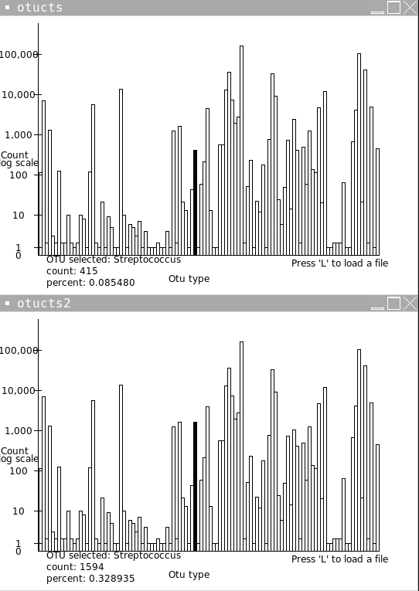

- What do you expect to work on next quarter, in relation to the goal of your project for the year?
:D

Attatced are some of the most changed parts of my source code with the implementatin of the driver/gui format.

class Counter:
def quit(self):
exit(0)
def treecount(self,curr,name,path):
s=0
if "num" in curr.keys():
if curr["num"]>0:
s+=1
self.nn.append([curr["num"],name,path[:]])
if len(curr.keys())>1:
for i in curr.keys():
if not i=="num":
tp=path[:]
tp.append(i)
s+=self.treecount(curr[i],i,tp)
return s
def click(self,evnt):
txd=int(self.xd)
tx2=(evnt.x-51)/self.xd
tx=int(tx2)
if tx*txd in self.rects:
self.canvas.itemconfigure(self.rects[tx*txd][0],fill="black")
self.canvas.itemconfigure(self.currotu,text="OTU selected: %s \ncount: %i"%(self.rects[tx*txd][1],self.rects[tx*txd][2]))
temp=Tk()
temp.title("%s"%(self.rects[tx*txd][1]))
tc=Canvas(temp,width=150,height=200,bg='white')
tp=self.rects[tx*txd][3]
for i in range(len(tp)):
tc.create_text(75,15+15*i,text="%s"%(tp[i]))
tc.create_text(75,15*len(tp)+15,text= "%s"%(self.rects[tx*txd][1]))
tc.pack()
if not(self.tf[0]==None):
self.tf[0].destroy()
self.tf[0]=temp
def c2(self,evnt):
print "hi"
def move(self,evnt):
txd=int(self.xd)
tx2=(evnt.x-51)/self.xd
tx=int(tx2)
if tx*txd in self.rects:
self.cotu=self.rects[tx*txd][1]
#self.px[1]=self.px[0]
#if self.px[1]*txd in self.rects:
#self.canvas.itemconfigure(self.rects[self.px[1]*txd][0],fill="")
#if tx*txd in self.rects:
#self.canvas.itemconfigure(self.rects[tx*txd][0],fill="black")
#self.canvas.itemconfigure(self.currotu,text="OTU selected: %s \ncount: %i"%(self.rects[tx*txd][1],self.rects[tx*txd][2]))
#self.px[0]=tx
def update(self):
if self.potu in self.rectn:
self.canvas.itemconfigure(self.rects[self.rectn[self.potu]][0],fill="")
self.potu=self.cotu
if self.cotu in self.rectn:
self.canvas.itemconfigure(self.rects[self.rectn[self.potu]][0],fill="black")
self.canvas.itemconfigure(self.currotu,text="OTU selected: %s \ncount: %i \npercent: %f" %(self.rects[self.rectn[self.potu]][1],self.rects[self.rectn[self.potu]][2],float(self.rects[self.rectn[self.potu]][2]*100)/self.sum1))

def treeadd(self,npath, curr, depth,l): # adds a new node to the tree
if depth==l:
return
else:
if npath[depth] in curr: #if branch already in tree continue down
self.treeadd(npath,curr[npath[depth]],depth+1,l)
else: #else add the new branch and continue
curr[npath[depth]]={"num":0}
self.treeadd(npath,curr[npath[depth]],depth+1,l)
def addval(self,path,curr,depth,l,val):
if depth==l:
curr["num"]+=val
return
else:
self.addval(path,curr[path[depth]],depth+1,l,val)
#if len(curr.keys())>1:
#for i in curr.keys():
#if not i == "num":
#s+=treecount(curr[i])
#return s
#else:
#print curr["num"]
#return 1
def initialize(self):
rawread= open(self.tree).read().split('\n')
count=0
for s in rawread:
count +=1
temp=s.split('\t')
if len(temp)>1:
npath=temp[1].split('; ')
for i in range(len(npath)):
if npath[i][0]=='"':
npath[i]=npath[i][1:len(npath[i])-1]
ls=npath[i].split(' ')
ts=""
for i2 in ls:
ts+=i2
npath[i]=ts
self.treeadd(npath, self.nmap, 0,len(npath))
self.treecount(self.nmap,"",[])
if len(self.nn)==0:
fil = askopenfilename(filetypes=[("Text Files","*.txt"),("allfiles","*")])
# global rects
# global xd
dataread= open(fil).read().split('\r')
for i in range(2,len(dataread)):
s=0
line=dataread[i].split(' ')
for i2 in range(1,len(line)-1):
s+=int(line[i2])
self.addval(line[len(line)-1].split("; "),self.nmap,0,len(line[len(line)-1].split("; ")),s)
self.treecount(self.nmap,"",[])
self.root=Tk()
tp=fil.split('/')
self.root.title(tp[len(tp)-1].split('.')[0])
self.canvas=Canvas(self.root,width=self.w,height=self.h,bg='white')
self.currotu=self.canvas.create_text(150,self.h-30,text="OTU selected: None \ncount: 0\n percent: 0")
self.tf=[None]
self.canvas.create_line(50, 10, 50, self.h-50)
self.canvas.create_line(50, self.h-50, self.w-50, self.h-50)
self.canvas.create_text(self.w/2-25,self.h-20,text="Otu type")
self.canvas.create_text(20,self.h/2,text="Count")
self.canvas.create_text(25,self.h/2+10,text="log scale")
diff=(self.h-100)/5
self.canvas.create_text(25,self.h-50,text="0")
self.canvas.create_line(45,self.h-60,55,self.h-60)
self.canvas.create_text(25,self.h-60,text="1")
self.canvas.create_line(45,self.h-50-diff,55,self.h-50-diff)
self.canvas.create_text(25,self.h-50-diff,text="10")
self.canvas.create_line(45,self.h-50-diff*2,55,self.h-50-diff*2)
self.canvas.create_text(25,self.h-50-diff*2,text="100")
self.canvas.create_line(45,self.h-50-diff*3,55,self.h-50-diff*3)
self.canvas.create_text(25,self.h-50-diff*3,text="1,000")
self.canvas.create_line(45,self.h-50-diff*4,55,self.h-50-diff*4)
self.canvas.create_text(25,self.h-50-diff*4,text="10,000")
self.canvas.create_line(45,self.h-50-diff*5,55,self.h-50-diff*5)
self.canvas.create_text(25,self.h-50-diff*5,text="100,000")
self.canvas.create_text(self.w-100,self.h-40,text="Press 'L' to load a file")
self.canvas.pack()
self.sum1=0
for i in self.nn:
self.sum1+=i[0]
self.xd=float(self.w-100)/len(self.nn)
for i in range(len(self.nn)):
if(self.nn[i][0]>1):
self.rects[i*int(self.xd)]=[self.canvas.create_rectangle(51+i*self.xd,self.h-50,51+self.xd*i+self.xd,self.h-50-math.log(self.nn[i][0],10)*diff),self.nn[i][1],self.nn[i][0],self.nn[i][2]]
self.rectn[self.nn[i][1]]=i*int(self.xd)
else:
self.rects[i*int(self.xd)]=[self.canvas.create_rectangle(51+i*self.xd,self.h-50,51+self.xd*i+self.xd,self.h-50-10*self.nn[i][0]),self.nn[i][1],self.nn[i][0],self.nn[i][2]]
self.rectn[self.nn[i][1]]=i*int(self.xd)
self.root.bind('<Button-1>',self.click)
self.root.bind('<Motion>',self.move)
self.root.bind('<Button-3>',self.c2)
self.root.mainloop()

def __init__(self,tree):
self.px=[0,0]
self.tree=tree
self.nmap={}
self.w=540
self.h=360
self.fil=""
self.nn=[]
self.rects={}
self.xd=50.0
self.rectn={}
self.cotu=""
self.potu=""
opencounters=[]
tree="rdp.txt"
ct=StringVar
cotu=""
root=Tk()
def load():
opencounters.append(Counter(tree))
opencounters[len(opencounters)-1].initialize()
def treechange():
global tree
nt=askopenfilename(filetypes=[("Text Files","*.txt"),("allfiles","*"),("pythonfiles","*.py")]).split("/")
tree=nt[len(nt)-1]
currtr.config(text="current tree:%s"%(tree))
def quit():
for i in opencounters:
i.quit()
exit(0)
def check():
global cotu
flag=0
totu=""
for i in opencounters:
if not cotu==i.cotu:
flag=1
totu=i.cotu
break
if flag==1:
for i in opencounters:
i.cotu=totu
i.update()
cotu=totu
root.after(10, check)
currtr=Label(root,text="Current tree: %s"%(tree))
currtr.grid(column=0,row=0)
treeb=Button(root,text="Change tree",command=treechange)
treeb.grid(column=1,row=0)
loadb=Button(root,text="load new file",command=load)
loadb.grid(column=1,row=1)
qb=Button(root,text="Quit",command=quit)
qb.grid(column=1,row=2,columnspan=1)
root.after(10, check)
root.mainloop()

