COMPUTER SYSTEMS RESEARCH
Code Writeup of your program, example report form 2009-2010
- Your name:Bill Yu, Period: 4
- Date of this version of your program: June 1st, 2010
- Project title: Complex Dynamic Cretaceous Era Ecosystem Simulation
- Describe how your program runs as of this version. Include
-- files that may be needed
-- algorithms, specific procedures or methods you wrote
-- kinds of input your program uses
-- screenshots, what kinds of output does your program have
-- does your program handle errors, or does it crash on errors of input?
-- tests: summarize the basic analysis and testing of this version of your program

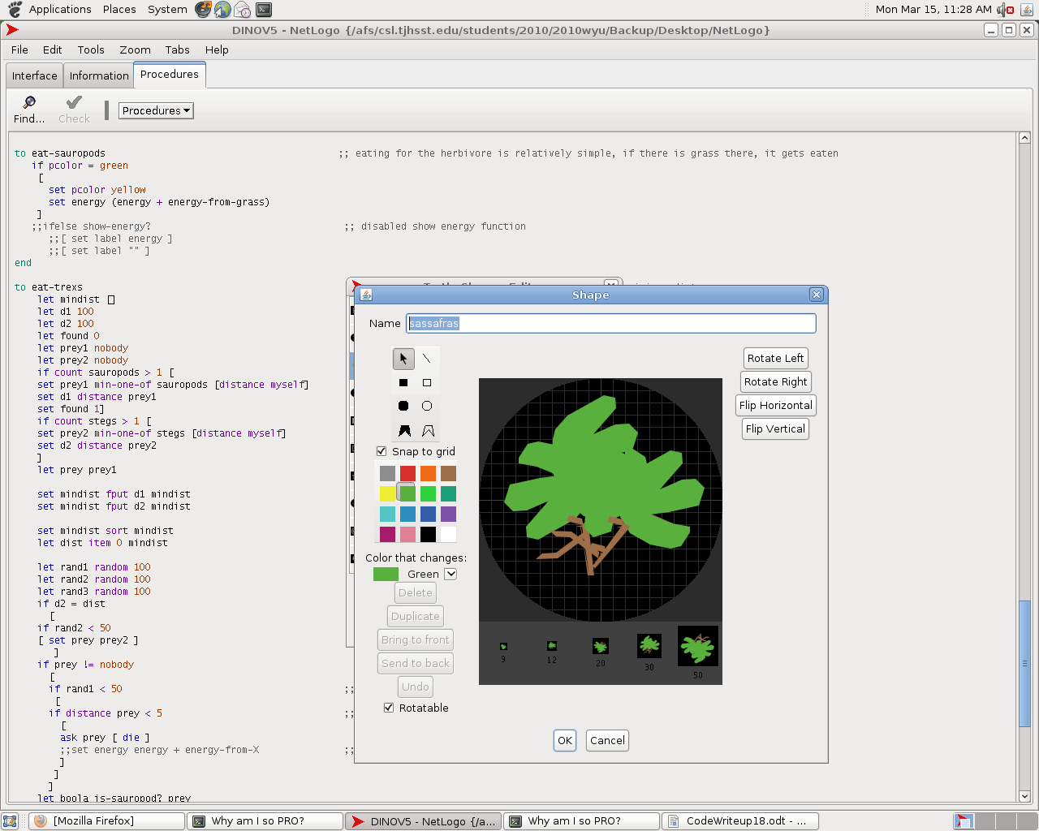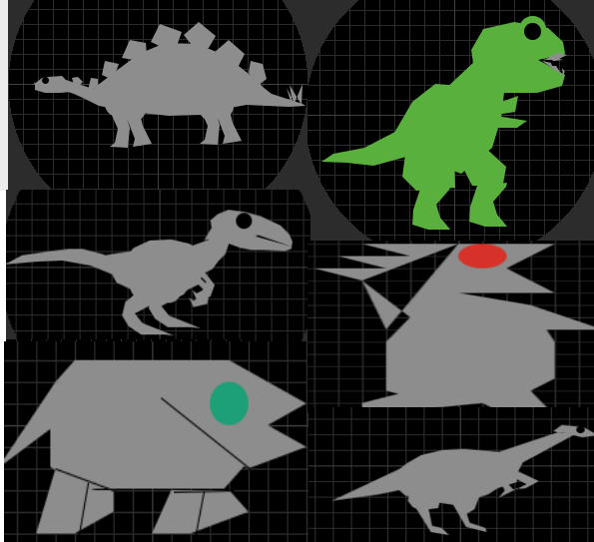

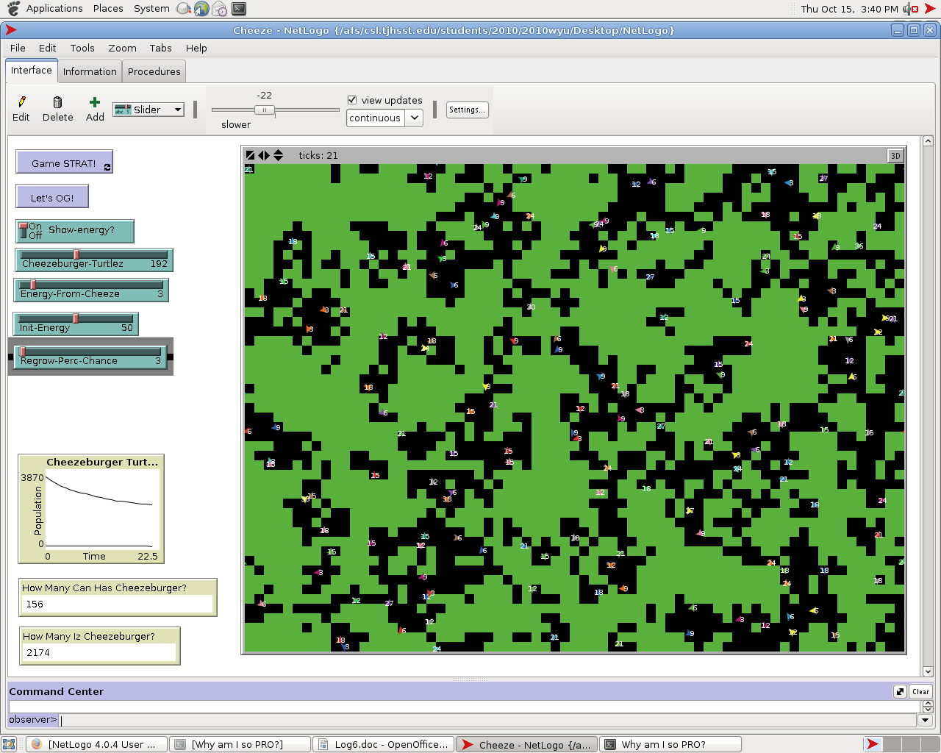

What do you expect to work on next quarter, in relation to the goal of your project for the year?

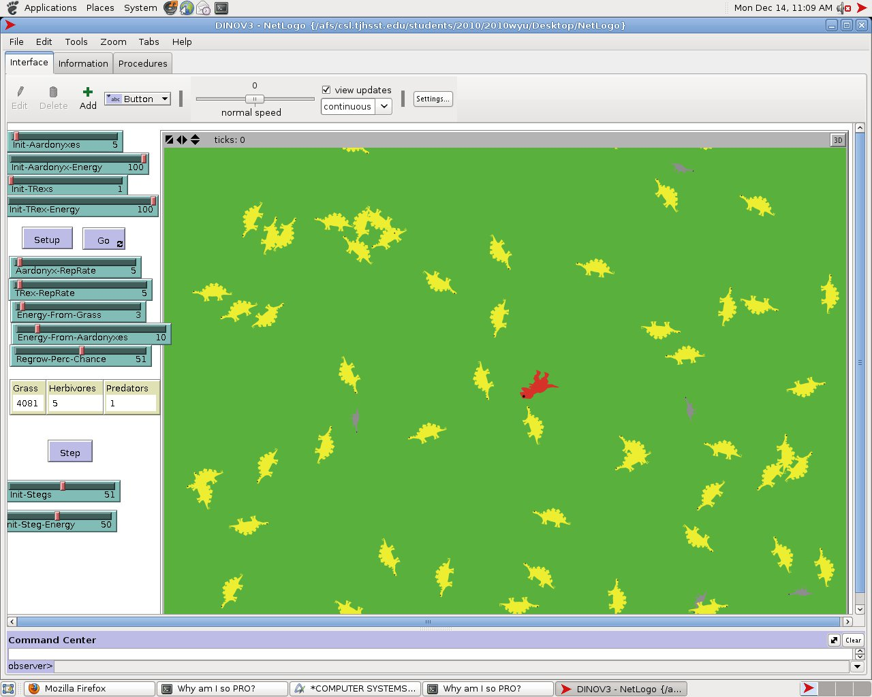

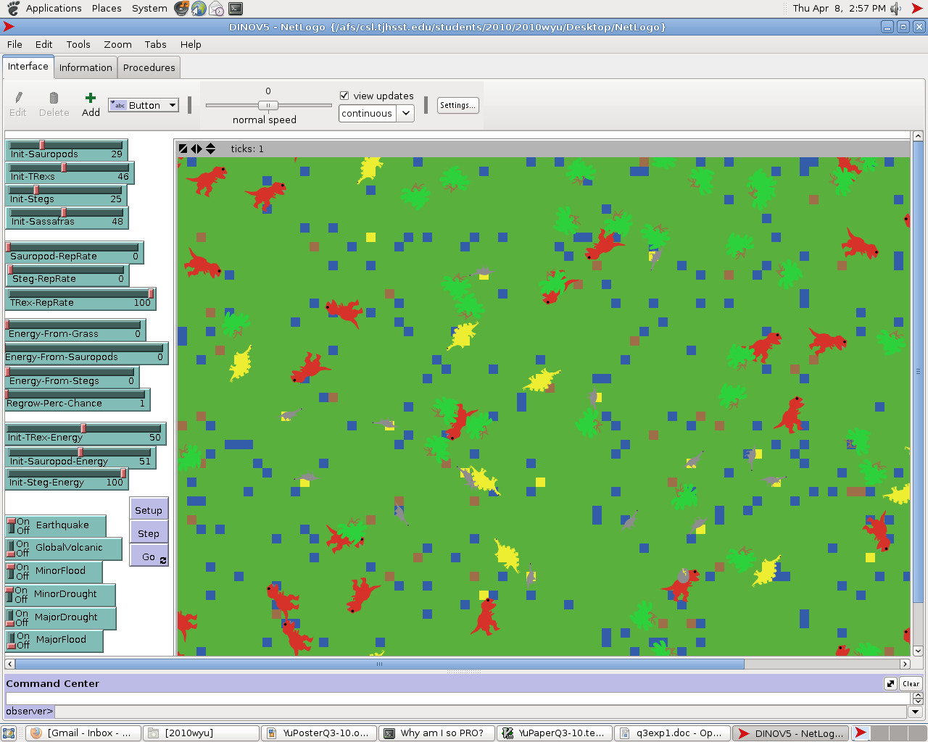

Turtles:
Velociraptor (Unused model)
T-Rex (Used predator)
Steg (Used defensible herbivore) -REPLACED WITH ANKYLOSAURUS
Aardonyx (Used herbivore) - REPLACED WITH GENERIC SAUROPOD
PredatorX (Random evolution, unused)
Generic Herbivore (Random food source, unused)
Sassafras (Immobile, unique producer)
Patches:
If patches are not green, they are not accessible for herbivores to feed off of.
Patch colors may be:
Yellow (moved on)
Blue (excess water)
Red / Orange / Black (burnt)
Brown (earthquake)

Methods (Each turtle dinosaur is 'asked' to:)
Eat-[Dinosaur] (Dinosaur's eating method, moving towards selecting closer prey if predator)
Move-[Dinosaur] (Dinosaur's moving method, contains turning and distance)
Reproduce-[Dinosaur] – ADDED ALGORITHM WITH EGGS AND TIME
Death (Dinosaurs die)
Regrow-grass (Grass is regrown)
Algorithms of note:
Algorithm for prey selection
Predation range algorithm allowing predators to prey on nearby food sources while not being directly on the same spot
Graphing algorithm (for modeling purposes) – Does not work by BehaviorSpace (putting the data into excel files, but can still put it on a graph and store data manually)
Algorithm for egg production
Various methods used in the various natural disasters
Algorithm for sassafras, how it behaves like a patch, but in fact is a turtle
The coding for the sassafras in unique in that it lasts much longer when consumed, allowing up to 100 set instances of consumption before it is deleted. - Reproduction for the sassafras was unfortunately overlooked, but will soon be added.

Current variables:

Viewable on pictures above

Response variables:

Population

Steps (time)

Errors:
I wish that I had used Python, so that I could program in some more advanced code.

- What do you expect to work on next quarter, in relation to the goal of your project for the year?
We're done! :D

