COMPUTER SYSTEMS RESEARCH
Code Writeup 2009-2010
- Your name: Mo Lu, Period: 04
- Date of this version of your program: 01/28/2010
- Project title: Coverage Efficiency in Autonomous Robots With Emphasis on Simultaneous Localization and Mapping Algorithms
- Describe how your program runs as of this version.
-- files that may be needed
-- algorithms, specific procedures or methods you wrote
-- kinds of input your program uses
-- screenshots, what kinds of output does your program have
-- does your program handle errors, or does it crash on errors of input?
-- tests: summarize the basic analysis and testing of this version of your program
Code
Inputs: Hard-coded matrix, 0's represent 1's represent obstacles, 9 Represents Robots, 2 represents unmowable terrain type.
Obstacles
Terrain Types, area input
Horizontal
Vertical
Diagonal
Circular (Problematic, see results)
Robot Class
Knows Location in Matrix
Knows Direction/Angle
Scan Method
Map Method
Move Ahead Method
Backtrack Method
Change Facing
Run Method
Angle Return Method
isBoundary
Scan Method
Scan 2 spaces ahead
Return distance until out-ping scan encounters a 1 or a undefined value (boundary)
Calculate location of the 1, based off current location
Recur, scan in 180 degree forward direction, increments of 0, 45 and 90 degrees
Return spaces that have a value of [1]
Map Method
Creates matrix of 0's
Store 1's in matrix
Move Ahead Method
while location+1!=[1] and isboundary(location)=false:
move ahead 1 space
if location+1=[1]
map(location+1)
newangle=scan(location)
moveahead(location, angle)
Backtrack Method(Location)
set robot coordinates to [x-1][y-1]
Change Facing(Location)
if at boundary of environment:
change facing 180 degrees
isBoundary(location)
if location+1=undefined
map(location+1)
return true
else
return false
Run
While Map()!=Environment
Scan()
Move Ahead{}

Results
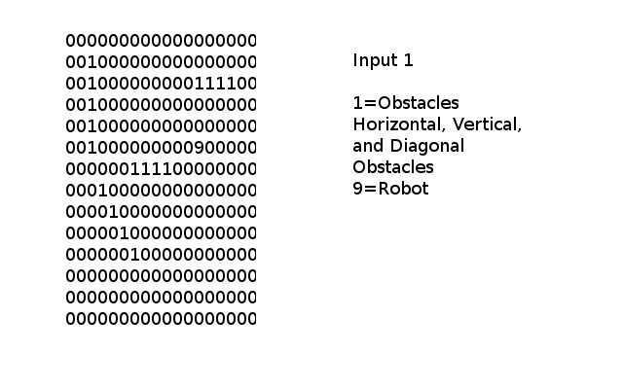
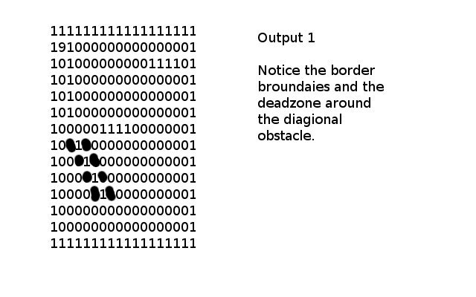
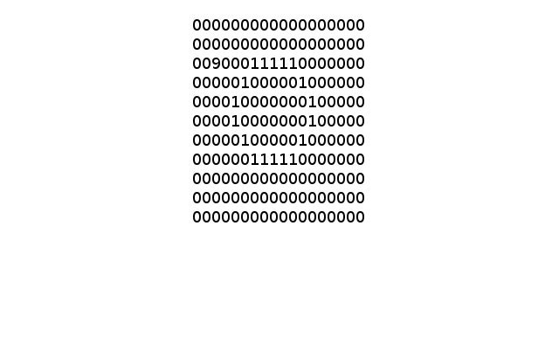

Testing, Errors, and Goals
These testing categories are dependent on obstacle and boundary recognition, obstacle mapping, location tracking, and unmowable terrain recognition. Current focus is on the testing of obstacle/boundary recognition and obstacle mapping. Testing for the current focus is determined by how accurate the obstacle map is when compared to the environment. Later, the simulation will be adapted for testing in a random matrix environment, and then a non-matrix based environment (ie. Live environment). This means that the program must be as reflective of reality as possible, so I will need to fix the errors I am having with diagonal and circular obstacles. With diagonal obstacles, the angle scanning method returns obstacles in a certain direction, such as the 45 degree. This makes the program incorrectly recognize the space ahead as an obstacle, so diagonals with one level too thick. Circular obstacles never complete the scanning process, because when the circle is more than 1 unit thick, the inside of the circle never gets scanned and there is an overflow error. Many conditions must be met for success of this project, if the original goal is to be met. Current goal is to successfully adapt the mapping program for use with LMS rangefinder. Future testing will address the accuracy of the mapping, with more advanced obstacle types, such as terrain types and polygons. Current analysis of the project is determined by the correlation of the obstacle map with the environment. When processing works, need to test for 1) Time Efficiency, 2) Coverage Percentage and 3) Backtracking.

