COMPUTER SYSTEMS RESEARCH
Code Writeup of your program, example report form 2009-2010
- Your name: __Neelesh Shrivastava____________________, Period: _4___
- Date of this version of your program: _1/22/10______
- Project title: _Multi Pred Multi Prey___________
- Describe how your program runs as of this version. Include
-- files that may be needed – just the program
-- algorithms, specific procedures or methods you wrote – uses agent-based modeling
-- kinds of input your program uses - none
-- screenshots, what kinds of output does your program have
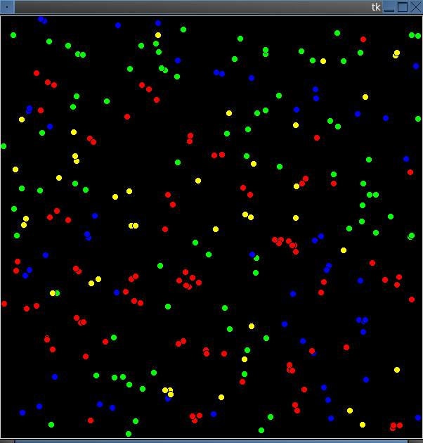
the program also outputs the position of each creature
-- does your program handle errors, or does it crash on errors of input?
There is no input so there can be no errors of input.
-- tests: summarize the basic analysis and testing of this version of your program
If I kept tabs on the population at each time step, I could see how the population changed over time and try to figure out an equation that governed each species growth.
# Neelesh Shrivastava

# Started 9.14.09

# 1.24.10

from Tkinter import *

import math

import random

w,h=600,600

dx,dy=12,12

root=Tk()

canvas=Canvas(root,width=w,height=h,bg='black')

class creature:

def __init__(self,x,y,color,rank):

self.id=canvas.create_oval(x,y,x+9,y+9,fill=color)

self.x=x*1.0

self.y=y*1.0

self.color=color

self.rank=rank

self.food=random.randint(10,40)

def move(self):

self.x+=random.randint(-10,10)

if self.x > 590:

self.x=590

if self.x <0:

self.x=0

self.y+=random.randint(-10,10)

if self.y > 590:

self.y=590

if self.y<0:

self.y=0

canvas.coords(self.id,self.x,self.y,self.x+9,self.y+9)

self.food=self.food-3

return True

def eat(self,lst):

if self.rank == 0:

from random import randint

self.food=self.food+randint(0,10)

else:

full=0

print self.x,self.y

z=0

while z < len(lst):

if( (((lst[z].x-self.x)**2+(lst[z].y-self.y)**2)**(.5)<30) and (lst[z].rank<self.rank) and lst[z]!=self)and full==0:

self.food=lst[z].food+self.food

canvas.delete(lst[z].id)

lst.pop(z)

full=1;

else:

z=z+1

def reproduce(self,lst):

if self.food > 50:

self.food=self.food-25

lst.append(creature(self.x,self.y,self.color,self.rank))

def die(self,lst,num):

if self.food<0:

lst.pop(num)

canvas.delete(self.id)

return False

return True

def step(self,lst,num):

creature.move(self)

creature.eat(self,lst)

creature.reproduce(self,lst)

return creature.die(self,lst,num)

alist=[]

x=0

y=0

while y < 200:

alist.append(creature(random.randint(0,590),random.randint(0,590),'green',0))

y=y+1

while x < 50:

alist.append(creature(random.randint(0,590),random.randint(0,590),'yellow',1))

alist.append(creature(random.randint(0,590),random.randint(0,590),'blue',2))

alist.append(creature(random.randint(0,590),random.randint(0,590),'red',3))

x=x+1

def tick():

x=0

while x < len(alist):

b=creature.step(alist[x],alist,x)

if b == True:

x+=1

canvas.after(200,tick)

canvas.pack()

canvas.after(200,tick)

root.mainloop()

- What do you expect to work on next quarter, in relation to the goal of your project for the year?
I have decided to change projects to a Cartesian vs. Polar Predator Prey so I will edit this program to work only with 1 predator and 1 prey and have 2 branch versions; one which runs in polar (the current way it runs) and one in cartesian.

