COMPUTER SYSTEMS RESEARCH
Code Writeup of your program, example report form 2009-2010
- Your name: Alex Tran, Period: 4
- Date of this version of your program: 1/14/10
- Project title: Statistical Analysis Of Gut Microbiota
- Describe how your program runs as of this version. Include

*Note this is on the last stable version of my program, which does not include any of the new driver modifications I have been making as this one is not in running order yet*
My program requires that A.) the user can specify a taxonomic library in the folder of the program, and that B.) they can specify a file with OTU counts in the same folder as the program.
I have written several tree search algorithms to aid with the running of my program, but most coding has been spent working on a user friendly gui, and most time is spent debugging visual errors or adding in tools for user functionality.
Below are some screenshots of the current version running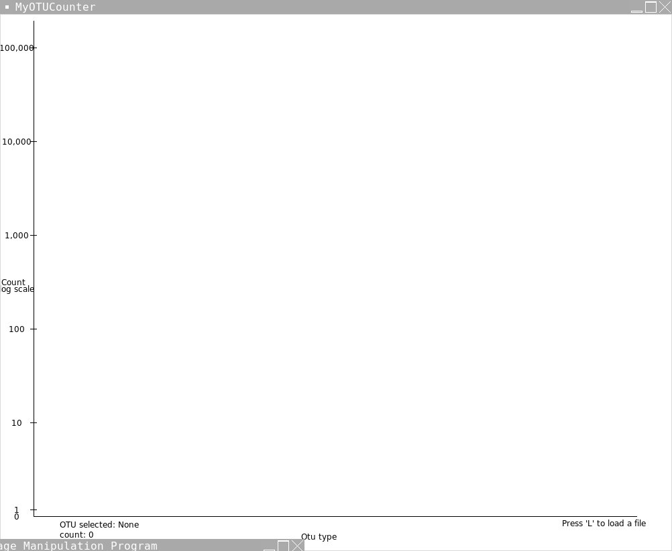
This is the screen shown to a user that has just opened the program in the bottom right corner they are prompted to press 'L' to load a file, which will then generate this screen.
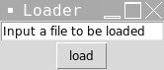
The user will then type a file (in this case "otu.txt") and press either the enter button, or click the load button. The program will fetch this file, or throw an "error file not found" message to the user, while not crashing the program.
But assuming the program loads the file successfully it will generate the following histogram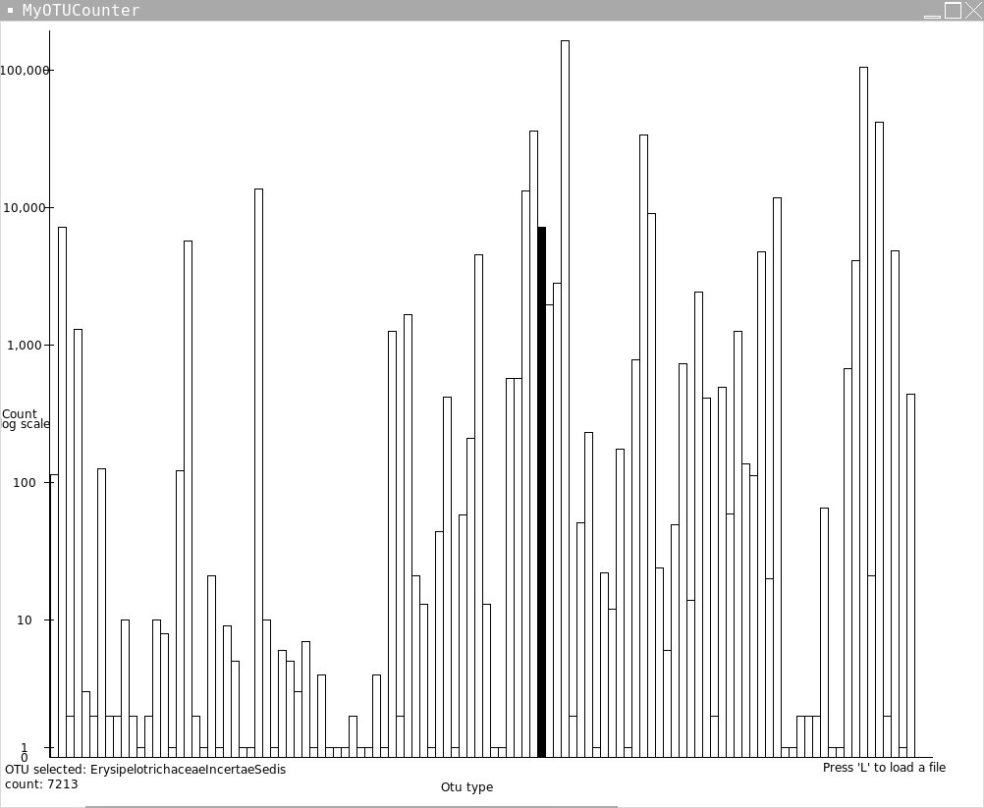
If the user moves the mouse it will highlight a bar, and give them the name of the data point, and the count. If they then proceed to click on it it will give them full taxonomic information of the OTU, and % compisition of this sample's gut microbiotal community, and how it ranks with the other OTUs.
- What do you expect to work on next quarter, in relation to the goal of your project for the year?
Next Quarter I plan to get multiple file loading rather quickly, and then move onto a system which can compare two files and test for significant difference between them.
The following is the source code used to generate the above images *note this is an older version, as the new one is highly changed and not in working order as of yet.*
# -*- coding: iso-8859-1 -*-
px=[0,0]
from Tkinter import *
from string import lowercase
from time import time
import math
nmap={} # a map by number notation eg 1.3.3.7 each step has a count for each step
smap={} # a map by name notation returns number path
#eg. if given Archaea will return -1
w=1000
h=800
fil=""
nn=[]
rects={}
xd=50
root=Tk()
root.title("MyOTUCounter")
canvas=Canvas(root,width=w,height=h,bg='white')
currotu=canvas.create_text(150,770,text="OTU selected: None \ncount: 0")
tf=[None]
def quit(evnt):
exit(0)
def treecount(curr,name,path):
s=0
if "num" in curr.keys():
if curr["num"]>0:
s+=1
nn.append([curr["num"],name,path[:]])
if len(curr.keys())>1:
for i in curr.keys():
if not i=="num":
tp=path[:]
tp.append(i)
s+=treecount(curr[i],i,tp)
return s
def click(evnt):
tx=(evnt.x-51)/xd
if tx*xd in rects:
canvas.itemconfigure(rects[tx*xd][0],fill="black")
canvas.itemconfigure(currotu,text="OTU selected: %s \ncount: %i"%(rects[tx*xd][1],rects[tx*xd][2]))
temp=Tk()
temp.title("%s"%(rects[tx*xd][1]))
tc=Canvas(temp,width=150,height=200,bg='white')
tp=rects[tx*xd][3]
for i in range(len(tp)):
tc.create_text(75,15+15*i,text="%s"%(tp[i]))
tc.create_text(75,15*len(tp)+15,text= "%s"%(rects[tx*xd][1]))
print
tc.pack()
if not(tf[0]==None):
tf[0].destroy()
tf[0]=temp
def c2(evnt):
print "hi"
def move(evnt):
tx=(evnt.x-51)/xd
px[1]=px[0]
if px[1]*xd in rects:
canvas.itemconfigure(rects[px[1]*xd][0],fill="")
if tx*xd in rects:
canvas.itemconfigure(rects[tx*xd][0],fill="black")
canvas.itemconfigure(currotu,text="OTU selected: %s \ncount: %i"%(rects[tx*xd][1],rects[tx*xd][2]))
px[0]=tx
def treeadd(npath, curr, depth,l): # adds a new node to the tree
if depth==l:
return
else:
if npath[depth] in curr: #if branch already in tree continue down
treeadd(npath,curr[npath[depth]],depth+1,l)
else: #else add the new branch and continue
curr[npath[depth]]={"num":0}
treeadd(npath,curr[npath[depth]],depth+1,l)
def addval(path,curr,depth,l,val):
if depth==l:
curr["num"]+=val
return
else:
addval(path,curr[path[depth]],depth+1,l,val)
rawread= open("rdp.txt").read().split('\n')
count=0
for s in rawread:
count +=1
temp=s.split('\t')
if len(temp)>1:
npath=temp[1].split('; ')
for i in range(len(npath)):
if npath[i][0]=='"':
npath[i]=npath[i][1:len(npath[i])-1]
ls=npath[i].split(' ')
ts=""
for i2 in ls:
ts+=i2
npath[i]=ts
treeadd(npath, nmap, 0,len(npath))
#if len(curr.keys())>1:
#for i in curr.keys():
#if not i == "num":
#s+=treecount(curr[i])
#return s
#else:
#print curr["num"]
#return 1
def load(evnt):
global nmap
treecount(nmap,"",[])
if len(nn)==0:
global rects
global xd
temp=Tk()
temp.title("Loader")
e= Entry(temp,text="Input file to be loaded")
e.insert(0, "Input a file to be loaded")
e.grid(row=0)
def btn(*ignore):
global fil
fil=e.get()
temp.quit()
temp.bind('<Key-Return>',btn)
button=Button(temp,text="load",command=btn).grid(row=1)
temp.mainloop()
temp.unbind('<Key-Return>')
dataread= open(fil).read().split('\r')
for i in range(2,len(dataread)):
s=0
line=dataread[i].split(' ')
for i2 in range(1,len(line)-1):
s+=int(line[i2])
addval(line[len(line)-1].split("; "),nmap,0,len(line[len(line)-1].split("; ")),s)
treecount(nmap,"",[])
print len(nn)
xd=950/len(nn)
for i in range(len(nn)):
#canvas.create_text(50+40*i,770,text=nn[i][1])
if(nn[i][0]>1):
rects[i*xd]=[canvas.create_rectangle(51+i*xd,750,51+xd*i+xd,750-math.log(nn[i][0],10)*diff),nn[i][1],nn[i][0],nn[i][2]]
else:
rects[i*xd]=[canvas.create_rectangle(51+i*xd,750,51+xd*i+xd,750-10*nn[i][0]),nn[i][1],nn[i][0],nn[i][2]]
temp.destroy()
else:
tmp=Tk()
tmp.title("We're Sorry")
l=Label(tmp,text="Sorry multiple file loading\nhas not been implemented at this time.")
l.grid(row=0)
canvas.create_line(50, 10, 50, 750)
canvas.create_line(50, 750, 950, 750)
canvas.create_text(475,780,text="Otu type")
canvas.create_text(20,400,text="Count")
canvas.create_text(25,410,text="log scale")
diff=700/5
canvas.create_text(25,750,text="0")
canvas.create_line(45,740,55,740)
canvas.create_text(25,740,text="1")
canvas.create_line(45,750-diff,55,750-diff)
canvas.create_text(25,750-diff,text="10")
canvas.create_line(45,750-diff*2,55,750-diff*2)
canvas.create_text(25,750-diff*2,text="100")
canvas.create_line(45,750-diff*3,55,750-diff*3)
canvas.create_text(25,750-diff*3,text="1,000")
canvas.create_line(45,750-diff*4,55,750-diff*4)
canvas.create_text(25,750-diff*4,text="10,000")
canvas.create_line(45,750-diff*5,55,750-diff*5)
canvas.create_text(25,750-diff*5,text="100,000")
canvas.create_text(900,760,text="Press 'L' to load a file")
canvas.pack()
sum1=0
for i in nn:
sum1+=i[0]
root.bind('<Button-1>',click)
root.bind('<Motion>',move)
root.bind('<Button-3>',c2)
root.bind('<q>',quit)
root.bind('<l>',load)
root.mainloop()

