COMPUTER SYSTEMS RESEARCH
Code Writeup of your program, example report form 2009-2010
- Your name: Bill Yu, Period: 4
Date of this version of your program: Last major edit: Jan. 12th 2010
Project title: Dynamic Complex Dinosaur Ecosystem Simulation
Describe how your program runs as of this version. Include
-- files that may be needed Check
-- algorithms, specific procedures or methods you wrote Check
-- kinds of input your program uses Check
-- screenshots, what kinds of output does your program have Check
-- does your program handle errors, or does it crash on errors of input?Check
-- tests: summarize the basic analysis and testing of this version of your program Check
Files needed (turtle image files, including some earlier prototypes):
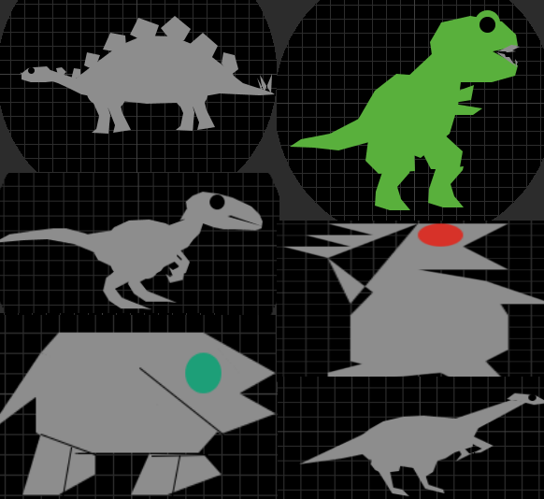
In addition to the turtle image files (which come with NetLogo), Microsoft Excel is recommended so that the BehaviorSpace function works and stores data onto a spreadsheet for record purposes.
Turtles:
Velociraptor (Unused model)
T-Rex (Used predator)
Steg (Used defensible herbivore)
Aardonyx (Used herbivore)
PredatorX (Random evolution, unused)
Generic Herbivore (Random food source, unused)
Methods (Each turtle dinosaur is 'asked' to:)
Eat-[Dinosaur] (Dinosaur's eating method, moving towards selecting closer prey if predator)
Move-[Dinosaur] (Dinosaur's moving method, contains turning and distance)
Reproduce-[Dinosaur]
Death (Dinosaurs die)
Regrow-grass (Grass is regrown)
Algorithms of note:
Algorithm for prey selection
Predation range algorithm allowing predators to prey on nearby food sources while not being directly on the same spot
Graphing algorithm (for modeling purposes) – Does not work by BehaviorSpace (putting the data into excel files, but can still put it on a graph and store data manually)

Current variables:

Grass regrowth (Grass)

Initial populations (Turtles)

Energy gain (Turtles)

Initial energy (Turtles)

Reproduction rate (Turtles)

Response variables:

Population

Steps (time)

Fluctuation rate (last change)

Errors:

No errors based on current inputs, but new inputs need to be added

Impossible to create errors based on slider parameters, but impossible situations can be created (such as 0 energy for Herbivores eating Grass)

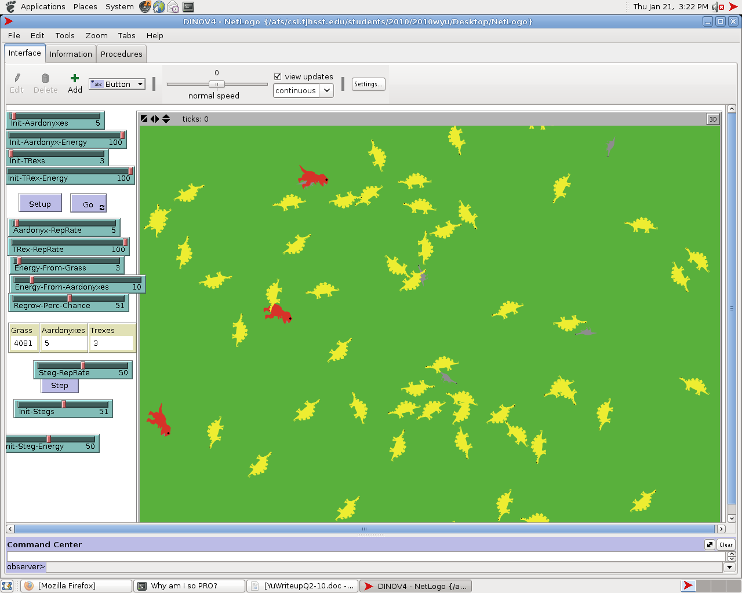

- What do you expect to work on next quarter, in relation to the goal of your project for the year?
Main problem: Getting some substance into the program - making it versatile and broad enough to work for many different dinosaur species, and presenting accurate or efficient resources.

- Inputs: Standard dinosaur inputs (a lot of the characteristics will already be hard-coded). The main inputs will be the initial population, and the reproduction rate (both of which have little information on).
- Outputs: Populations, change in populations, change in change in population (respectively the derivative graphs). The overall trends and the irregular ecosystem combination results (all regarding to ending population). The output will be planned to go into an auto-stored excel for later research and reference.
- Tests: Will vary since this is a purely hypothetical ecosystem - however basic ecosystem rules must apply. Accurate reproduction, consumption, foraging, daily actions must all be represented.
- Algorithms / Resources:
- Add other resources besides plants (maybe more specific brushes etc.) and possibly water (or start it). Add more dinosaurs, and more brushes, all the while doing more research
- Work on dinosaur fight sequence between different species, based on different variables (ex. Dino with short teeth will not be able to eat the armored tank dino
- Work on dinosaur fight conclusions, such as victorious-eating, victorious-enemy dead, victorious-enemy wounded, etc.
-Add more dinosaurs, do more research, maybe begin work on trait passing (will not be an integral part of the program yet)
- Begin work on natural disasters (simple, portions of ecosystems are effected)
- We talked about finding a specific era of dinosaurs (or a specific) age to focus on.

