COMPUTER SYSTEMS RESEARCH
Code Writeup of your program, example report form 2009-2010
- Your name: Neelesh Shrivastava, Period: 4
- Date of this version of your program: 4/6/10
- Project title: Polar vs. Cartesian in Predator-Prey
- Describe how your program runs as of this version. Include
-- files that may be needed
-- algorithms, specific procedures or methods you wrote
-- kinds of input your program uses
-- screenshots, what kinds of output does your program have
-- does your program handle errors, or does it crash on errors of input?
-- tests: summarize the basic analysis and testing of this version of your program
The program requires no input files, just Python and the prepackaged extension, Tkinter.
Both programs use agent-based modeling to find out how results will differ if the coordinate system is Cartesian or Polar.
No current inputs, but can be changed to allow input of starting number of each species, food intake of prey, food consumption of both, food level at which reproduction occurs, and distance predator checks for food to allow a simpler way to change these inputs without going into the code.
Screenshots after the respective program, it outputs the positions graphically as well as printing the positions, later I will be looking more at the overall population of each which I keep track of internally so its a simple print to find it out.
No inputs yet, so it can't crash on input errors.
The programs work because the simulation works as intended; the creatures wander around eating, reproducing, and dying. However, until we find a stable system I will be looking at creating the stable system so that analysis can be done on the program.
# Polar program
# Neelesh Shrivastava

# Started 2.18.10

# 4.6.10

from Tkinter import *

import math

import random

w,h=600,600

dx,dy=12,12

root=Tk()

canvas=Canvas(root,width=w,heigh=h,bg='black')

pi=3.1415926535

class creature:

def __init__(self,r,theta,rank):

self.id=0

self.theta=theta

if theta > pi:

self.theta=(theta*pi)/180.0

self.x = r * math.cos(theta)

self.y = r * math.sin(theta)

if rank == 0:

self.id=canvas.create_oval(self.x,self.y,self.x+dx,self.y+dy,fill='blue')

else:

self.id=canvas.create_oval(self.x,self.y,self.x+dx,self.y+dy,fill='yellow')

self.r=r*1.0

self.rank=rank

self.food=random.randint(100,400)

def move(self):

self.r+=random.randint(-6,6)

te=random.randint(-3,3)

self.theta+=(te*pi)/180.0

if self.theta<0:

self.theta=0

if self.theta>pi/2:

self.theta=pi/2

if self.r<0:

self.r=0

if self.r>850:

self.r=850

self.x=self.r*math.cos(self.theta)

self.y=self.r*math.sin(self.theta)

if self.x<0:

self.x=0

if self.y<0:

self.y=0

canvas.coords(self.id,self.x,self.y,self.x+dx,self.y+dy)

if self.rank!=0:

self.food=self.food-30

return True

def eat(self,lst):

if self.rank == 0:

self.food=self.food+random.randint(0,50)

else:

full=0

z=0

while z <len(lst):

if((((lst[z].x-self.x)**2+(lst[z].y-self.y)**2)**(.5)<30) and (lst[z].rank<self.rank) and lst[z]!=self) and full==0:

self.food=lst[z].food+self.food

canvas.delete(lst[z].id)

lst.pop(z)

full=1;

else:

z=z+1

def reproduce(self,lst):

if self.rank ==0:

if self.food>600:

self.food=self.food-400

lst.append(creature(self.r*1.0,self.theta*1.0,self.rank))

else:

if self.food>1000:

self.food=self.food-500

lst.append(creature(self.r*1.0,self.theta*1.0,self.rank*1.0))

x=0

def die(self,lst,num):

if self.food<0:

lst.pop(num)

canvas.delete(self.id)

return False

return True

def step(self,lst1,lst2,num):

creature.move(self)

creature.eat(self,lst1)

print self.r,self.theta

if self.rank == 0:

creature.reproduce(self,lst1)

return creature.die(self,lst1,num)

else:

creature.reproduce(self,lst2)

return creature.die(self,lst2,num)

preylist=[]

predlist=[]

x=0

while x<100:

preylist.append(creature(random.randint(0,588),random.randint(4,90),0))

x=x+1

x=0

while x<50:

predlist.append(creature(random.randint(0,588),random.randint(4,90),1))

x=x+1

def tick():

x=0

while x<len(preylist):

b=creature.step(preylist[x],preylist,predlist,x)

if b==True:

x+=1

x=0

while x<len(predlist):

b=creature.step(predlist[x],preylist,predlist,x)

if b==True:

x+=1

canvas.after(300,tick)

canvas.pack()

canvas.after(300,tick)

root.mainloop()

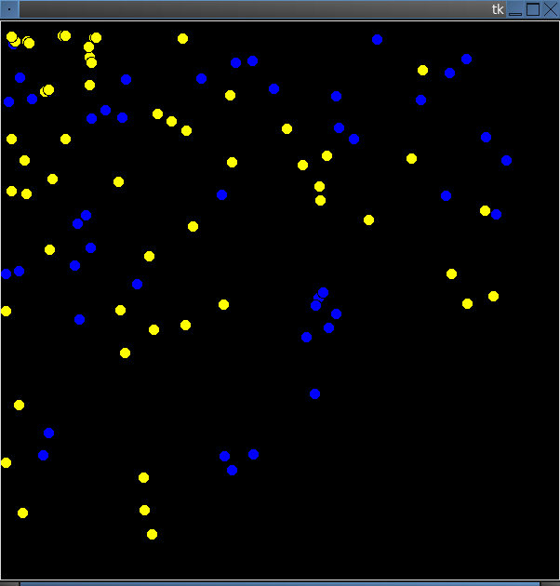

# Cartesian Program
# Neelesh Shrivastava

# Started 2.18.10

# 4.6.10

from Tkinter import *

import math

import random

w,h=600,600

dx,dy=12,12

root=Tk()

canvas=Canvas(root,width=w,heigh=h,bg='black')

class creature:

def __init__(self,x,y,rank):

self.id=0

if rank == 0:

self.id=canvas.create_rectangle(x,y,x+dx,y+dy,fill='green')

else:

self.id=canvas.create_rectangle(x,y,x+dx,y+dy,fill='red')

self.x=x*1.0

self.y=y*1.0

self.rank=rank

self.food=random.randint(100,400)

def move(self):

self.x+=random.randint(-10,10)

self.y+=random.randint(-10,10)

if self.x>588:

self.x=588

if self.x<0:

self.x=0

if self.y>588:

self.y=588

if self.y<0:

self.y=0

canvas.coords(self.id,self.x,self.y,self.x+dx,self.y+dy)

if self.rank!=0:

self.food=self.food-30

return True

def eat(self,lst):

if self.rank == 0:

self.food=self.food+random.randint(0,50)

else:

full=0

x=0

z=0

while z <len(lst):

if((((lst[z].x-self.x)**2+(lst[z].y-self.y)**2)**(.5)<30) and (lst[z].rank<self.rank) and lst[z]!=self) and full==0:

self.food=lst[z].food+self.food

canvas.delete(lst[z].id)

lst.pop(z)

full=1;

else:

z=z+1

def reproduce(self,lst):

if self.rank ==0:

if self.food>600:

self.food=self.food-400

lst.append(creature(self.x,self.y,self.rank))

else:

if self.food>1000:

self.food=self.food-500

lst.append(creature(self.x,self.y,self.rank))

def die(self,lst,num):

if self.food<0:

lst.pop(num)

canvas.delete(self.id)

return False

return True

def step(self,lst1,lst2,num):

creature.move(self)

creature.eat(self,lst1)

if self.rank == 0:

creature.reproduce(self,lst1)

return creature.die(self,lst1,num)

else:

creature.reproduce(self,lst2)

return creature.die(self,lst2,num)

preylist=[]

predlist=[]

x=0

while x<200:

preylist.append(creature(random.randint(0,588),random.randint(0,588),0))

x=x+1

x=0

while x<50:

predlist.append(creature(random.randint(0,588),random.randint(0,588),1))

x=x+1

def tick():

x=0

while x<len(preylist):

b=creature.step(preylist[x],preylist,predlist,x)

if b==True:

x+=1

x=0

while x<len(predlist):

b=creature.step(predlist[x],preylist,predlist,x)

if b==True:

x+=1

canvas.after(300,tick)

canvas.pack()

canvas.after(300,tick)

root.mainloop()
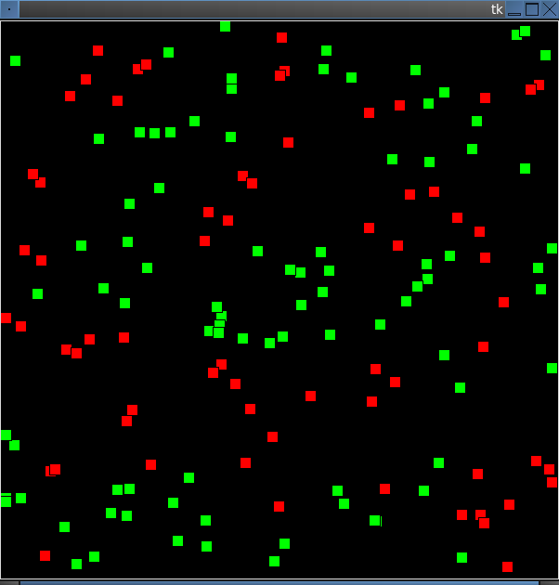

- What do you expect to work on next quarter, in relation to the goal of your project for the year?
I expect to analyze the code and simulation as soon as I get a stable system in both to find any noticable differences between the two.

