COMPUTER SYSTEMS RESEARCH
Code Writeup of your program, example report form 2009-2010
- Your name: Alex Tran, Period: 4
- Date of this version of your program: 4/8/10
- Project title: Statistical Analysis of Gut Microbiota in Mouse Fecal Matter
- Describe how your program runs as of this version. Include
-- files that may be needed
-- algorithms, specific procedures or methods you wrote
-- kinds of input your program uses
-- screenshots, what kinds of output does your program have
-- does your program handle errors, or does it crash on errors of input?
-- tests: summarize the basic analysis and testing of this version of your program
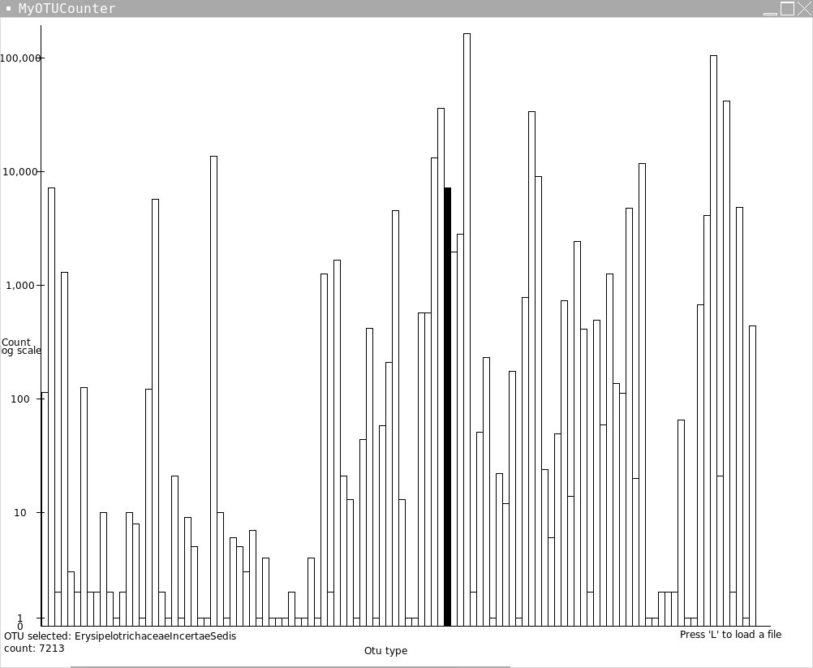
My program currently requires that the user has at least one valid data file to be read as well as a file containing the framework of their desired taxanomic tree if they do not wish to use the built in RDP tree, which the program currently defaults to. The program is also semi-dependent on the 2 files, which it creates to monitor the use of each tree and the recent files opened however if not detected on startup the program will simply create these for the user, which makes them not really necessary. The functionality of the program is that it can read standardized formatted data, and display it to the reader as well as allowing the reader to see some basic statistics of the data such as the mode OTU or the percentage of the observed whole for any OTU. The user can access this information by clicking on any bar in the histogram they desire more information about on the screen below. Another feature that is newer is the implementation of a file browser as seen on the next page. This is a file browser very similar to the one used in Microsoft Office or any other comparable program.

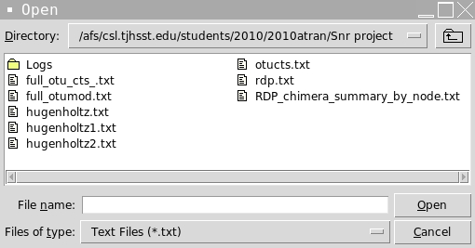

- What do you expect to work on next quarter, in relation to the goal of your project for the year?
Next quarter is crunch time. I plan to finish up my project with the implementation of a combobox and finally finish up multiple file loading, which is already in place, but hasn't been implemented due to the interface not being ready for an effective integration, and add in cPickle archiving support for recent files and taxanomic trees, and after that prepare for the TJ STAR and make additions which will make the program more universally useful for other labs outside of the Gordon lab. Attached below are excerpts of my current prototypes source code that have been largely changed this quarter.
# -*- coding: iso-8859-1 -*-
px=[0,0]
from Tkinter import *
from string import lowercase
from time import time
import math
from tkFileDialog import askopenfilename
nmap={}
w=1000
h=800
fil=""
nn=[]
rects={}
xd=50.0
root=Tk()
root.title("MyOTUCounter")
canvas=Canvas(root,width=w,height=h,bg='white')
currotu=canvas.create_text(150,h-30,text="OTU selected: None \ncount: 0")
tf=[None]
def quit(evnt):
exit(0)
def treecount(curr,name,path):
s=0
if "num" in curr.keys():
if curr["num"]>0:
s+=1
nn.append([curr["num"],name,path[:]])
if len(curr.keys())>1:
for i in curr.keys():
if not i=="num":
tp=path[:]
tp.append(i)
s+=treecount(curr[i],i,tp)
return s
def click(evnt):
txd=int(xd)
tx2=(evnt.x-51)/xd
tx=int(tx2)
if tx*txd in rects:
canvas.itemconfigure(rects[tx*txd][0],fill="black")
canvas.itemconfigure(currotu,text="OTU selected: %s \ncount: %i"%(rects[tx*txd][1],rects[tx*txd][2]))
temp=Tk()
temp.title("%s"%(rects[tx*txd][1]))
tc=Canvas(temp,width=150,height=200,bg='white')
tp=rects[tx*txd][3]
for i in range(len(tp)):
tc.create_text(75,15+15*i,text="%s"%(tp[i]))
tc.create_text(75,15*len(tp)+15,text= "%s"%(rects[tx*txd][1]))
print
tc.pack()
if not(tf[0]==None):
tf[0].destroy()
tf[0]=temp
def c2(evnt):
print "hi"
def move(evnt):
txd=int(xd)
tx2=(evnt.x-51)/xd
tx=int(tx2)
print tx
px[1]=px[0]
if px[1]*txd in rects:
canvas.itemconfigure(rects[px[1]*txd][0],fill="")
if tx*txd in rects:
canvas.itemconfigure(rects[tx*txd][0],fill="black")
canvas.itemconfigure(currotu,text="OTU selected: %s \ncount: %i"%(rects[tx*txd][1],rects[tx*txd][2]))
px[0]=tx
def treeadd(npath, curr, depth,l): # adds a new node to the tree
if depth==l:
return
else:
if npath[depth] in curr: #if branch already in tree continue down
treeadd(npath,curr[npath[depth]],depth+1,l)
else: #else add the new branch and continue
curr[npath[depth]]={"num":0}
treeadd(npath,curr[npath[depth]],depth+1,l)
def addval(path,curr,depth,l,val):
if depth==l:
curr["num"]+=val
return
else:
addval(path,curr[path[depth]],depth+1,l,val)
rawread= open("rdp.txt").read().split('\n')
count=0
for s in rawread:
count +=1
temp=s.split('\t')
if len(temp)>1:
npath=temp[1].split('; ')
for i in range(len(npath)):
if npath[i][0]=='"':
npath[i]=npath[i][1:len(npath[i])-1]
ls=npath[i].split(' ')
ts=""
for i2 in ls:
ts+=i2
npath[i]=ts
treeadd(npath, nmap, 0,len(npath))
#if len(curr.keys())>1:
#for i in curr.keys():
#if not i == "num":
#s+=treecount(curr[i])
#return s
#else:
#print curr["num"]
#return 1
def load(evnt):
global nmap
treecount(nmap,"",[])
if len(nn)==0:
fil = askopenfilename(filetypes=[("Text Files","*.txt"),("allfiles","*"),("pythonfiles","*.py")])
global rects
global xd
dataread= open(fil).read().split('\r')
for i in range(2,len(dataread)):
s=0
line=dataread[i].split(' ')
for i2 in range(1,len(line)-1):
s+=int(line[i2])
addval(line[len(line)-1].split("; "),nmap,0,len(line[len(line)-1].split("; ")),s)
treecount(nmap,"",[])
print len(nn)
xd=float(w-100)/len(nn)
print xd*len(nn)
for i in range(len(nn)):
if(nn[i][0]>1):
rects[i*int(xd)]=[canvas.create_rectangle(51+i*xd,h-50,51+xd*i+xd,h-50-math.log(nn[i][0],10)*diff),nn[i][1],nn[i][0],nn[i][2]]
else:
rects[i*int(xd)]=[canvas.create_rectangle(51+i*xd,h-50,51+xd*i+xd,h-50-10*nn[i][0]),nn[i][1],nn[i][0],nn[i][2]]
else:
tmp=Tk()
tmp.title("We're Sorry")
l=Label(tmp,text="Sorry multiple file loading\nhas not been implemented at this time.")
l.grid(row=0)
canvas.create_line(50, 10, 50, h-50)
canvas.create_line(50, h-50, w-50, h-50)
canvas.create_text(w/2-25,h-20,text="Otu type")
canvas.create_text(20,h/2,text="Count")
canvas.create_text(25,h/2+10,text="log scale")
diff=(h-100)/5
canvas.create_text(25,h-50,text="0")
canvas.create_line(45,h-60,55,h-60)
canvas.create_text(25,h-60,text="1")
canvas.create_line(45,h-50-diff,55,h-50-diff)
canvas.create_text(25,h-50-diff,text="10")
canvas.create_line(45,h-50-diff*2,55,h-50-diff*2)
canvas.create_text(25,h-50-diff*2,text="100")
canvas.create_line(45,h-50-diff*3,55,h-50-diff*3)
canvas.create_text(25,h-50-diff*3,text="1,000")
canvas.create_line(45,h-50-diff*4,55,h-50-diff*4)
canvas.create_text(25,h-50-diff*4,text="10,000")
canvas.create_line(45,h-50-diff*5,55,h-50-diff*5)
canvas.create_text(25,h-50-diff*5,text="100,000")
canvas.create_text(w-100,h-40,text="Press 'L' to load a file")
canvas.pack()
sum1=0
for i in nn:
sum1+=i[0]
root.bind('<Button-1>',click)
root.bind('<Motion>',move)
root.bind('<Button-3>',c2)
root.bind('<q>',quit)
root.bind('<l>',load)
root.mainloop()
Combobox prototype
class ChoiceBox(Entry):
"""ComboBox(parent, itemList=[], *args, kwargs)

def __init__(self, parent, itemList=[], *args, **kwargs):
Entry.__init__(self, parent, *args, **kwargs)

self.pyvar = pyvar = StringVar(self) # this is the sharing mechanism
self.config(textvariable=pyvar) # add the StringVar to self.

self.popup = popup = Menu(self, tearoff=0)
self.bind("<Button-1>", self.mousedown, add="+")

for item in itemList:
if type(item) == tuple:
submenu = self.GetSubMenu(item[0])
for subitem in item[1]:
self.AddCBMenuItem(submenu, subitem)
else:
self.AddCBMenuItem(popup, item)

def GetSubMenu(self, label):
menu = Menu(self, tearoff=0)
self.popup.add_cascade(menu=menu, label=label)
return menu

def AddCBMenuItem(self, menu, label):
menu.add_checkbutton(label=label,
command=self.MenuSelect,
variable=self.pyvar, # add the StringVar to a menu.
onvalue=label, offvalue='')

def mousedown(self, event):
x = event.x_root - event.x
y = event.y_root - event.y
self.popup.post(x, y)
print "hi"
return 'break'

def get(self):
return self.pyvar.get()

def clear(self):
self.pyvar.set('')

def MenuSelect(self):
pass

if __name__ == '__main__':

def _test():
root = Tk()
## cb = ChoiceBox(root, [('test', ['one', 'two', 'three'])])
cb = ChoiceBox(root, ['Recent', 'Load', 'Summarize'])
cb.pack()
root.mainloop()

_test()

