COMPUTER SYSTEMS RESEARCH
Code Writeup of your program, example report form 2009-2010
- Your name: Bill Yu, Period: 4
- Date of this version of your program: 4/2/10
- Project title: Dynamic Complex Cretaceous Era Ecosystem Simulation
- Describe how your program runs as of this version. Include
-- files that may be needed
-- algorithms, specific procedures or methods you wrote
-- kinds of input your program uses
-- screenshots, what kinds of output does your program have
-- does your program handle errors, or does it crash on errors of input?
-- tests: summarize the basic analysis and testing of this version of your program
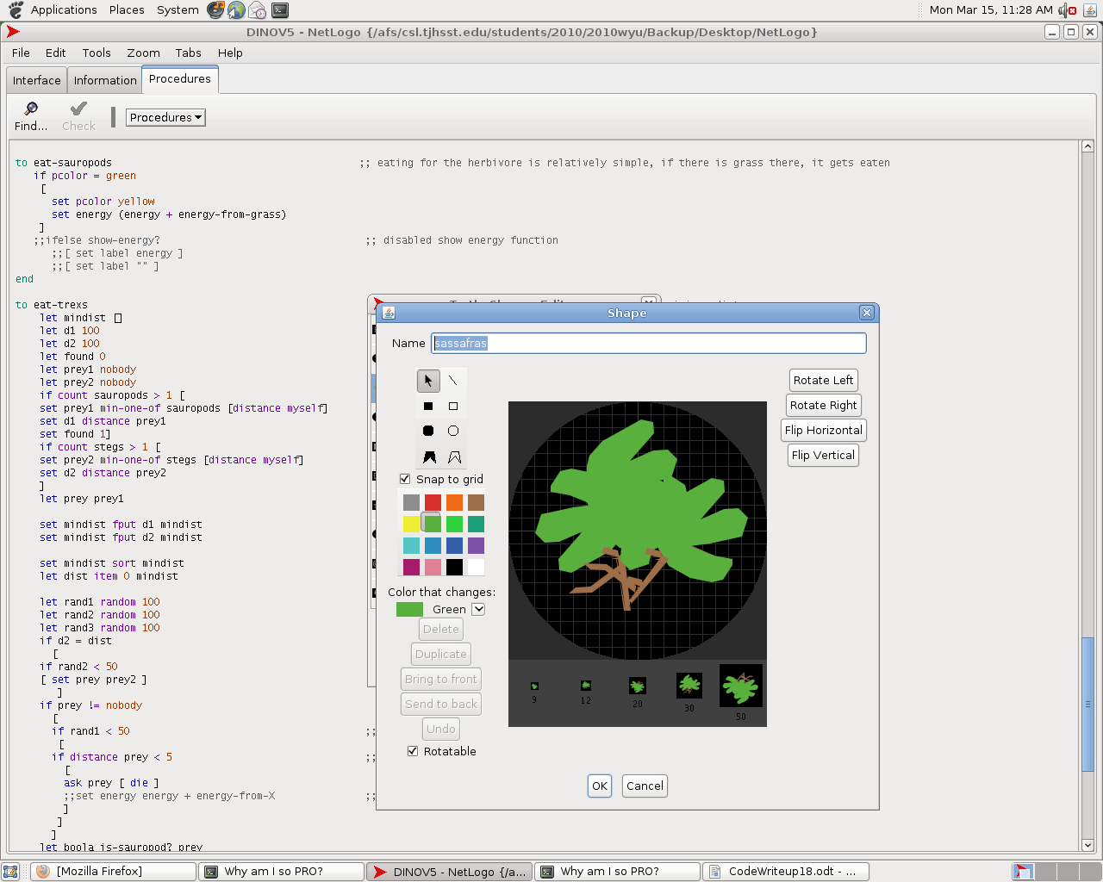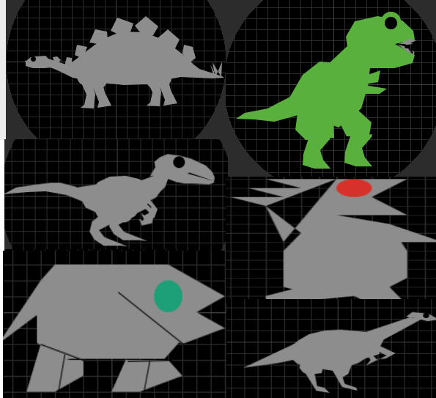
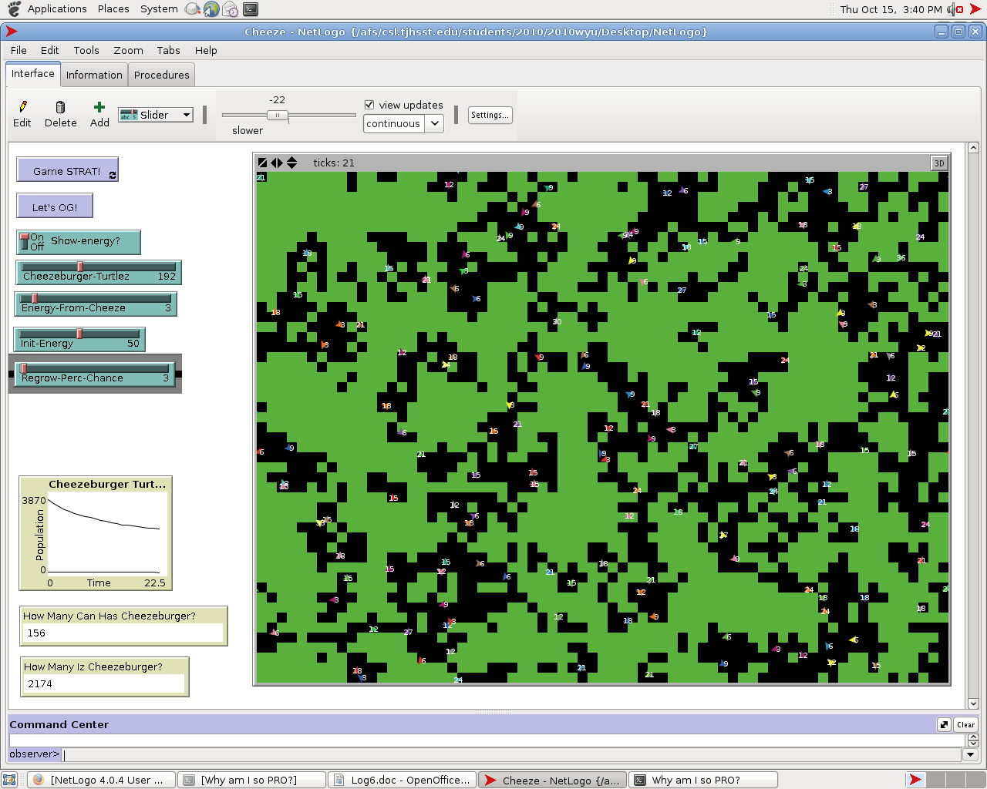

- What do you expect to work on next quarter, in relation to the goal of your project for the year?

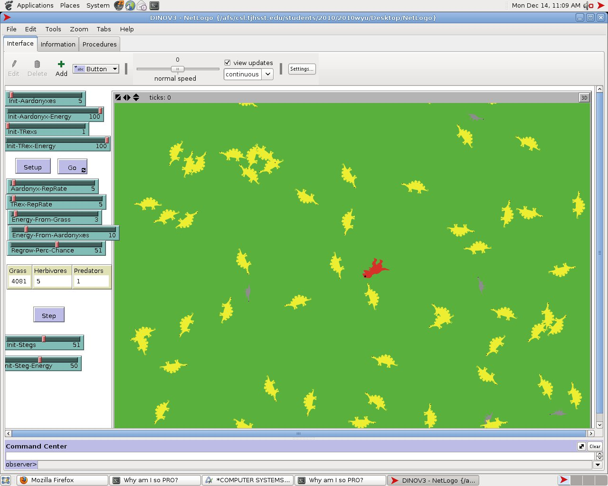

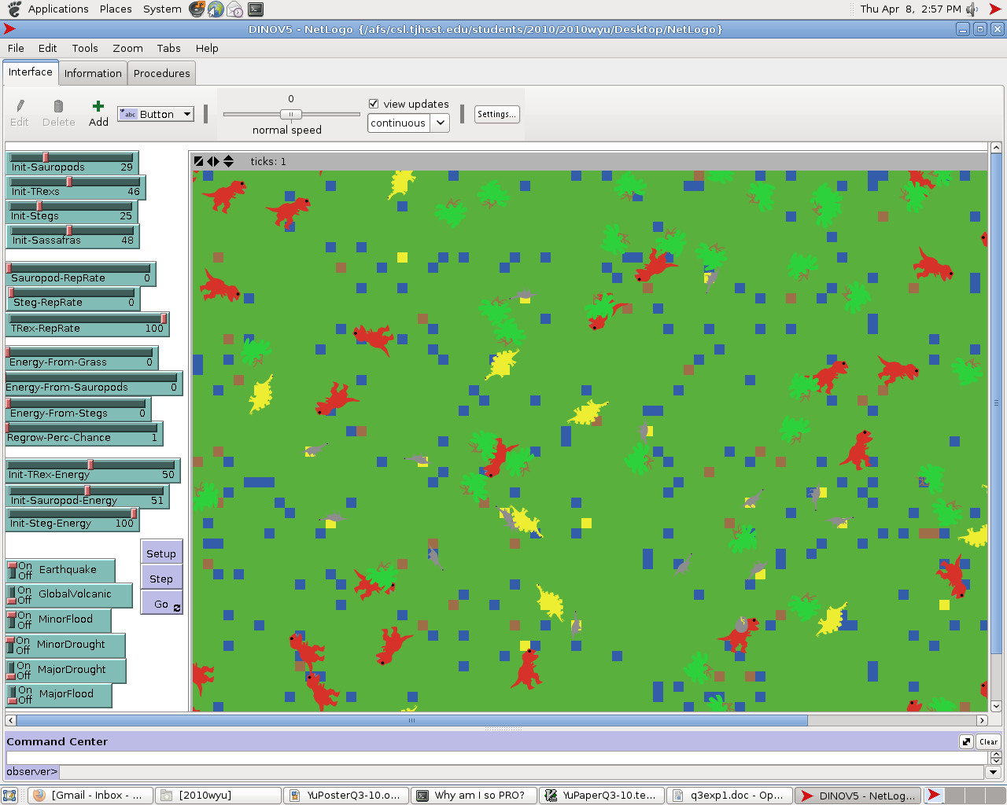

Turtles:
Velociraptor (Unused model)
T-Rex (Used predator)
Steg (Used defensible herbivore) -REPLACED WITH ANKYLOSAURUS
Aardonyx (Used herbivore) - REPLACED WITH GENERIC SAUROPOD
PredatorX (Random evolution, unused)
Generic Herbivore (Random food source, unused)
Sassafras (Immobile, unique producer)
Patches:
If patches are not green, they are not accessible for herbivores to feed off of.
Patch colors may be:
Yellow (moved on)
Blue (excess water)
Red / Orange / Black (burnt)
Brown (earthquake)

Methods (Each turtle dinosaur is 'asked' to:)
Eat-[Dinosaur] (Dinosaur's eating method, moving towards selecting closer prey if predator)
Move-[Dinosaur] (Dinosaur's moving method, contains turning and distance)
Reproduce-[Dinosaur] – ADDED ALGORITHM WITH EGGS AND TIME
Death (Dinosaurs die)
Regrow-grass (Grass is regrown)
Algorithms of note:
Algorithm for prey selection
Predation range algorithm allowing predators to prey on nearby food sources while not being directly on the same spot
Graphing algorithm (for modeling purposes) – Does not work by BehaviorSpace (putting the data into excel files, but can still put it on a graph and store data manually)
Algorithm for egg production
Various methods used in the various natural disasters
Algorithm for sassafras, how it behaves like a patch, but in fact is a turtle
The coding for the sassafras in unique in that it lasts much longer when consumed, allowing up to 100 set instances of consumption before it is deleted. - Reproduction for the sassafras was unfortunately overlooked, but will soon be added.

Current variables:

Viewable on pictures above

Response variables:

Population

Steps (time)

Errors:

Currently, the only existing error is that I can not get each egg to hatch into specifically different dinosaurs without adding an additional and cheap variable (which will likely happen). In order to do it using a general algorithm, I simply need to create uniquely colored eggs than have some sort of color boolean check if it is a certain color, and hatch it. Unfortunately, the boolean method in NetLogo can not be found.

What do you expect to work on next quarter, in relation to the goal of your project for the year?
Inputs: Standard dinosaur inputs (a lot of the characteristics will already be hard-coded). The main inputs will be the initial population, and the reproduction rate (both of which have little information on).
Outputs: Populations, change in populations, change in change in population (respectively the derivative graphs). The overall trends and the irregular ecosystem combination results (all regarding to ending population). The output will be planned to go into an auto-stored excel for later research and reference.
Tests: Will vary since this is a purely hypothetical ecosystem - however basic ecosystem rules must apply. Accurate reproduction, consumption, foraging, daily actions must all be represented.
I hope to add maybe a few more chance algorithms such as completely making the time variable make sense with dinosaur growth. Other than that, I hope to completely move my program over to python in order to better capture data.

;; Comments followed by ;;

;;---Initialization---;;
breed [sauropods sauropod] ;; small sauropod
breed [trexs trex] ;; large predatory beast
breed [stegs steg] ;; medium-large armored herbivore (short for stegosaurus)
breed [sasses sass]
breed [eggs egg]
turtles-own [energy survival] ;; energy variable, survivability variable
eggs-own [create]
;;--------------------;;

;;---Setup---;;
to setup
let time 0
let init-eggs 0
clear-all
ask patches [ set pcolor green ] ;; grassy/vegetation-filled environment
set-default-shape eggs "egg"
create-eggs init-eggs
[
set color grey
set size 0.5
set energy 100
]
set-default-shape sasses "sassafras"
create-sasses init-sassafras
[
set color lime
set size 4.0
set energy 100
let r1 random-xcor
let r2 random-ycor
setxy r1 r2
]
set-default-shape sauropods "aardonyx" ;; sets the custom turtle shape
create-sauropods init-sauropods ;; aadrdonyx creation
[
set color grey ;; sets variable color (repeats for all existing species)
set size 4.0 ;; sets picture-size ratio (repeats for all existing species)
set energy 1 + random init-sauropod-energy ;; initial energy (repeats for all existing species)
setxy random-xcor random-ycor
]
set-default-shape trexs "trex" ;; trex creation
create-trexs init-trexs
[
set color red
set size 5.0
set energy 1 + random init-trex-energy
setxy random-xcor random-ycor
]
set-default-shape stegs "steg" ;; stegosaurus creation
create-stegs init-stegs
[
set color yellow
set size 5.0
set energy 1 + random init-steg-energy
setxy random-xcor random-ycor
]
;;update-plot ;; disabled modeling function
end
;;-----------;;

;;---Start---;;
to go ;; the main step method
tick
if not any? turtles [stop]
regrow-grass ;; step regrowing grass
if MinorDrought
[
ask patches [
if random 100 < 7 [ set pcolor yellow ]]
ask sasses [
if random 100 < 10 [ die ]
]
]
if MajorDrought [
ask patches [
if random 100 < 25 [ set pcolor yellow ]]
ask sasses [
if random 100 < 25 [ die ]
]
]
if MinorFlood
[
ask patches [
set pcolor green
if random 100 < 5 [ set pcolor blue ]]
]
if MajorFlood
[
ask patches [
set pcolor yellow
if random 100 < 15 [ set pcolor blue ]]
ask sasses [
if random 100 < 15 [ die ]
]
]
if Earthquake
[
ask patches [
if random 100 < 1[ set pcolor brown ]]
ask sauropods
[ if random 100 < 25 [ die ]]
ask trexs
[ if random 100 < 30 [ die ]]
ask stegs
[ if random 100 < 35 [ die ]]
ask sasses [
if random 100 < 5 [ die ]
]
]
if GlobalVolcanic
[
;;loop [
;ask patch-at random-pxcor random-pycor
;[
;set pcolor red
;ask neighbors [ set pcolor red
;ask neighbors [ set pcolor red
;ask neighbors [ set pcolor red
;ask neighbors [ set pcolor red
;ask neighbors [ set pcolor orange
;ask neighbors [ set pcolor orange
;ask neighbors [ set pcolor orange
;ask neighbors [ set pcolor orange
;ask neighbors [ set pcolor black
;ask neighbors [ set pcolor black
;ask neighbors [ set pcolor black ]]]]]]]]]]]
;]
;; ]
clear-all
ask patches [ set pcolor red ]
ask patches [
if random 100 < 25[ set pcolor orange ]]
ask patches [
if random 100 < 25[ set pcolor brown ]]
ask patches [
if random 100 < 25[ set pcolor black ]]
]

ask sauropods ;; each ask method makes the species, move, reduce energy,
[
move-sauropods ;; eat if possible, reproduce if possible, and check for death
set energy energy - 2 ;; movement energy
eat-sauropods
reproduce-sauropods
death
]
ask trexs
[
move-trexs
set energy energy - 4
eat-trexs
reproduce-trexs
death
]
ask stegs
[
move-stegs
set energy energy - 3
eat-stegs
reproduce-stegs
death
]
;ask eggs
; [
; if pcolor yellow
; [
; hatch-trexs 1 [ rt random-float 360 fd 1 set color red set size 5.0 set create ticks ]
; ]
; if pcolor white
; [
; hatch-sauropods 1 [ rt random-float 360 fd 1 set color grey set size 4.0 set create ticks ]
; ]
; if pcolor grey
; [
; hatch-stegs 1 [ rt random-float 360 fd 1 set color yellow set size 5.0 set create ticks ]
; ]
; ]
end
;;-----------;;

;;---Methods---;;

to move-stegs ;; fd is distance rt and lt are angle variablitiy
rt random 40
lt random 40 ;; (therefore this is agility and speed)
let randms random 4
fd randms / 2 ;; 1/4 chance to move 2, otherwise move 1
end

to move-sauropods
rt random 30
lt random 30
let randms random 4
fd randms / 2 ;; 1/4 chance to move 2, otherwise move 1
end

to move-trexs
rt random 50
lt random 50
let randms random 3
fd randms ;; equal chance to move 1, 2 ,3
end

to reproduce-stegs ;; reproduction requires a population of at least 2,
if count stegs > 2 ;; the reproduction rate in scale by a factor of 10
[
if random-float 100 < steg-reprate / 20 ;; further scale by factor of two for female species
[
set energy (energy / 2)
;;hatch 1 [ rt random-float 360 fd 1 ]
;;ask eggs [ hatch 1 [ rt random-float 360 fd 1 ] ]
hatch-eggs 1 [ rt random-float 360 fd 1 set color grey set size 2.0 set create ticks]

]
]
end

to reproduce-sauropods
if count sauropods > 2
[
if random-float 100 < sauropod-reprate / 20 ;; sauropod reproduction (identical)
[
set energy (energy / 2)
;;hatch 1 [ rt random-float 360 fd 1 ]
hatch-eggs 1 [ rt random-float 360 fd 1 set color white set size 1.0 set create ticks]
]
]
end

to reproduce-trexs
if count trexs > 2
[
if random-float 100 < trex-reprate / 20 ;; trex reproduction (identical)
[
set energy (energy / 2)
;;hatch 1 [ rt random-float 360 fd 1 ]
hatch-eggs 1 [ rt random-float 360 fd 1 set color yellow set size 2.5 set create ticks]
]
]
end

to eat-stegs ;; 100% chance of grass consumption
if pcolor = green
[
set pcolor yellow ;; black represents eaten grass, green represents existing grass
set energy (energy + energy-from-grass)

]
end

to eat-sauropods ;; eating for the herbivore is relatively simple, if there is grass there, it gets eaten
let eaten 0
if count sasses-here > 0
[
let xfer random energy-from-grass
set energy (energy + eaten)
set eaten 1
ask one-of sasses-here [
set energy energy - xfer
death ]
]
if pcolor = green
[
set pcolor yellow
set energy (energy + energy-from-grass)
]
;;ifelse show-energy? ;; disabled show energy function
;;[ set label energy ]
;;[ set label "" ]
end

to eat-trexs ;; predators requires more of a prey selection of minimum distance,
let mindist []
let d1 100
let d2 100
let found 0
let prey1 nobody
let prey2 nobody
if count sauropods > 1 [
set prey1 min-one-of sauropods [distance myself]
set d1 distance prey1
set found 1] ;; in addition to a predation range algorithm that chooses one within its range
if count stegs > 1 [
set prey2 min-one-of stegs [distance myself]
set d2 distance prey2
] ;; allows for multiple species of prey
let prey prey1 ;; prey are assorted in ascending strengths
;; ascending strengths allow easier first prey
set mindist fput d1 mindist ;; distance variable integer
set mindist fput d2 mindist ;; stores distances, then sorts in ascending order
;; array is good for more future prey
set mindist sort mindist
let dist item 0 mindist ;; first item, lowest distance
;; arbitrary prey, weakest first, otherwise
let rand1 random 100 ;; chance of predation determiner
let rand2 random 100 ;; chance of going after smaller dist
let rand3 random 100 ;; chance of fight
if d2 = dist ;; checking if d2 is the closer
[
if rand2 < 50 ;; 50% chance of going for closer, harder prey
[ set prey prey2 ]
]
if prey != nobody
[
if rand1 < 50 ;; 50% chance of trex predation
[
if distance prey < 5 ;; predation range
[
ask prey [ die ]
;;set energy energy + energy-from-X ;; energy gain
]
]
]
let boola is-sauropod? prey
let boolb is-steg? prey
if boola [
set energy energy-from-sauropods] ;; no fight, helpless prey
if boolb [
set energy energy-from-stegs ;; if below threshold, trex gets hurt, energy reduced
if rand3 < 15 ;; 15 percent chance of fight back
[
set energy energy - 20
;;set effect maimed
]
]

end

to death ;; death algorithm
if energy < 0 [ die ]
end

to regrow-grass
ask patches [
if random 100 < Regrow-Perc-Chance [ set pcolor green ]
]
end

;;-------------------------------------------------------------------------------------;;

