COMPUTER SYSTEMS RESEARCH
Portfolio Update 4th Quarter 2009-2010
Research Paper, Poster, Slides, Coding, Analysis and Testing of your project's program.
Name: Peter Ballen Period: 5 Date: 6/9
Project title or subject: PFCSP
Computer Language: Python, TKinter
Describe the updates you have made to your research portfolio for 4th quarter.
- Research paper: Paste here new text you've added to your paper for 4th quarter. Describe and include new images, screenshots, or diagrams you are using for 4th quarter.
Specify text you've written for any of the following sections of your paper:
- -Experiment
It can be intresting to manipulate the model to better understand how various constraints are connected to their states. The following commands are often helpful in such a task:
\begin{itemize}
\item Highlight - Highlight the dot that corresponds to a given state.
\item Unhighlight - Unhighlight a previously highlighted dot.
\item Poll - Give the happiness heuristic function of a given state.
\item Identify - Give the opinion values of a given state.
\item Mouse Input - Clicking by a dot will give the state it corresponds to.
\end{itemize}
Using these commands, it is possible to gain a greater understanding of the model. It is difficult to replicate the interactivity in a paper, but hopefully the previous discussion has been clear enough to understand.
- -Extending the model
section{Extentions}
\begin{figure}[!htp]
\begin{center}
\includegraphics[scale = .3]{graphlinear.png}
\end{center}
\caption{Basic linear evaluation function}
\end{figure}
\par
Throughout the Voter model, we have assumed that the best estimator of a Voter's happiness is a linear distance function, whose graph is shown below. With this function, given a distance d between a proposal and the Voter, h(d) = d.
\par
The linear model was convenient because it was easy to visually interprete. However, there is no reason we could have not used a more complicated function. For example, consider the exponential function h(d) = exp(d)/exp(1), where d is still the distance between the Voter and the proposal. The graph and resulting model are shown below.
\par
\begin{figure}[!htp]
\begin{center}
\includegraphics[scale = .3]{graphexponential.png}
\end{center}
\caption{Exponential evaluation function}
\end{figure}
\par
Notice how the optimal solutions, drawn in blue and red, have not dramatically change. It is also possible to consider a noncontinuous evaluation function. Consider the function h(d) = ceiling(d), where the ceiling command rounds the distance d up to the nearest ,1 increment. For example, h(.9) = h(.84) = h(.8001) = .9. The graph and resulting model are shown below.
\par
\begin{figure}[!htp]
\begin{center}
\includegraphics[scale = .3]{graphpiecewise.png}
\end{center}
\caption{Piecewise evaluation function}
\end{figure}
\par
In this case, the optimal solutions have varied dramatically: the weighted solution has moved towards the upper-right corner and the unweighted solution have shifted towards the bottom-left corner. The piecewise model shifts both solutions away from the middle towards the extremes.
\par
These are all very simple extentions. More complicated extentions could use far more complicated equations, as well as having several more variables. However, no matter how complicated the model becomes, the fundamental ideas are identical to those presented earlier in the paper.
- Conclusion
In this paper, we have discussed the fundamental differences between hard constraint satisfaction and soft constraint satisfacton. We have done basic constraint interpretation to classify constraints as antagonistic or sympathetic, and to prioritize constraints based on importance. Finally, we used these ideas to construct a basic model of taxes and unemployment and evaluated tax proposals. This paper has discussed the basic idea of fuzzy constraint satisfaction and its use in finding solutions to problems that do not have a perfect solution.
- Pictures
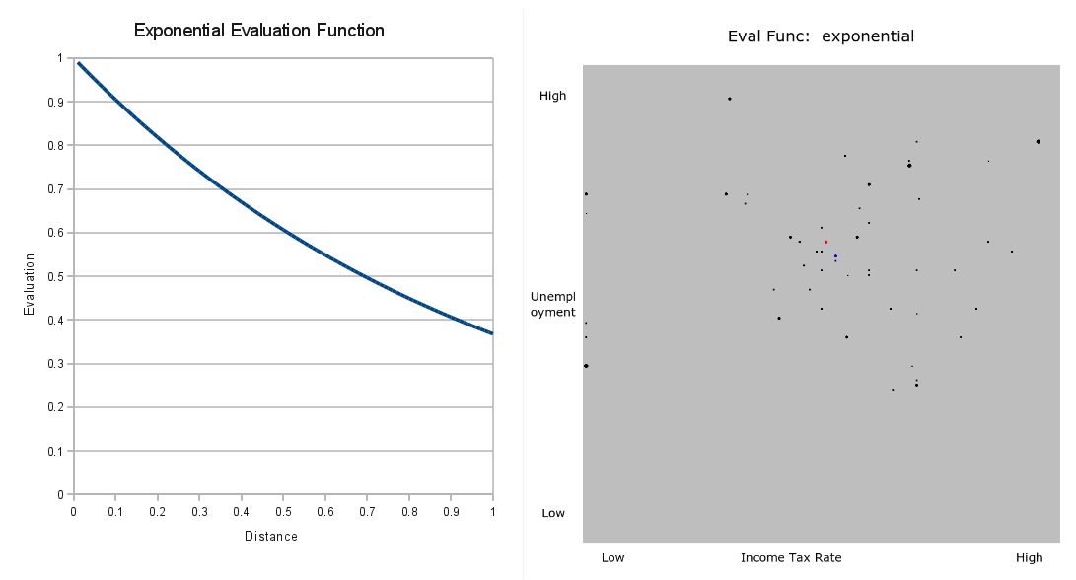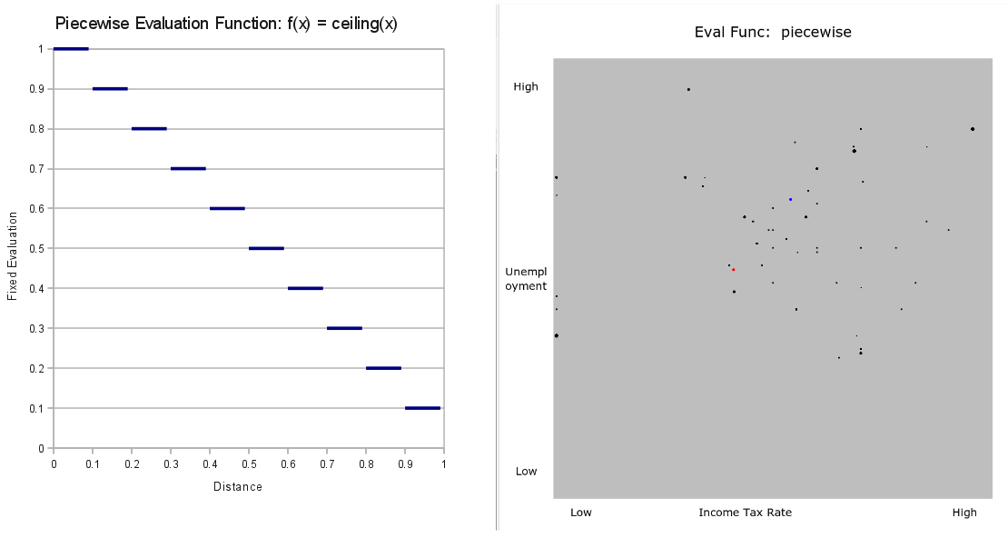

- Poster: Copy in new text you've added to your poster for 4th quarter.
List the titles you're using for each of your subsections. Include new text you're adding
- Subsection heading: Conclusion and text:
Looking at the location at the dots, we can determine that both the House and the Senate support raising unemployment benefits. The Senate, the red dot, favors higher benefits with a lower tax increase, suggesting deficit spending. The House, the blue dot, favors less taxes but also less benefits.

Although the states vary widely in ideology, and no state is 100% satisfied, with fuzzy prioritized constant satisfaction we can estimate how society as a whole would respond to the proposal.

The final conclusion: raise taxes slightly to increase unemployment benefits, showcases one of the fundamental features of society. When Voters have wildly diverse opinions on both sides of the issue, no matter how extreme these views may be, the best solution almost always lies in the center.

- Subsection heading: Abstract and text:
The purpose of this project is to demonstrate the use of fuzzy constraint satisfaction techniques by creating an artificial society, then maximizing the happiness of that society. It will also explore the impacts of a sympathetic versus an antagonistic society using real governmental data.

- Presentation slides: Provide a brief outline summarizing the main points of your presentation for 4th quarter
-Introduces the exciting user-interface I added during Q4 (highlight command, unhighlight, identify, mouse input).
-Introduces extensions to the model by using three different evaluation models (linear, exponential, and piecewise).

- Coding: attach new code that you wrote 4th quarter. Describe the purpose of this code in terms of your project's goal and research. Also provide clear commentary on the main sections of your code.
-The user interface is the main feature. See attached code writeup for full details.
-Also, I created a smaller version of the program that can run on non-wide-screen monitors.

5. Testing, Analysis – specific listings/descriptions of the tests and analysis you've done this
quarter.
-Playing with the user interface.
-Different evaluation models. Using a different function will produce different results. Exponential is shown below, piecewise is in the paper as well.

- Running your project – describe what your project's program actually does in it's current stage. Include current analysis and testing you're doing. Specifically what have you done this quarter.

Given a text file of data and priorities, the code will calculate, using pruning, the optimal solution that will make the society happiest. With user input, it is possible to look at individual voters (the state of Virginia, for example) and switch between different evaluation functions.

- What is the Final focus and statement of your project for this year?

The purpose of fuzzy constraint satisfaction is to find solutions to problems that do not have perfect solutions (where hard constraint satisfaction fails). The society model is one such example. The code is very flexible, allowing any type of data input, any type of priority listing, and any type of evaluation function. Once these variables have been set, the optimal solution can be found and used accordingly.

