COMPUTER SYSTEMS RESEARCH
Portfolio Update 4th Quarter 2009-2010
Research Paper, Poster, Slides, Coding, Analysis and Testing of your project's program.
Name: Jennifer Lee, Period: 5, Date: June 15, 2010
Project title or subject: Automated Detection of Human Emotion
Computer Language: python + webcam

Describe the updates you have made to your research portfolio for 4th quarter.
- Research paper: Paste here new text you've added to your paper for 4th quarter. Describe and include new images, screenshots, or diagrams you are using for 4th quarter.
Specify text you've written for any of the following sections of your paper:

- Results – if you're reaching any preliminary conclusions
Results, after thirty trials, show reasonable accuracy in classification of emotion. All emotions reached at least 90% accuracy with the exception of sadness which reached 60%.
- Discussion
While the results of the emotion classification was at first rather inaccurate, after 30 trials, the results greatly improved. Happy, Neutral, and Angry emotions ended with at least a 90\% success rate with the classification of Angry obtaining a 100% success rate. The high success rate for happy and angry can be attributed to the relatively large displacement of both markers when expressing those emotions. The neutral emotion, on the other hand, also has a large success rate due to the lack of displacement of the markers. However, sadness had the lowest success rate due to its overlap with the anger and neutral emotions. Sadness is characterized by a downward mouth movement and a upward eyebrow movement, neither of which are very pronounced thus leading to confusion.
An extremely notable problem with my experiment is that it was only tested with myself. Thus, results may be completely off when testing with other people. However, because of the backpropogation technique and society's general consensus on what a smile is (no one smiles by frowning) I am confident the program would reach similar success rates after a good number of run throughs.
  - images, screenshots, or diagrams in your paper
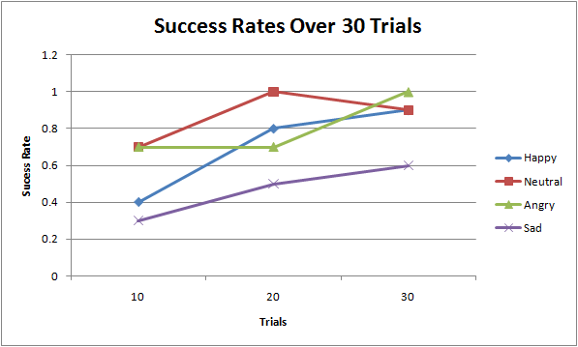
A bunch of tables were also added.

- Poster: Copy in new text you've added to your poster for 4th quarter.
List the titles you're using for each of your subsections. Include new text you're adding
- Subsection heading: Results and text:
Results, after thirty trial runs, show that the program is relatively successful when classifying all four emotions with the exception of sadness. Plotting the success rate over time also shows how the backpropogation greatly increased the success rate over time.

- Subsection heading: Discussion and text:
While the results of the emotion classification was at first rather inaccurate, after 30 trials, the results greatly improved. The high success rate for happy and angry can be attributed to the relatively large displacement of both markers when expressing those emotions. The neutral emotion, on the other hand, also has a large success rate due to the lack of displacement of the markers. However, sadness had the lowest success rate due to its overlap with the anger and neutral emotions. An extremely notable problem with my experiment is that it was only tested with myself. Thus, results may be completely off when testing with other people. However, because of the backpropogation technique and society's general consensus on what a smile is (no one smiles by frowning) I am confident the program would reach similar success rates after a good number of runs.

- images, screenshots, or diagrams in your poster.
- Presentation slides: Provide a brief outline summarizing the main points of your presentation for 4th quarter
Result slides were added.

- Coding: attach new code that you wrote 4th quarter. Describe the purpose of this code in terms of your project's goal and research. Also provide clear commentary on the main sections of your code.
None.

5. Testing, Analysis – specific listings/descriptions of the tests and analysis you've done this
quarter.

Testing, ran 30 trials for each emotion and summarized the accuracy every 10 trials.
Tables:

- Running your project – describe what your project's program actually does in it's current stage. Include current analysis and testing you're doing. Specifically what have you done this quarter.

EVERYTHING. I finished the GUI and put everything together. The main focus of this quarter was testing and analyzing rather than coding.

- What is the Final focus and statement of your project for this year?
IT WAS SUCCESSFUL \ o /

