COMPUTER SYSTEMS RESEARCH
Project Experiment 1 for 4th quarter 2009-2010
- Your name: Deniz Oran, Period: 5
- Project title: Steganography and its Steganalysis
- Language and/or software you are using: JAVA

- 4th quarter experiment 1 for your program. - What are you doing now that you will write about in your research paper. For example, what images are you using, what tests you are analyzing, what results you are finding and concluding...
  - Problem definition for this quarter – The main problem was deciphering the efficiency of the decoding algorithm and, if applicable, identifying any aspects that need to be optimized.

Since I had already tested the efficacy of the encoding algorithm by varying the image size and determining its effect on the run time of the encoding algorithm in the previous quarter, I decided to test the efficiency of the decoding algorithm by using the same images used in the previous test that have been encoded with a message and determining the time the program took to extract the message.
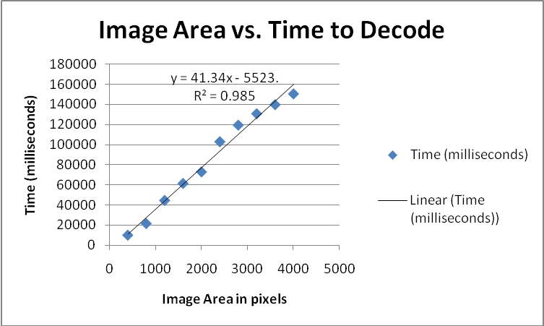

It’s intriguing that both the encoding and decoding are linearly related, thus indicating an overall big O of O(n), but that the intercepts (not the slopes) are different, which accounts for the decoding time’s steepness. This might be explained by variations in the computer environment or simply the availability of system resources. The difference in the encoding and decoding doesn’t appear to be statistically significant though. The following is the image size vs. encoding time graph that was generated last quarter for comparison.
