COMPUTER SYSTEMS RESEARCH
Portfolio Update 4th Quarter 2009-2010
Research Paper, Poster, Slides, Coding, Analysis and Testing of your project's program.
Name: Deniz Oran, Period: 5, Date: 05/31/2010
Project title or subject: Steganography and its Steganalysis
Computer Language: JAVA
Note: Now for full credit on all assignments you must provide specific plans and work using a degree of sophistication of algorithms and data structures at or beyond the level of APCS, AI 1/2, Parallel 1/2. Using shell programs or code available on the Web or in a book is not sufficient for full credit. You must provide actual development of your own code and research, analysis and testing of this code of your own. Be sure to list specific data structures, algorithms and coding you are doing at a sufficient level of sophistication for full credit. Also for full credit, you cannot merely repeat the same algorithms/data structures week after week – your program and your learning need to be evolving at a sophisticated level.

Describe the updates you have made to your research portfolio for 4th quarter.
- Research paper: Paste here new text you've added to your paper for 4th quarter. Describe and include new images, screenshots, or diagrams you are using for 4th quarter.
Specify text you've written for any of the following sections of your paper:
- Abstract
None
- Introduction or Background
None
- Development section(s) – the work you've actually done
None, since the code was finished during third quarter
Results – if you're reaching any preliminary conclusions
Experiments
In addition to testing the encoding algorithm by varying the image size and determining its effect on the run time of the encoding algorithm, the efficiency of the decoding algorithm was tested by using the same images used in the previous test that have been encoded with a message and determining the time the program took to extract the message.
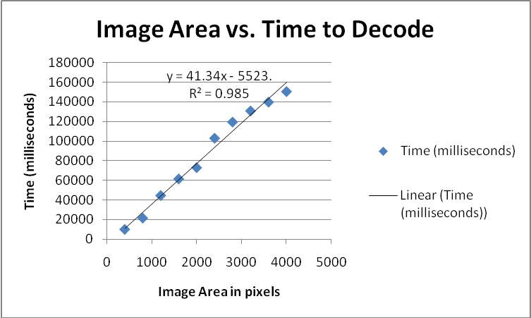

It’s intriguing that both the encoding and decoding are linearly related, thus indicating an overall big O of O(n), but that the intercepts (not the slopes) are different, which accounts for the decoding time’s steepness. This might be explained by variations in the computer environment or simply the availability of system resources. The difference in the encoding and decoding doesn’t appear to be statistically significant though. The following is the image size vs. encoding time graph that was generated last quarter for comparison.
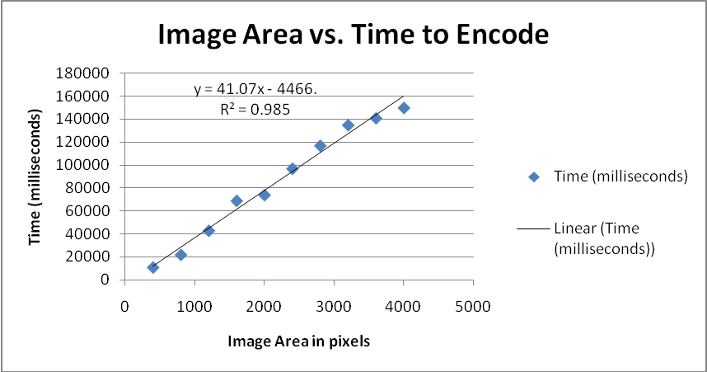

- Additions to your bibliography
Image Steganography, A New Approach to Transferring Security Information H.B. Bahar and Ali Aboutalebi Tabriz University July 2008
Information Hiding Techniques: A Tutorial Review Sabu M Thampi
Detection of Hiding in the Least Significant Bit Onkar Dabeer
Practical Steganalysis of Digital Images – State of the Art
Jessica Fridrich*, Miroslav Goljan
SUNY Binghamton, Department of Electrical Engineering, Binghamton, NY 13902-6000
On The Limits of Steganography Ross J. Anderson, Fabien A.P. Petitcolas 1998
Steganographic Techniques and their use in an Open-Systems Environment Bret Dunbar 2002
Probably Secure Steganography Nicholas J. Hopper John Langford Luis von Ahn 2002

- images, screenshots, or diagrams in your paper

- Poster: Copy in new text you've added to your poster for 4th quarter.
List the titles you're using for each of your subsections. Include new text you're adding
I edited some of the grammatical errors and typographical mistakes on the poster, I also included a better diagram.
- Presentation slides: Provide a brief outline summarizing the main points of your presentation for 4th quarter
-History of Steganography
-Overview of the algoriths
-Picture of the GUI
-Description of Testing
-Results

- Coding: attach new code that you wrote 4th quarter. Describe the purpose of this code in terms of your project's goal and research. Also provide clear commentary on the main sections of your code.

-The major coding for the project was finished by the end of Third Quarter. The only code that was written this quarter was timers and temporary variables to test the program.

5. Testing, Analysis – specific listings/descriptions of the tests and analysis you've done this
quarter.

In addition to testing the encoding algorithm by varying the image size and determining its effect on the run time of the encoding algorithm, the efficiency of the decoding algorithm was tested by using the same images used in the previous test that have been encoded with a message and determining the time the program took to extract the message.

It’s intriguing that both the encoding and decoding are linearly related, thus indicating an overall big O of O(n), but that the intercepts (not the slopes) are different, which accounts for the decoding time’s steepness. This might be explained by variations in the computer environment or simply the availability of system resources. The difference in the encoding and decoding doesn’t appear to be statistically significant though. The following is the image size vs. encoding time graph that was generated last quarter for comparison.

- Running your project – describe what your project's program actually does in it's current stage. Include current analysis and testing you're doing. Specifically what have you done this quarter.

The program encodes text messages into images using Least Significant Bit Steganography and decodes an image that has been encoded with the mentioned method and integrates those algorithms into an easy to use GUI.

- What is the Final focus and statement of your project for this year? It is finished.

