Code Writeup

Your Name: Bharat Ponnaluri, Period: 5

Date of this version of your program: 5/28/2010

Project title: Design of a Real Time Strategy Game with a Genetic AI

Currently, my program is able to generate expressions for input-output pairs. It is inaccurate for large numbers because the genetic algorithm is unable to recognize polynomials. However, the population does not stagnate because the average change in fitness and standard devation of the population are not 0.

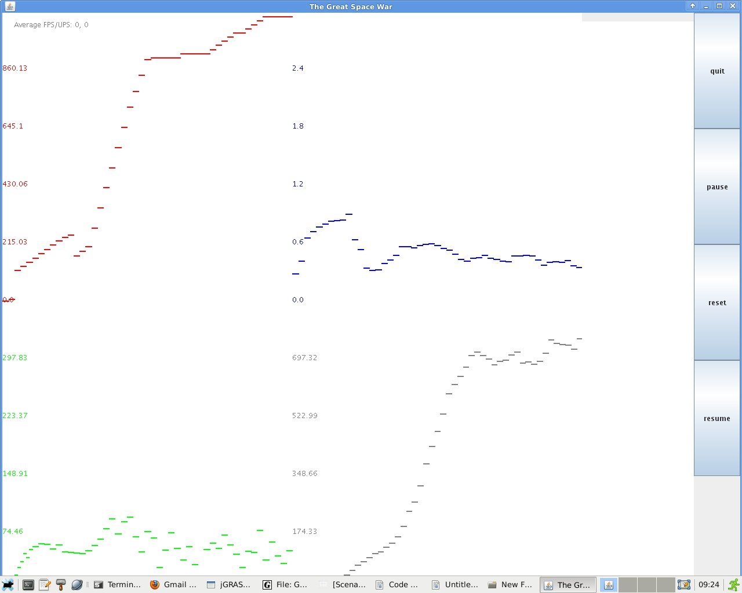

Sample expressions for input-ouput pairs created from the formla x^4+x^3+x^2+x+1 where the inputs are multiples of 5 between -50 and 50.

2*x*6/2*x*8/7*x*7-6*x/1+6*x/9-5*x+2-4*x/9-1*x-8-4*x*7-2*x/2/9*x*3*3*x*8/4
4*x*6+1*x-1*5*x-3+5*x*5*8*x/7*6*x+8*1*x-1-9*x*8*2*x-3*9*x/1+3*x+1+9*x-4+8

3*x+9+1*x/10/6*x*5*2*x/10*1*x/3/1*x*7-5*x-4/8*x+3/1*x-8+4*x-3+9*x*2*4*x-2-7

Sample Expressions when the inputs are multiples of 500 between 5000 and -5000
2*x*6/2*x*8/7*x*7-6*x/1+6*x/9-5*x+2-4*x/9-1*x-8-4*x*7-2*x/2/9*x*3*3*x*8/4

I also started to write scenarios that will be used to test out the fitness of the AI's in my genetic algorihtm. The first scenario involves onle player who has a lot of cities and oen palyer who has a superiority in troops. The AI has a decent understanding of this scenario as the player with more troops tries to attack and the other AI tries to build up troops. However, the AI's attack and defend in a suboptimal manner. In the second scenario, there are four AI's who start out with an equal amount of troops and cities, which leads to a massive troop buildup. In the third scenario, one AI controls half the map and the rest of the map is split.

Scenario 1
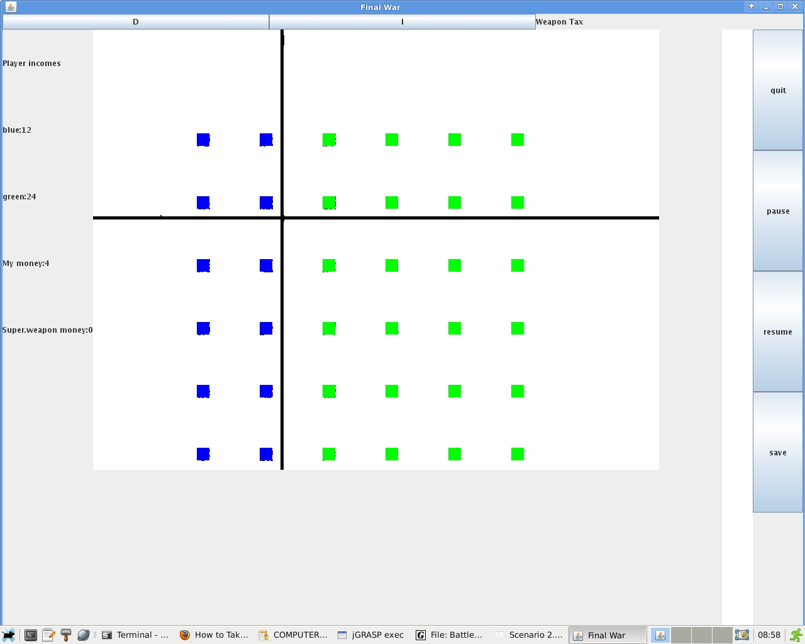

Scenario 2
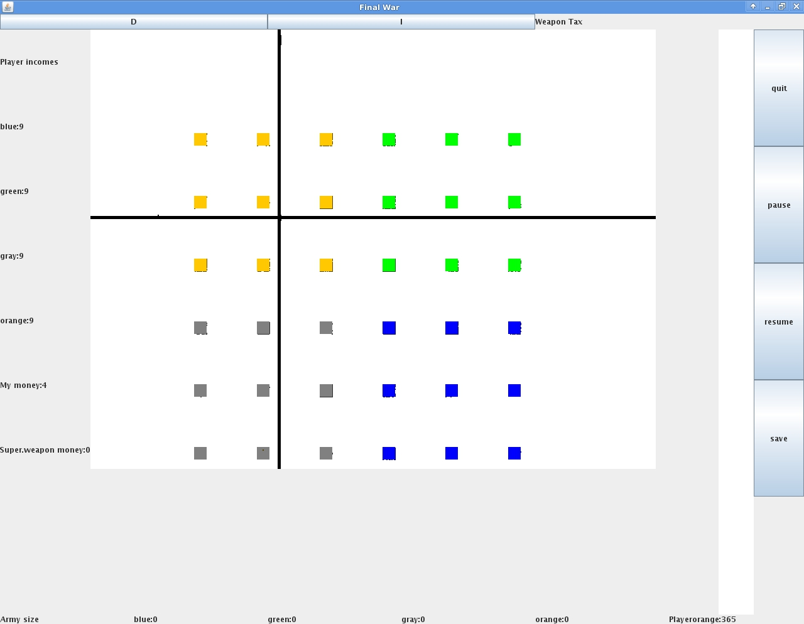

Scenario 3
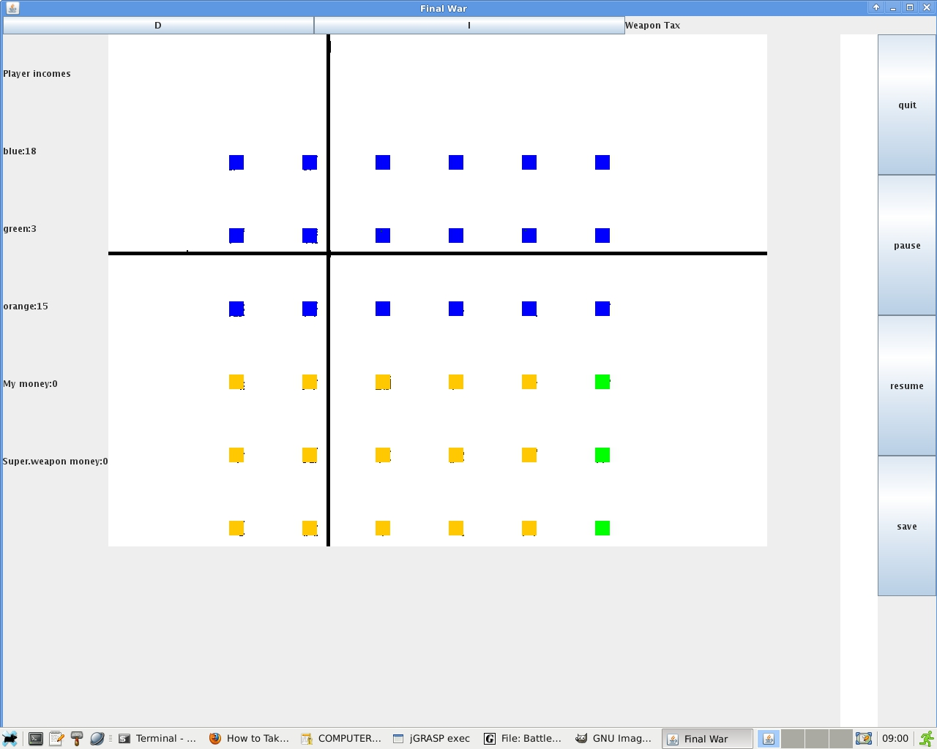

Files that may be needed: Currently, my program does nto need any additional files. Initially, to create the scenarios that I would use with the genetic algorithm, I decide to write the scenarios from a text file, but I found that it was too complicated.

Algorithms, specific procedures or methods you wrote:
Genetic algorithms
Heuristic Evaluation Functions
Hardcoded Scenarios

Error Handling: For the most part, my program is able to effectively handle errors. However, my program ocassionally generates null pointer exceptions and crashes.

Testing: To test out the ability of a genetic algorihtm to generete formulas for input-output pairs, I had my program generate input-ouput pairs based on a defined formula and see if the genetic algorithm could figure it out. I experimented with four different ways of calculating the fitness, but they all were not successful. My genetic algorithm initially creates expressions with polynomials and mutates to create polynomials, but the algorithm has a tendency to create polynomial functions that are far from accurate.

    - Method 1: Using the total fitness for each input-ouput pair and adding them together
      - Result: Did not work because it allowed the program to maximize the fitness value for one input/-output pair while neglecting the others
    - Method 2: Same as Method 1, but the fitness value of each input output pair is capped at 10
      - Result: Initially did not work because of a bug in my program. After fixing the bugs, this method worked decently. However, it could not recognize polynomials.
    - Method 3: Multiplying the fitness for each input-output pair
      - Result: Led to values which were too high or low for the genetic algorithm to process.

    - Method 4: Combination of Methods 2&3
      - Result: The fitness value remained at 0. Did not recognize that the input-output pairs were represented by a quartic polynomial. Also, due to the slight error when computers do calculations using decimal values, the fitness value will be inaccurate by a large magnitude

Future Plans

I plan to continue working on this project until I am able to successful create an AI using a genetic algorithm. In the next few weeks, I plan to fix the formula-generating genetic algorithm that I created and create several scenarios. Once that is finished,I will run my genetic algorithm and play against the AI that I created, hopefully sometime this summer.

