COMPUTER SYSTEMS RESEARCH
Portfolio Update 4th Quarter 2009-2010
Research Paper, Poster, Slides, Coding, Analysis and Testing of your project's program.
Name: __Anna Stapleton________, Period: __5__, Date: _05/26/10_____
Project title or subject: __Input and Sharing of Infectious Disease Data at the Grassroots Level___
Computer Language: ____NetLogo_______

Note: Now for full credit on all assignments you must provide specific plans and work using a degree of sophistication of algorithms and data structures at or beyond the level of APCS, AI 1/2, Parallel 1/2. Using shell programs or code available on the Web or in a book is not sufficient for full credit. You must provide actual development of your own code and research, analysis and testing of this code of your own. Be sure to list specific data structures, algorithms and coding you are doing at a sufficient level of sophistication for full credit. Also for full credit, you cannot merely repeat the same algorithms/data structures week after week – your program and your learning need to be evolving at a sophisticated level.

Describe the updates you have made to your research portfolio for 4th quarter.
- Research paper: Paste here new text you've added to your paper for 4th quarter. Describe and include new images, screenshots, or diagrams you are using for 4th quarter.
Specify text you've written for any of the following sections of your paper:
- Results
\\Three sets of testing conditions were run. In the first group, the World Area was held constant at 1024 square units (corresponding to 921,600 square meters), while the number of nodes was varied. The number of nodes was set to 50, 40, 30, and 20 in succession, with 10 trials being run for each set of conditions. For each trial, 365 ticks were run, and the program outputted the number of nodes which had passed their information. From the data, the average successful pass rate for each condition was calculated and plotted against node density (see Figure 4).
\\Data from the first round of trials made clear that a system of those dimensions would have very low success rates. The highest node density tested in that scenario was .031, corresponding to about one node per 32 square meters. The average SPR for that density was .078, meaning that about one in twelve nodes successfully transfered data. In the field, such a remarkably low success rate would be unacceptable and ineffective in providing useful data on infectious disease activity.
\\Because of the inadequacy of the first set of conditions tested, the second set of tests were designed to show the high density of nodes necessary to achieve an acceptable SPR. The World Area was again held constant at 1024 square units, while the number of nodes was set to 75 and 100, with the same number of trials per condition set being used as in the first round of tests. With a node density of .098 (corresponding to the 100 nodes condition), the average SPR was .475. When the node density was set to .073 (with the 75 nodes condition), average SPR was .571. This suggests that in order to have one of every two nodes successfully pass their information, the system would need to have one node per every 10 square meters. Not only is this still an unacceptably low success rate, but the density of nodes involved renders the system unrealistic.
\\The final round of testing was designed to demonstrate the success this system might achieve given a more realistic set of constraints. The World Area was set to 9801 square units (the largest allowed in NetLogo), corresponding to 8,820,900 square meters. For reference purposes, this is roughly a third of the land area of Rwanda. Supposing that there were to be one node per every 100 square kilometer area, the number of nodes was set to 88, meaning a node density of about .009. Under this set of conditions, the average SPR attained was .038, meaning that approximately one in every 27 nodes successfully transfered its data.
-Future Work
Several aspects of the NetLogo model could be improved in order to produce a more accurate representation of the system. One improvement would be to introduce stochasticity at different levels of the calculations. For example, as the model stands, any node with a pass chance of greater than .5 will be considered successful in passing its information. In reality, a fifty percent chance of success obviously does not guarantee sucess, nor does a less than fifty percent chance guarantee failure. Allowing for stochasticity at that level would create a more realistic scenario when determining whether a node can successfully pass its information.
\\A second critique of the current model is that it does not currently take into account the amount of time a node stays in contact with the master node. For example, node A may be connected to the master node such that it has a pass success rate of .45. Because this is less than .5, node A would not successfully pass its information, even if it maintains a .45 pass success rate for multiple ticks. In reality, the longer a node is in contact with the master node, the more opportunities the node has to pass its information, and there is therefore a greater chance of one of those attempts succeeding. A more accurate model of this network would need to be able to track the amount of time a node has been in contact with the master, and readjust its pass success chance accordingly.
\\Thirdly, the current model does not represent a mesh network's ability to propagate shared information. For example, suppose node A is linked directly to nodes B and C. Node B would automatically pass all of its information to node A, and node C would do the same. At this point, node A possesses all the information for nodes A, B, and C. This means that if node A can successfully transfer information to the master node, it will transfer not only its own information, but the information of nodes B and C, even if nodes B and C are not within range to pass the information themselves. In order for this to be properly reflected in the model, each node would need to calculate a pass chance for every node it connects to, not just the master node. The fact that this factor is not incorporated into the model means that the data produced is likely to be a gross underestimation of the actual average SPR.

- images, screenshots, or diagrams in your paper
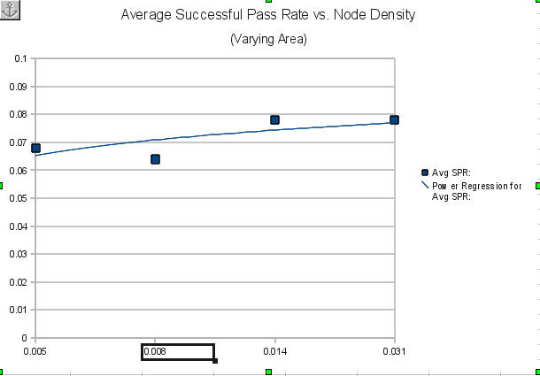
- Poster: Copy in new text you've added to your poster for 4th quarter.
List the titles you're using for each of your subsections. Include new text you're adding
- Subsection heading: __Results and Discussion___ and text:
The interface/database system was successfully created to meet the specified design criteria. The NetLogo model of the implementation of such a system revealed that successful transfer rates improved with increased density of network nodes in the area. However, multiple improvements to the model must be made before it can produce reliable data.
  - images, screenshots, or diagrams in your poster.
Same graph as in paper
- Presentation slides: Provide a brief outline summarizing the main points of your presentation for 4th quarter
- Abstract
- Introduction
- Development:
  - phase 1
  - phase 2
  - phase 3
- Testing
- Improvements
- Long Term goals

- Coding: attach new code that you wrote 4th quarter. Describe the purpose of this code in terms of your project's goal and research. Also provide clear commentary on the main sections of your code.
I didn't do any new coding this quarter. Instead I just was running experiments in NetLogo on the model I had finished during 3rd quarter.

5. Testing, Analysis – specific listings/descriptions of the tests and analysis you've done this
quarter.
Three sets of testing conditions were run. In the first group, the World Area was held constant at 1024 square units , while the number of nodes was varied. The number of nodes was set to 50, 40, 30, and 20 in succession, with 10 trials being run for each set of conditions. For each trial, 365 ticks were run, and the program outputted the number of nodes which had passed their information. From the data, the average successful pass rate for each condition was calculated and plotted against node density.
The second set of tests held the number of nodes constant while varying the world area. This was designed to test a much lower density of nodes. The same experiment design of 10 trials per condition with 365 ticks per trial was used. Again, the number of nodes which successfully passed information was outputted, and then used to calculate the average successful pass rate.
The final set of tests was designed to reflect more realistic conditions. The world area was established to be as large as possible, so that it corresponded to roughly a third the land area of Rwanda. Supposing that there were to be one node per every 100 square kilometer area, the number of nodes was set to 88, meaning a node density of about .009. This set of conditions was subjected to the same trial design and data processing as the previous two.

- Running your project – describe what your project's program actually does in it's current stage. Include current analysis and testing you're doing. Specifically what have you done this quarter.

The program itself hasn't changed since last quarter. Instead, I've been working with the model to run experimental trials, as described above. The model runs a set number of 365 ticks per each trial. In each tick, the program checks every node to find whether it is linked either directly or indirectly to the master node. For every node which is master-linked, it then checks for the level of connection and physical distance from the master, and based on that data calculates the likelihood that each node will be able to successfully pass its data to the master. The number of nodes which do successfully pass their data in each trial is the output of the program. This data is then used to calculate average successful pass rates for each trial.

- What is the Final focus and statement of your project for this year?
The final focus of my project is the application of a mesh network in creating a reliable system of disease surveillance. The results of my work this year are that my current model, while providing a good baseline for future work, does not accurately reflect a real-life implementation of such a network. In future, it needs to be extended to account for stochasticity, the temporal length of a connection, and the propagation of information passing through the system.

