COMPUTER SYSTEMS RESEARCH
Code Writeup of your program, example report form 2009-2010
- Your name: Aileen Wang, Period: 5
- Date of this version of your program: End of May
- Project title: Black-Scholes
- Describe how your program runs as of this version. Include
- files that may be needed
  - Internet data source: Yahoo! Finance or other financial data provider
  - Two model programs: Black-Scholes and volatility
  - Open source code: Import/export data from Java to/from Excel
  - Data mining and macros: To retrieve data from data provider (online)
- algorithms, specific procedures or methods you wrote
  - Black-Scholes model, partial derivative calculations for a series of data points in the form of a matrix (arrays)
  - Volatility calculation: Also uses matrices and data points, estimates future volatility of day n using the trend of day n-1 and day n-2
- kinds of input your program uses
  - Numerical inputs
    - Call and put values (data mining from online financial data provider)
    - Volatility (data mining raw, but volatility numbers are calculated by program)
    - Risk-free rate (US default treasury bond rate)
    - Time until maturity (data mining, incremental)
- screenshots, what kinds of output does your program have
  - Tabular output
  - Graphical output
  - 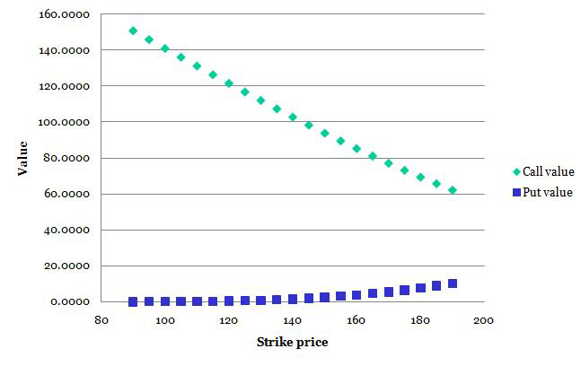
- does your program handle errors, or does it crash on errors of input?
  - Errors in form of data will not process (i.e. notanumber is entered for a stock price)
  - Program will not run if inputs are not numerical
- tests: summarize the basic analysis and testing of this version of your program
  - The program integrates open source coding, basic data processing, and data mining in order to give a series of numbers which can be converted into graphs for further analysis
  - Connecting and automating between the numbers and graphs make it easy.
    - Changing one number only can change everything, no need to manually adjust every single output

- What do you expect to work on next quarter, in relation to the goal of your project for the year?

I don’t think a fifth quarter exists…I hope.

