COMPUTER SYSTEMS RESEARCH
Code Writeup of your program, example report form 2009-2010
- Your name: Tyler Haines , Period: 5
- Date of this version of your program: Second Quarter version (1/22/10)
- Project title: Simulation of Virus Spread in a Modern Environment
- Describe how your program runs as of this version.
Virus:
The virus is made to be really random. For example, I have the method for infection:
public void becomeInfected(double dist)
{
if(dist <= MAX_DISTANCE && dist != 0)
{
infected = Math.random()*Math.pow(dist/MAX_DISTANCE, 2) <= INFECTION_CONSTANT;
}
}
Where MAX_DISTANCE changes randomly every turn using the constants shown in all caps.
MAX_DISTANCE = (Math.random()*DISTANCE_FLUC)+MAX_DISTANCE_BASE;
Pathing:
My pathing currently works, but it needs refining. I am currently using the slope of the wall (assuming it is either vertical or horizontal) and setting the correct acceleration value. (Not shown is the for loop through all the walls)
//Create a temporary line to use in checking
Line2D wallLine = poly.getIntersectsLine(new Line2D.Double(xPos, yPos, forwardPoint.getX(), forwardPoint.getY()));
if(wallLine != null)
{
//Find the wall slope
double wallSlope = (wallLine.getY2()-wallLine.getY1())/(wallLine.getX2()-wallLine.getX1());
//Horizontal wall
if(wallSlope == 0)
if(forwardPoint.getY() < wallLine.getY1())
ay = 0.05;
else if(forwardPoint.getY() > wallLine.getY1())
ay = -0.05;
else
ay = 0;
//Vertical wall
else
if(forwardPoint.getX() < wallLine.getX1())
ax = 0.05;
else if(forwardPoint.getX() > wallLine.getX1())
ax = -0.05;
else
ax = 0;

Here is a screen shot of my current program:
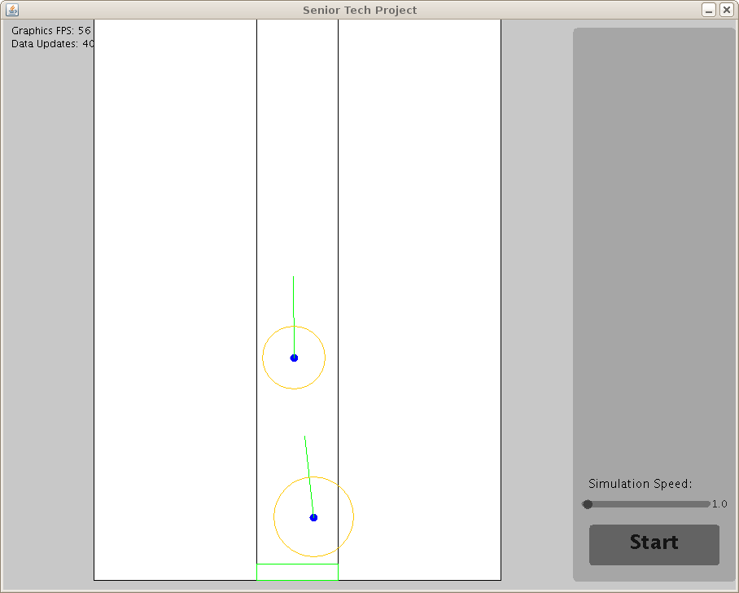
The filled circles in the image are the people in the building and the lighter circles around them are the current MAX_DISTANCE for that they are carrying. The line sticking out the from of them is the probe point for the pathing.
- What do you expect to work on next quarter, in relation to the goal of your project for the year?

I'm expecting to finish the pathing (finally). This pathing has taken a little bit longer than I hoped I'm getting close! After the pathing, I am going to fine tune the virus spreading rates and implement the infection rate viewing. If I have time before fourth quarter, I will look for real virus infection data and try and match its spread rates in my simulation.

