COMPUTER SYSTEMS RESEARCH
Code Writeup of your program, example report form 2009-2010
- Your name: ___Anna Stapleton________, Period: _5___
- Date of this version of your program: __01/25/10____________
- Project title: _ Input and Sharing of Infectious Disease Data at the Grassroots Level____
- Describe how your program runs as of this version. Include
The program enters data into a pair of linked MySQL tables via a Java user interface. This requires a Java-MySQL interface program called JDBC. Through this interface, a user is able to enter data and search the databases from Java.
The database itself is comprised of a pair of tables. The first table contains basic patient information (name, date of birth, gender, etc.) Each patient in the table is automatically assigned an ID number. The second table contains data about the illness being reported at a specific visit (symptoms, date of visit, date symptoms first appeared, etc.) Each of these reports also has an ID number, which matches the ID number of the patient. This makes it possible to track a patient's history because all of their visits are linked to them. It also helps prevent redundant entry of basic patient information, saving doctors time during patient visits. The two tables look like this:
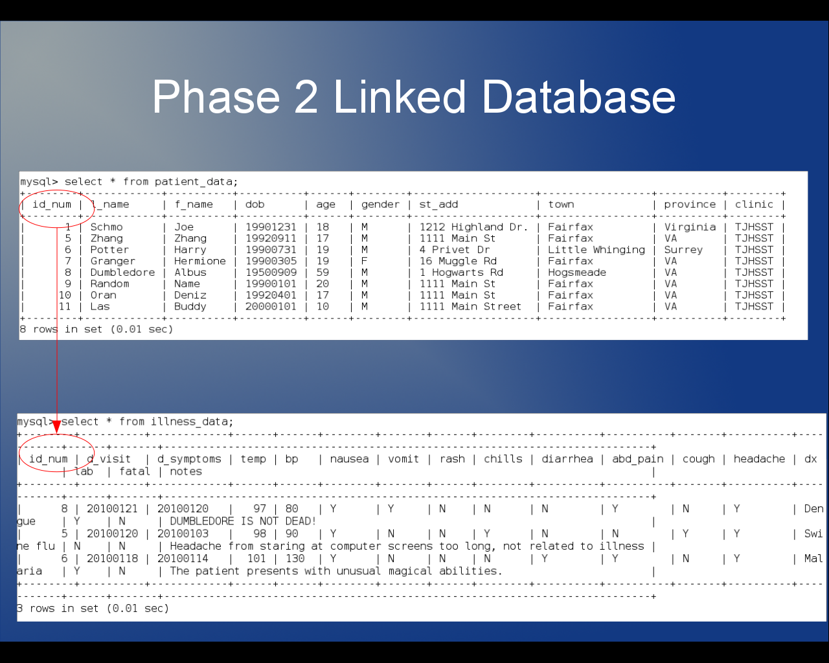

The user interface is set up in multiple steps. The first screen lets the user choose new or returning patient. If it is a new patient, the user is then asked to enter basic patient information (name, date of birth, gender, etc.) Once that information is entered, the user is asked for information relating to the illness. However, if the user selects returning patient, they are only asked to enter the first and last name of the patient, which finds the patient's ID number. They are then asked to enter the illness data.

- What do you expect to work on next quarter, in relation to the goal of your project for the year?

Next quarter I will focus on the networking aspect of my project. I plan to use a NetLogo model to explore the physical limitations of mesh networking via OLPC computers. Since the program is intended to be implemented on OLPC laptops and connected via mesh networking, this model will help to predict some of the limitations and capabilities of such a network.

