COMPUTER SYSTEMS RESEARCH
Code Writeup of your program, example report form 2009-2010
- Your name: Sam Zhang, Period: 5
Date of this version of your program: 1/25/2010
Project title: Dynamic word-sense disambiguation with semantic similarity
Describe how your program runs as of this version. Include
-- files that may be needed
-- algorithms, specific procedures or methods you wrote
-- kinds of input your program uses
-- screenshots, what kinds of output does your program have
-- does your program handle errors, or does it crash on errors of input?
-- tests: summarize the basic analysis and testing of this version of your program

The program currently uses an implementation of the Wu and Palmer heuristic, which is detailed in their paper Verb Semantics and Lexical Selection, utilizing hypernym distance to the "least common hypernym", distance to the root, and distance between words. The full algorithm is thus:
"ConSim(C1, C2) = Nl+N22,N+23 *N3
C3 is the least common superconcept of C1
and C2. N1 is the number of nodes on the path
from C1 to C3. N2 is the number of nodes on the
path from C2 to C3. N3 is the number of nodes
on the path from C3 to root.

The results this gives me is shown in figure 1 below:
The higher the number, the more similar the words are. Notice how the only set that failed the similarity test was "acrobat, clown, and man", with man ranking higher in similarity to the two words than to their intersimilarity. This is due to a lack of a "Circus Performer" entry in WordNet, an issue which will be addressed in the following section (What do you expect to work on next quarter). The Metallica test doesn't count because it wasn't expected to work, as WordNet clearly doesn't include references from popular culture. Again, this will be addressed in the following section. The problem of moon, sun, and earth returning the wrong pairing using a direct hypernym relation is circumvent by the Wu-Palmer algorithm's inclusion of direct word distance.

Figure 1. Results
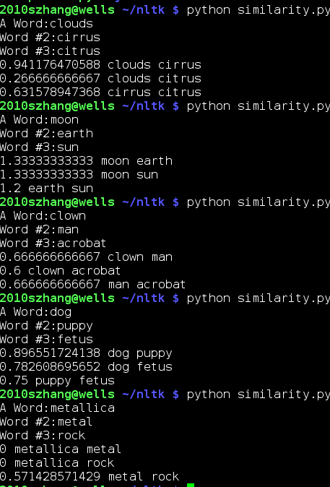

- What do you expect to work on next quarter, in relation to the goal of your project for the year?
I plan to incorporate support for terms in the contemporary semiotic sphere, by providing support for OpenCyc. OpenCyc is an ontology, similar to WordNet, yet it differs because 1.) its backbone is the Web Ontology Language (OWL), a true ontological language, 2.) it includes contemporary cultural terms in its corpora, and 3.) it requires its own programming language. Thus the transition to OWL of this project will 1.) be a complete port of the code, 2.) enable a greater inclusion of cultural terms (e.g. Metallica as per the previous test), and 3.) facilitate the transition toward Semantic Web accessibility, the next step in AI development at large.

