COMPUTER SYSTEMS RESEARCH
Portfolio Update 3rd Quarter 2009-2010
Research Paper, Poster, Slides, Coding, Analysis and Testing of your project's program.
Name: Peter Ballen Period: 5 Date: 4/5/10
Project title or subject: PFCSP
Computer Language: Python, TKinter

Describe the updates you have made to your research portfolio for 3rd quarter.
- Research paper: Paste here new text you've added to your paper for 3rd quarter. Describe and include new images, screenshots, or diagrams you are using for 3rd quarter.
Specify text you've written for any of the following sections of your paper:
- Results
So far, the code has been used for demonstrative purposes - the Voters are
voting on abstract proposals that don't mean anything in the real world.
The following is a real-world example to help lend context and relevance to
the ideas presented above.
Begin by thinking back to September, 2009. The United State's economy
is in bad shape. The stock market has crashed, job creation is nonexistent,
and the unemployment numbers are creeping higher and higher. An economic
think-tank comes up with the following proposal.
In response to the failing economy, we must take drastic action. We
propose that we substantially increase unemployment bene
ts (money given
to unemployed men and women from the government to help them buy food
and search for work). To o
set the cost of these bene
ts, we recommend
raising the national income tax on individuals and families making more
than 50,000 dollars annually.
Wondering how the proposal would be received in Congress, the think-
tank wants to predict public reaction to the plan. First, they gather infor-
mation about the state income tax rate of each state (and the District of
Columbia). Second, they gather information about the unemployment rate
of each state. Using this data, it is possible to gain a rough predictor of how
the Voters of that state would feel about the proposal.
Pennsylvania, for example, has a low income tax rate but a high unem-
ployment rate. They would favor exxtending unemployment bene
ts, but
they don't want to raise taxes to do so. Instead, they would favor de
cit
spending (funding the bene
ts by increasing the national debt). In contrast,
South Carolina has a high tax rate but very low unemployment. They would
be more inclined towards raising the income tax, but spending the increased
revenue in other areas such as education or defense.
Using prioritized fuzzy constraint satisfaction, the think-tank calculated two
numbers. The
rst number, drawn in blue, is the optimal proposal for the
House of Representatives, where each states' representation is determined by
its population. The second number, drawn in red, is the optiaml proposal
for the Senate, where each state has an equal amount of representation.
Both numbers fall in the middle of the high/low tax rate axis, and slightly
above the middle of the high/low unemployment rate axis. From this result, is
becomes clear that both the House and the Senate would support a moderate
tax level. They don't want too much de
cit spending, but they also don't
want to raise the income tax too high. Similarly, it becomes apparent that
most states do favor slightly increasing unemployment bene
ts. The Senate
would prefer a larger bill that dips slightly into the de
cit, with less taxes
and more bene
ts. The House, in contrast, is in favor of a smaller bill funded
only by tax money, at the cost of slightly less benefi
ts.

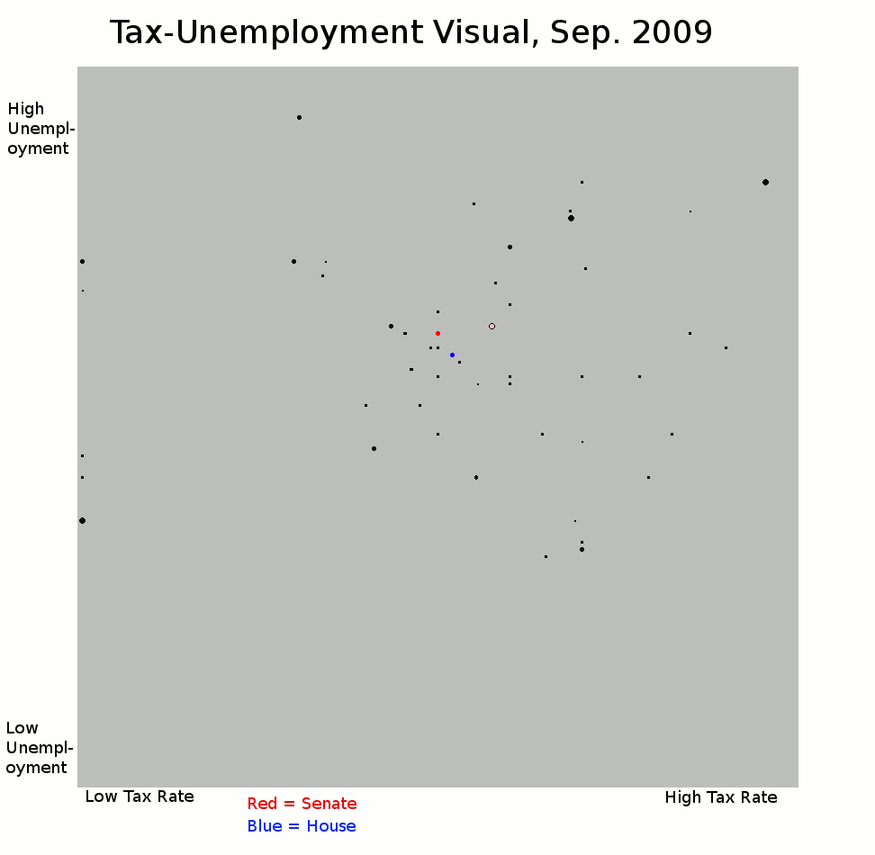
- Additions to your bibliography
[] Loretta Bass, Lynne Casper, Population Division Working Paper No. 28,
U.S. Bureau of the Census, 1999

[] US Tax Foundation, State Individual Income Taxes 2009, 2009

[] Bureau of Labor Statistics, Unemployment Rates for States, 2009

- images, screenshots, or diagrams in your paper --- above

- Poster: Copy in new text you've added to your poster for 3rd quarter.
List the titles you're using for each of your subsections. Include new text you're adding
- Subsection heading: Experiment - Tax vs. Unemployment
A think tank comes up with the following proposal: We should raise the income tax and spend the money to combat unemployment. Some states: those with high tax rates and high unemployment, would favor the plan. Other states: such as those with low tax rates or low unemployment rates, would oppose the plan. By plotting each voter on a 2-D scale as before, we can use prioritized fuzzy constraint satisfaction to calculate the optimal solution.

Looking at the location at the dots, we can determine that both the House and the Senate support raising unemployment benefits. The Senate, the red dot, favors higher benefits with a lower tax increase, suggesting defecit spending. The House, the blue dot, favors less taxes but also less benefits.

Although the states vary widely in ideology, and no state is 100% satisfied, with fuzzy prioritized constant satisfaction we can estimate how society as a whole would respond to the proposal.

- Presentation slides: Provide a brief outline summarizing the main points of your presentation for 3rd quarter
The slides summarize the experiment with income tax and unemployment rate to calculate the optimal amount to raise/lower taxes in order to extend unemployment benefits. For the full summary, look at the experiment portion (the slides essentially summarize the experiment).

- Coding: attach new code that you wrote 3rd quarter. Describe the purpose of this code in terms of your project's goal and research. Also provide clear commentary on the main sections of your code.
//Voters now have tags which can be used to keep track of which voter corresponds to which state.
//The prunesimulation no longer displays anything on the board. That is handled in main.
//Return the optimal solution as two values (optimal x, optimal y). The values are used by main.
def main():
//Initialize all variables and the canvas.
//Begin reading from the text file with data. Each line is split into a separate Voter.
//The lines are then split by tabs. Each line will have a state name (stored as a tag in the Voter), a state priority (the number of electoral votes that Voter should get), a tax rate (which is then scaled to be between 0 and 1) and an unemployment rate (which is also scaled to fall between 0 and 1).
//A Voter is then initialized, given the proper values, and stored in Population.
//That Voter's corresponding priority is stored in Priorities.
//fixPriorities is run after all Voters are read in.
//prunesimulation is run to get the optimal weighted solution.
//The Voters are drawn on the board, and optimal unweighted solution is drawn in blue.
//The priorities are then all set to one and fixPriorities is called, so that each state will now have the same priority.
//prunesimulation is run again, to get the optimal unweighted solution.
//The optimal unweighted solution is drawn on canvas in red.
//The canvas is displayed, canvas.mainloop() is called, and call it a day.

5. Testing, Analysis – specific listings/descriptions of the tests and analysis you've done this
quarter.
  - It's September, 2009, and the US economy is in bad shape. People are getting fired right and left, job creation is essentially nonexistent, and the unemployment numbers are creeping higher and higher. Thankfully, the TJ Economic Advisory Council has a plan, and creates the following proposal.
  - Proposal: In response to the failing economy, we must take drastic action. We propose that we substantially increase unemployment benefits (money given to unemployed men and women from the government to help them buy food and search for work). To offset the cost of these benefits, we recommend raising the national income tax on individuals and families making more than $50,000 annually.
  - Worried about getting Congress' approval, the council wants to predict public reaction to the plan.
  - First, they gather information about the state income tax rates of each state (and DC). They decide that states with higher tax rates (like California or Maine) would be more supportive than states with lower tax rates (like Florida or Nevada).
  - Second, they gather information about the unemployment rate of each state. Again, they decide that states with higher unemployment rates (like Oklahoma or Nebraska) would be more supportive than states with lower unemployment rates (like Iowa or North Carolina.)
  - Using this data, they can predict how an individual state would feel about the proposal. For example:
    - Pennsylvania has an incredibly low tax rate, but an incredibly high unemployment rate. They favor extending benefits, but don't want to raise taxes to do so. Instead, they want deficit spending.
    - South Carolina has a high tax rate, but very low unemployment. They have no problem raising the national income tax, but they don't want to spend the money on unemployment benefits. Instead, they want to spend it on health care.
    - This provides a good demonstration. Both Pennsylvania and South Carolina don't like the proposal, but for two very different reasons.
  - Using the data and my PFCSP program, the advisors plot each state on a graph. They then calculate two different numbers.
  - [See Attached Image]
  - Using this data, the analysts compare two numbers. The first number, drawn in blue, is the proposal the house (where states get proportional representation) would favor. The second number, drawn in red, is how the proposal the senate (where each state gets the same number of votes) would favor. Both numbers fall in the middle of the high/low tax rate, and slightly above the middle of the high/low unemployment rate.
  - The pink dot slightly to the right of the optimal solutions represents VA, just to see how we would turn out in this scenario.
  - From this data, is becomes clear that both the House and the Senate prefer a moderate tax level. They don't want a deficit spending spree, but they don't want to raise the income tax too high. Similarly, it becomes apparent that most states do favor slightly increasing unemployment benefits.
  - The Senate would prefer a bill that dips slightly into the deficit, with less taxes and more benefits. The House in contrast is in favor of funding the bill only with tax money, at the cost of slightly less benefits.
- Running your project – describe what your project's program actually does in it's current stage. Include current analysis and testing you're doing. Specifically what have you done this quarter.

I gave one example of how the code could work in the testing/analysis section above. The data could easily come from any source: tax data, unemployment rate, depression rate, education rate, annual mean income,
take your pick. The voters could also have any type of priority: they could be ranked by representation in the senate, ranked by population, ranked by pollution rates, or some other random ranking. In every case, the underlying idea is the same: given a set of data, find the optimal solution that makes the most people happy.

- What is your focus for wrapping up your project for 4th quarter?

I want to make a mention that you don't necessarily need to use distance as the evaluation function, more complicated scenarios would probably have more complicated functions. I'd also make a mention that the code is easily expandable into higher dimensions, but it's not as pretty (hard to draw a ten dimensional image).

