COMPUTER SYSTEMS RESEARCH
Project Experiment 1 for 3rd quarter 2009-2010
- Your name: ____Joe Fetsch_______, Period: __5_
- Project title: ___Smallpox Bio-terrorism scenario modeling in Python__
- Language and/or software you are using: Python

- 3rd quarter experiment 1 for your program. - What are you doing now that you will write about in your research paper. For example, what images are you using, what tests you are analyzing, what results you are finding and concluding...
  - Problem definition for this quarter - think about the focus of what you are analyzing/testing. Be specific as to your experiment parameters, ranges of input data, ranges of output, and the kinds of scenarios or modeling that can be tested/graphed/analyzed with your program, and how you validate ranges of success (or non-success).

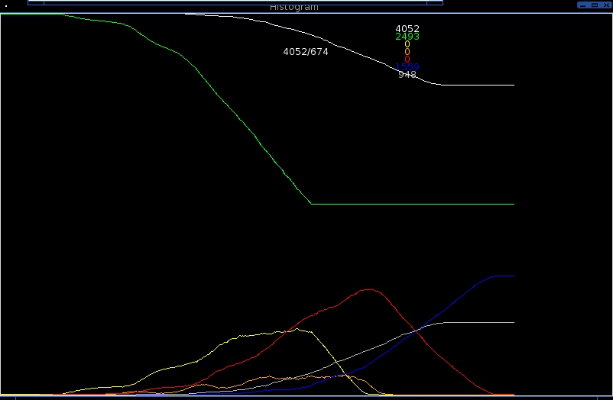
In the graph above, the population of the city has gone from 5000, the initial value, to 4052; a fatality rate of 20%. However, the population in this situation has been quarantined after two months of the simulation, while the rate of infection was still increasing, which would lead to many more cases of smallpox and many more fatalities. Throughout the simulation, about half of the agents became infected, which raises the relative fatality rate to slightly less than 40%.
After the quarantine was implemented, the number of healthy people levels off at 2495, as can be seen in the graph, while, at the same time, the number of carriers no longer increases after that time, immediately after the number of infected people becomes greater than the number of carriers in the simulated world. From the graph, it is possible to notice the increases in the number of carriers, infected agents, and immune agents as they progress, defining the generation of infection. After the last generation becomes infected, defined by the time of quarantine, all of the values drop off after the generation progresses to the next stage of disease.

The implementation of quarantine to my project will be included in the last few pages of my paper eventually, along with vaccine, which is what I will develop during the 4th quarter. They are used to provide more realistic statistics for the simulation if a vaccine is developed or a quarantine is implemented early, both of which cannot be predicted by any means, as neither has been done yet in the United States.

Success will be judged on the more focused data for the end situation as opposed to something with more spread such as in this chart:

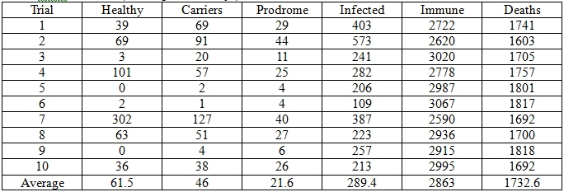

experiment 7 is a great outlier in this case, with luck, cases such as this will not exist after implementing quarantine and vaccine.

