COMPUTER SYSTEMS RESEARCH
Portfolio Update 3rd Quarter 2009-2010
Research Paper, Poster, Slides, Coding, Analysis and Testing of your project's program.
Name: ______Joe Fetsch_______, Period: ___5_, Date: ___3rd quarter________
Project title or subject: ____Smallpox Bioterrorism Scenario Computer Modeling in Python_____
Computer Language: _____Python__

Note: Now for full credit on all assignments you must provide specific plans and work using a degree of sophistication of algorithms and data structures at or beyond the level of APCS, AI 1/2, Parallel 1/2. Using shell programs or code available on the Web or in a book is not sufficient for full credit. You must provide actual development of your own code and research, analysis and testing of this code of your own. Be sure to list specific data structures, algorithms and coding you are doing at a sufficient level of sophistication for full credit. Also for full credit, you cannot merely repeat the same algorithms/data structures week after week – your program and your learning need to be evolving at a sophisticated level.

Describe the updates you have made to your research portfolio for 3rd quarter.
- Research paper: Paste here new text you've added to your paper for 3rd quarter. Describe and include new images, screenshots, or diagrams you are using for 3rd quarter.
Specify text you've written for any of the following sections of your paper:

Everything in the paper should be either new or modified from the 2nd quarter version. Please see paper itself for details

- Poster: Copy in new text you've added to your poster for 3rd quarter.
List the titles you're using for each of your subsections. Include new text you're adding
  - Subsection heading: ____Results and Conclusions______
This project provides an understanding of the fatalities and infection rates of such a population in a major city in a scenario as described in the abstract. The chance of this type of scenario being a possibility ranges from predictions of 60% to 80%, and fatalities are estimated to be about 35-40% of the population in the city if left unchecked, as infection rates are estimated to be about 80% of the population of the city targeted after 4 months without control of the population, and the quarantine method implemented can be used to simulate the fatality and infection rates of a city which is quarantined at a certain time.
In the graph above, the population of the city has gone from 5000, the initial value, to 4052; a fatality rate of 20%. However, the population in this situation has been quarantined after two months of the simulation, while the rate of infection was still increasing, which would lead to many more cases of smallpox and many more fatalities. Throughout the simulation, about half of the agents became infected, which raises the relative fatality rate to slightly less than 40%.
After the quarantine was implemented, the number of healthy people levels off at 2495, as can be seen in the graph, while, at the same time, the number of carriers no longer increases after that time, immediately after the number of infected people becomes greater than the number of carriers in the simulated world. From the graph, it is possible to notice the increases in the number of carriers, infected agents, and immune agents as they progress, defining the generation of infection. After the last generation becomes infected, defined by the time of quarantine, all of the values drop off after the generation progresses to the next stage of disease.

  - Subsection heading: __Discussion___ and text:
Python will be used in the final project in which a simulation of the scenario described in the Abstract will be run. Methods to begin a full military quarantine on the city in which the initial infection takes place, where all agents can no longer travel, reducing the risk of infection of other agents nearby to zero.

    - Subsection heading: ____Picture____ and text:
Figure 3: the above graph shows the average results of a run in which no control is taken over the population.

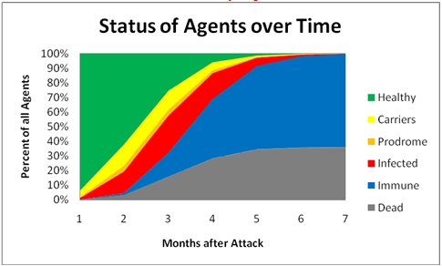
- Presentation slides: Provide a brief outline summarizing the main points of your presentation for 3rd quarter
Scenario – same as project goal for the entire year
Smallpox – a brief overview used to define the importance of the work being done
Agent structure – a definition of the agent to provide a better understanding of the mechanics of the simulation itself
World structure – a definition of the world the agents exist in and a clarification of the type of visual model used
Quarantine – time spent here to detail work done during the 3rd quarter.
Description of why the quarantine is important and why it cannot be predicted
Overview of results

- Coding: attach new code that you wrote 3rd quarter. Describe the purpose of this code in terms of your project's goal and research. Also provide clear commentary on the main sections of your code.

def quarantine():
global qcondition, time,qtime,idarray
if not qcondition:
print 'Quarantine measures in effect at time =',int(time/6),'days after attack'
qtime=time
qcondition=True

idarray=[] # this keeps track of the buttons (1,3 are vaccine, 2,4 are not)

def click(evnt):
global agents
v=evnt.x
w=evnt.y
v=v/dx
w=w/dy
if v<len(agents) and w<len(agents):
if isinstance(agents[v][w],Agent):
if agents[v][w].coords==(v,w):
agents[v][w].printself()
else:
print 'no agent at location',v,w
elif w>len(agents)+2:
if v>x/5 and v<2*x/5:
vaccine()
canvas.itemconfigure(idarray[0],state=DISABLED)
canvas.itemconfigure(idarray[0],fill='black')
#canvas.itemconfigure(idarray[2],state=DISABLED)
elif v>3*x/5 and v<4*x/5:
quarantine()
canvas.itemconfigure(idarray[1],state=DISABLED)
canvas.itemconfigure(idarray[1],fill='black')
#canvas.itemconfigure(idarray[3],state=DISABLED)

def quit(evnt):
print 'agents \thealthy \tcarriers \tinfected \timmune \tdead'
print numofagents,'\t','\t',numofhealthies,'\t','\t',numofcarriers,'\t','\t',numofinfected,'\t','\t',numofimmune,'\t','\t',numdead
exit(0)

idarray.append(canvas.create_rectangle(1*x/5*dx,h+3,2*x/5*dx,h+3+50, fill = 'dark green', disabledfill= 'black'))
idarray.append(canvas.create_rectangle(3*x/5*dx,h+3,4*x/5*dx,h+3+50, fill = 'dark red', disabledfill= 'black'))
idarray.append(canvas.create_text(3*x/1webapps/portal/frameset.jsp0*dx,h+3+20,fill = 'white',text='Vaccine',disabledfill='gray'))
idarray.append(canvas.create_text(7*x/10*dx,h+3+20,fill = 'white',text='Quarantine',disabledfill='gray'))

if time<800:
if vcondition:
canvas2.create_line(vtime,0,vtime,agentnum,fill='green')
if qcondition:
canvas2.create_line(qtime,0,qtime,agentnum,fill='red')
else:
if vcondition:
canvas2.create_line(800-time+vtime,0,800-time+vtime,agentnum,fill='green')
if qcondition:
canvas2.create_line(800-time+qtime,0,800-time+qtime,agentnum,fill='red')

Quarantine method: research was done to determine if a certain time of quarantine is more likely, though, because of the lack of data available and the simple fact that this has never happened in the United States or in a large city, there is absolutely no precedent to determine when a quarantine would begin. Therefore, the time at which a quarantine begins corresponds to whenever the user presses the button on the social representation. This ends all movement, isolating the agents from each other. Infection rates drop to zero for all agents in all situations, as each agent is now under strict quarantine.
In the graph representation of agents over time, a red line appears and can now scroll along with the rest of the graph.
Now, upon exit of the program, the statistics at that time are displayed, ending much confusion about the situation when a mistaken exit is made.
5. Testing, Analysis – specific listings/descriptions of the tests and analysis you've done this
quarter.

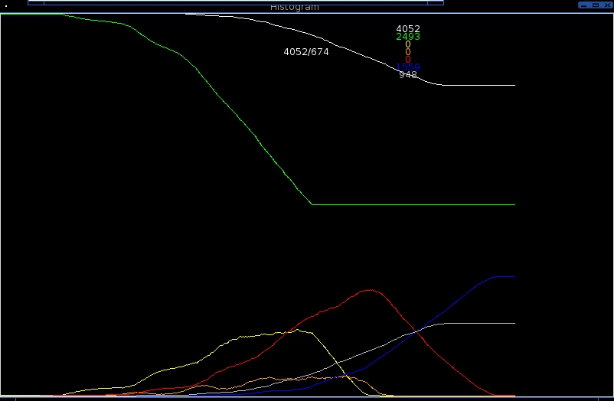
In the graph above, the population of the city has gone from 5000, the initial value, to 4052; a fatality rate of 20%. However, the population in this situation has been quarantined after two months of the simulation, while the rate of infection was still increasing, which would lead to many more cases of smallpox and many more fatalities. Throughout the simulation, about half of the agents became infected, which raises the relative fatality rate to slightly less than 40%.
After the quarantine was implemented, the number of healthy people levels off at 2495, as can be seen in the graph, while, at the same time, the number of carriers no longer increases after that time, immediately after the number of infected people becomes greater than the number of carriers in the simulated world. From the graph, it is possible to notice the increases in the number of carriers, infected agents, and immune agents as they progress, defining the generation of infection. After the last generation becomes infected, defined by the time of quarantine, all of the values drop off after the generation progresses to the next stage of disease.

6. Running your project – describe what your project's program actually does in it's current stage.
Include current analysis and testing you're doing. Specifically what have you done this quarter.

See above, also:

The implementation of quarantine to my project will be included in the last few pages of my paper eventually, along with vaccine, which is what I will develop during the 4th quarter. They are used to provide more realistic statistics for the simulation if a vaccine is developed or a quarantine is implemented early, both of which cannot be predicted by any means, as neither has been done yet in the United States.

Success will be judged on the more focused data for the end situation as opposed to something with more spread such as in this chart:

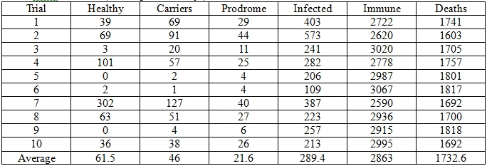

experiment 7 is a great outlier in this case, with luck, cases such as this will not exist after implementing quarantine and vaccine.

7. What is your focus for 4th quarter for your program and project?

Vaccine, the same way I implemented quarantine with different results and research on side effects of the vaccine and how it effects the population with regards to the simulation.

