COMPUTER SYSTEMS RESEARCH
Code Writeup of your program, example report form 2009-2010
Name: Tyler Haines , Period: 5 , Date: 4/7/10
Project title or subject: Simulating the Spread of a Virus in a Modern Building Environment
Computer Language: Java
- Describe how your program runs as of this version. Include
-- does your program handle errors, or does it crash on errors of input?
I always try and make my programs as mod-able as possible, meaning I try and make them really easy for other people other than me to add new content. This means I have to make it resist any errors that people may make. Using the try-catch block a lot, I can
-- screenshots, what kinds of output does your program have
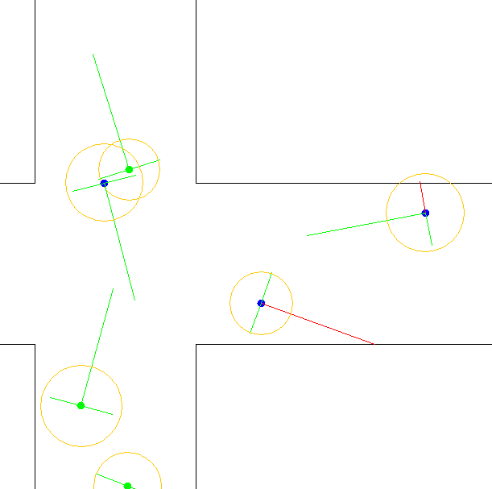
Presentation slides: Provide a brief outline summarizing the main points of your presentation for 3rd quarter

I added more screenshots of the simulation and example layouts. I also added more results, such as what I have found so far with my testing.

-- algorithms, specific procedures or methods you wrote

public void update()
{
...

double angle = Math.atan2(movement.getY(), movement.getX());
// Update probe point 1 (point ahead)
double forwardLength = 150;
forwardPoint.setLocation(xPos+(Math.cos(angle)*forwardLength), yPos+(Math.sin(angle)*forwardLength));
double sideLength = 40;
// Update probe point 2 (side)
double angle2 = angle+HALFPI;
sidePoint1.setLocation(xPos+(Math.cos(angle2)*sideLength), yPos+(Math.sin(angle2)*sideLength));
// Update probe point 2 (side)
double angle3 = angle-HALFPI;
sidePoint2.setLocation(xPos+(Math.cos(angle3)*sideLength), yPos+(Math.sin(angle3)*sideLength));

movement.setX(Math.cos(angle)*maxSpeed);
movement.setY(Math.sin(angle)*maxSpeed);

...
}

// Check for collisions of the probe points with the wall
public void checkCollisions(Map.Polygon[] polys)
{
forwardProbeIntersects = false;
side1ProbeIntersects = false;
side2ProbeIntersects = false;
for(Map.Polygon poly : polys)
{
// If the probe point is inside the wall
Line2D wallLine = poly.getIntersectsLine(new Line2D.Double(xPos, yPos, forwardPoint.getX(), forwardPoint.getY()));
if(wallLine != null)
{
forwardProbeIntersects = true;
double wallSlope = (wallLine.getY2()-wallLine.getY1())/(wallLine.getX2()-wallLine.getX1());
// Depending on how the wall is oriented in relation to the unit, it will accelerate away from the wall
if(wallSlope == 0)
{
if(forwardPoint.getY() < wallLine.getY1())
{
movement.add(new Vector(0, 0.05));
}
else if(forwardPoint.getY() > wallLine.getY1())
{
movement.add(new Vector(0, -0.05));
}
}
else
{
if(forwardPoint.getX() < wallLine.getX1())
{
movement.add(new Vector(0.05, 0));
}
else if(forwardPoint.getX() > wallLine.getX1())
{
movement.add(new Vector(-0.05, 0));
}
}
}

// Repeat the code for all the probe points
...

}
}

-- tests: summarize the basic analysis and testing of this version of your program
I have been testing the pathing system as I have worked on it. More recently, I have started testing the virus spread and different building layouts. The virus spreads from person to person, and I have noticed that it spreads at a faster rate when in a thinner and smaller hallway than compared to a larger hallway.

- What do you expect to work on next quarter, in relation to the goal of your project for the year?

- Continue testing and creating new building layouts to test with
- Create a much better display for the virus
- If I have time, tweak the pathing

