COMPUTER SYSTEMS RESEARCH
Portfolio Update 3rd Quarter 2009-2010
Research Paper, Poster, Slides, Coding, Analysis and Testing of your project's program.
Name: Tyler Haines , Period: 5 , Date: 4/7/10
Project title or subject: Simulating the Spread of a Virus in a Modern Building Environment
Computer Language: Java
Describe the updates you have made to your research portfolio for 3rd quarter.
- Research paper: Paste here new text you've added to your paper for 3rd quarter. Describe and include new images, screenshots, or diagrams you are using for 3rd quarter.
Specify text you've written for any of the following sections of your paper:
- Abstract
“This project explores the development and use of a real-time simulation to simulate the spread of a virus through the hallways and confined walking areas in a modern building environment, such as schools and other enclosed public places. In addition, the project explores the use and creation of various pathing algorithms used in real-time simulations.”
I rewrote the abstract to better sum up the project.
- Introduction or Background
“New and modern buildings today are generally designed to be large and open. The hallways are wide and tall, creating vast open spaces for people to walk in, as in Figure 1. Larger hallways are generally more appealing and easier to walk though, but they also serve an even greater purpose of reducing the spread of airborne diseases. In addition, larger hallways can reduce the spread of diseases spread by physical touch due to a decrease in the general density of people in the hallway or building space. The impact of having a larger hallway on the spread of a virus, compared to a narrower hallway of a older building, can be simulated by computers. The focus of this project is to develop is to develop software to simulate the spread of a virus in the hallways of a building.”
I rewrote the introduction. I feel it better introduces the project than the first introduction. I talk about the basic real-life reasons for doing a project of simulating a virus in a building.
- Development section(s) – the work you've actually done
“The simulation portion of the project is to create a real-time simulation of virtual people walking through a given building layout from location A to location B. Throughout his, her, or its journey, they may come across another person randomly infected with a virus. This virus then has the ability to spread to spread to the healthy person, depending partly on chance and partly on how the virus spreads. The simulation can keep track of where a new infection takes place and display these infections to see where the most infections took place.
The environments the virtual people walk through are very adjustable and customizable; almost any building can be created. One example map is shown in Figure 2.”
I rewrote the explanation of the simulation and the physical software part.
- Results – if you're reaching any preliminary conclusions
“So far, the simulation has shown some correlation between hallway width and the rate of infections when using an airborne-only virus. Hallways with smaller widths seem to increase the rate of infection, while hallways with larger widths generally decrease the rate of infection between people.”
- Additions to your bibliography
New additions were mainly for support for background information and for images.
@Online{swineflu,
author = {Center for Disease Control and Prevention},
title = {2009 H1N1 Flu ("Swine Flu") and You},
year = {2010},
url = {http://www.cdc.gov/h1n1flu/qa.htm}
}
@misc{hallway,
url = {http://csc.web.cern.ch/CSC/2006/images/Helsinki/Physics-building-Inside.jpg
}
@Online{opensteer,
title = {Open Steer},
url = {http://opensteer.sourceforge.net/},
howpublished = {MIT License}
}
@Article{schoolspread,
author = {S. Josephine Baker, M.D.},
title ={The Control of Communicable Diseases In Schools},
url = {http://ajph.aphapublications.org/cgi/reprint/6/10/1078.pdf}
}
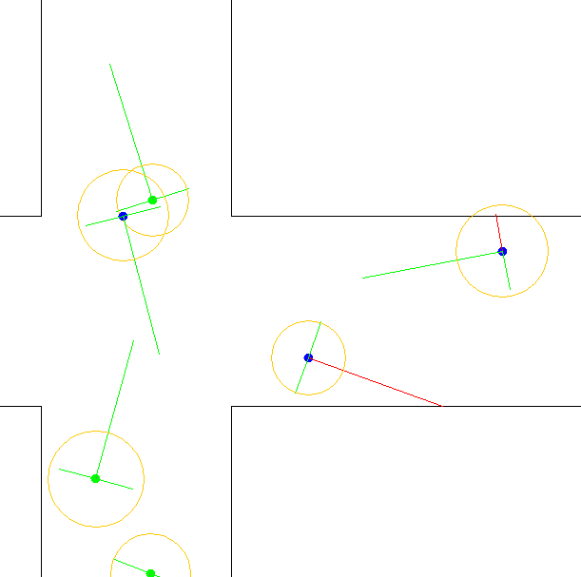
- images, screenshots, or diagrams in your paper
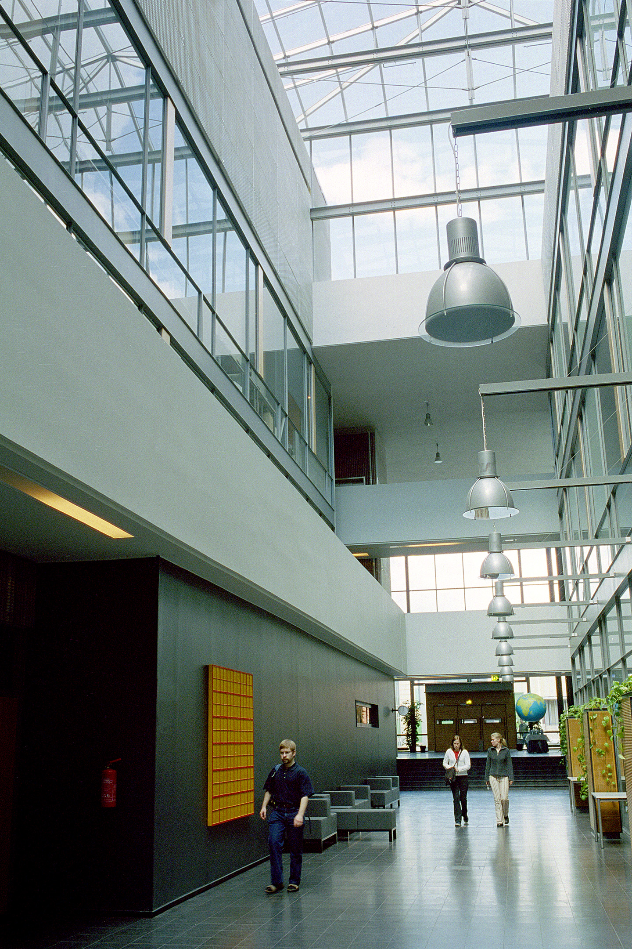
The image of the hallway is used as an example to show a large and wide hallway that reduces the spread of a virus. The screenshot is an example of the units avoiding the walls.

- Poster: Copy in new text you've added to your poster for 3rd quarter.
List the titles you're using for each of your subsections. Include new text you're adding
- Subsection heading: Abstract and text:
This project explores the development and use of a real-time simulation to simulate the spread of a virus through the hallways and confined walking areas in a modern building environment, such as schools and other enclosed public places. In addition, the project explores the use and creation of various pathing algorithms used in real-time simulations.
- Subsection heading: Background and Introduction and text:
The Virus
The virus type used in this simulation is a basic airborne virus with an infection chance from a person to another person dependent on the distance from the infected person to the non-infected person. There is, however, a randomness to the infection of another person. Many aspects of the virus spread are controllable by the user of the simulation software, including variables such as maximum distance for infection, infection rate, and others.
- Subsection heading: Results and Conclusion and text:
The results from this project show that there is indeed a correlation between hallway size and the rate of infection between people. The simulation itself is somewhat accurate at real human movement through hallways, but there are areas that could use some improvement, such as better wall avoidance, a better system to avoid other people, and a straighter movement down a straight hallway.
- images, screenshots, or diagrams in your poster.
- Presentation slides: Provide a brief outline summarizing the main points of your presentation for 3rd quarter

I added more screenshots of the simulation and example layouts. I also added more results, such as what I have found so far with my testing.

- Coding: attach new code that you wrote 3rd quarter. Describe the purpose of this code in terms of your project's goal and research. Also provide clear commentary on the main sections of your code.

public void update()
{
...

double angle = Math.atan2(movement.getY(), movement.getX());
// Update probe point 1 (point ahead)
double forwardLength = 150;
forwardPoint.setLocation(xPos+(Math.cos(angle)*forwardLength), yPos+(Math.sin(angle)*forwardLength));
double sideLength = 40;
// Update probe point 2 (side)
double angle2 = angle+HALFPI;
sidePoint1.setLocation(xPos+(Math.cos(angle2)*sideLength), yPos+(Math.sin(angle2)*sideLength));
// Update probe point 2 (side)
double angle3 = angle-HALFPI;
sidePoint2.setLocation(xPos+(Math.cos(angle3)*sideLength), yPos+(Math.sin(angle3)*sideLength));

movement.setX(Math.cos(angle)*maxSpeed);
movement.setY(Math.sin(angle)*maxSpeed);

...
}

// Check for collisions of the probe points with the wall
public void checkCollisions(Map.Polygon[] polys)
{
forwardProbeIntersects = false;
side1ProbeIntersects = false;
side2ProbeIntersects = false;
for(Map.Polygon poly : polys)
{
// If the probe point is inside the wall
Line2D wallLine = poly.getIntersectsLine(new Line2D.Double(xPos, yPos, forwardPoint.getX(), forwardPoint.getY()));
if(wallLine != null)
{
forwardProbeIntersects = true;
double wallSlope = (wallLine.getY2()-wallLine.getY1())/(wallLine.getX2()-wallLine.getX1());
// Depending on how the wall is oriented in relation to the unit, it will accelerate away from the wall
if(wallSlope == 0)
{
if(forwardPoint.getY() < wallLine.getY1())
{
movement.add(new Vector(0, 0.05));
}
else if(forwardPoint.getY() > wallLine.getY1())
{
movement.add(new Vector(0, -0.05));
}
}
else
{
if(forwardPoint.getX() < wallLine.getX1())
{
movement.add(new Vector(0.05, 0));
}
else if(forwardPoint.getX() > wallLine.getX1())
{
movement.add(new Vector(-0.05, 0));
}
}
}

// Repeat the code for all the probe points
...

}
}

- Testing, Analysis – specific descriptions of the tests and analysis you've done this quarter.

I have been testing the pathing system as I have worked on it. More recently, I have started testing the virus spread and different building layouts. The virus spreads from person to person, and I have noticed that it spreads at a faster rate when in a thinner and smaller hallway than compared to a larger hallway.

- Running your project – describe what your project's program actually does in it's current stage. Include current analysis and testing you're doing. Specifically what have you done this quarter.

The people walk through the building from entrance to exit, with a randomly spawned virus appearing in the people. The virus will spread through the people as they avoid the walls to get to their location. I have been working on the larger part of the project; getting the people to avoid the walls.

- What is your focus for wrapping up your project for 4th quarter?
- Continue testing and creating new building layouts to test with
- Create a much better display for the virus
- If I have time, tweak the pathing

