COMPUTER SYSTEMS RESEARCH
Project Experiment 1 for 3rd quarter 2009-2010
- Your name: Deniz Oran, Period: 5
- Project title: Steganography and its Steganalysis
- Language and/or software you are using:

- 3rd quarter experiment 1 for your program. - What are you doing now that you will write about in your research paper. For example, what images are you using, what tests you are analyzing, what results you are finding and concluding...
  - Problem definition for this quarter – The main problem was deciphering the efficiency of the encoding algorithm and, if applicable, identify any aspects that need to be optimized.

I concluded experimenting with variations in text length and produced the following graph with time taken in milliseconds on the y-axis and the message length in characters on the x-axis. I simply set a variable t equal to getSystemTime, displayed both after the encoding was finished, and subtracted them to compute the total time taken. The fairly large r squared value indicates that there is a strong correlation between the two variables.

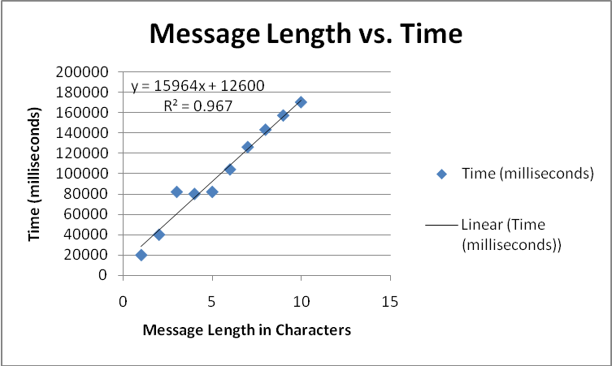

I then tested the efficacy of the encoding algorithm by varying the image size and determining its effect on the run time of the encoding algorithm.
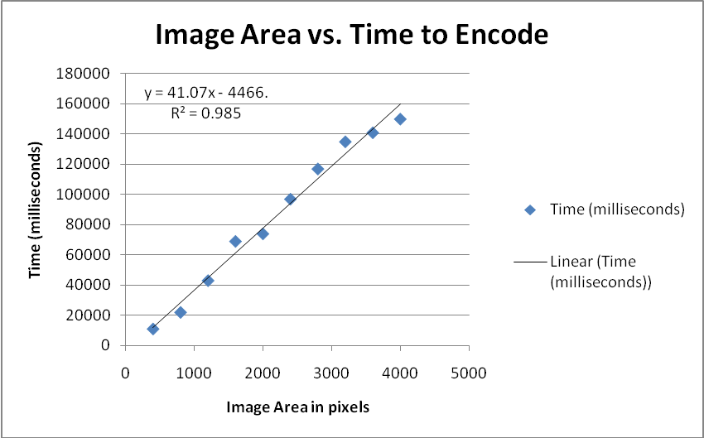

It’s intriguing that both are linearly related, thus indicating an overall big O of O(n), but that the slopes are different. The message length seems to have a larger effect on how fast the program processes the information because simply inputting a large image doesn’t take as long as traversing it and inputting the hidden message.

Since the decoding method was finished this quarter, there will be further testing on its efficiency next quarter alongside the efficacy of the program on other image formats.

