COMPUTER SYSTEMS RESEARCH
Portfolio Update 3rd Quarter 2009-2010
Research Paper, Poster, Slides, Coding, Analysis and Testing of your project's program.
Name: Deniz Oran, Period: 5, Date: April 7, 2010
Project title or subject: Implementation of Steganography and its Steganalysis
Computer Language: JAVA

Describe the updates you have made to your research portfolio for 3rd quarter.
- Research paper: Paste here new text you've added to your paper for 3rd quarter. Describe and include new images, screenshots, or diagrams you are using for 3rd quarter.
Specify text you've written for any of the following sections of your paper:
- Abstract-Rewrote to better exemplify the project
Although steganography is an ancient form of unobtrusive and covert communications, its implementation has become significantly more efficient due to the advent of image storage technology and the associated amounts of space available to encode a text message. An implementation of Least Significant Bit (LSB) steganographical techniques covertly encodes any text communication into a .PNG image file without causing the image to appear different than the uncompromised image to the naked human eye. The JAVA programming language is utilized to exploit the inherent "noise" or data that does not significantly contribute to the image. The program also features the LSB’s steganalysis or the decoding of an image encoded using the program. The text decoded was found to be identical to the text originally entered by the user encoding the communication. The features of the program have then been integrated into a Graphical User Interface (GUI) for ease of use and aesthetic appeal.

- Development section(s) – the work you've actually done
The JAVA programming language will be used because of its secure and stable structure along with its popularity. The most effective and most common way of covertly encoding a message or image is by hiding it in unused portions of commonly used lossless image formats such as .GIF or .PNG. To do this, a technique called LSB encoding is employed to edit numerous picayune parts of the image and placing parts of binary code that can be compiled by the reader to form a text message. The program therefore reads the entire binary composition of the image into a cubic data structure or three-dimensional array storing the pixel row, column, and color value by using the Writable Raster and DataBufferByte classes built into JAVA. The least significant bits are then found and replaced by the desired 1 or 0 by shifting the values of the byte and inserting the digit and deleting the previous one. The length of the message is then encoded before the message within the first few bytes of the image. The new image binary is then compiled together into a new matrix that can be saved in the host directory.
The second portion of the project is detecting the steganography and extracting the hidden message. Clearly the first test would simply be visually ensuring that the original image and the carrier appear identical. The second, and more sophisticated method, is through attempting to reverse engineer the encoding method. According to the previous research, there is no way to extract a message from an image without having an idea about how it’s encoded. This method is usually guessed by commercial software because of the prevalence of LSB encoding. To deter this, though, techniques such as inserting the information not at the beginning can be implemented. A commercial steganalysis program will be incapable of detecting this particular version of the encoding because the image wasn’t generated by that program. Regardless, if the image is suspected, the uncompromised carrier will be required to compare the images bit by bit and having both the original image and the altered image is highly unlikely.
The decoding method used essentially reversed what was done to encode the text. First the suspect image is inputted and converted to binary. The first 32 bytes are analyzed to look for the amount of characters in the message. That value is then used to loop over the appropriate remainder of the image, shifting the indices of each byte left and using the AND binary operator to eliminate all bits besides the least significant one. Those bits are then collected together and converted to the hidden ASCII message. If the algorithms used can’t be detected by commercial software, it will ensure the validity of the program and will demonstrate how viable the program can be if implemented in a real-world situation or within the intelligence community.

- Results – if you're reaching any preliminary conclusions
A comprehensive GUI that enables the user to encode text messages or images into a carrier image. The program will also enable a user to upload a suspected compromised image to be tested for its legitimacy. Because LSB steganography is the method of choice for professional software, it is also the easiest to detect because most software is made to be able to detect its own products. As a result, further work with mixing cryptography and steganography will have to be done to improve the program's resiliency. The advantage of using LSB encoding is its high storage capacity. A file must have eight bytes for each encoded character, which is relatively low compared to other alternatives. The initial research consisted of learning the binary structure of the various image formats and how to manipulate binary code. In addition, pixel structures and their manipulation was also researched in order to hide communications in their unused space. There are also numerous available steganography techniques, but few can encode as much information as LSB encoding. Some techniques involve digital watermarks, random insertion of fake messages, and password protection.

- Poster: Copy in new text you've added to your poster for 3rd quarter.
I included an explanation of the decoding method and that it currently works and deleted some of the extraneous background information.
- Presentation slides: Provide a brief outline summarizing the main points of your presentation for 3rd quarter

- Detecting a message encoded using steganography is only feasible if the original image is available or if the exact encoding method is known.
- The program will still be able to detect if an image has been compromised by converting the suspected image into hexadecimal but the message may not be extracted.
- This method won’t work if a proper LSB is done, since the encoding starts after the data for the hex tags, thus not altering them.
- Just attempt to reverse the process of Least Significant Bit encoding. This method is always tried by commercial software but hardly works if the LSB is done differently.
- The suspected image is inputted, converted to binary, the length of the message was hidden in the first 32 bytes, that length is the parameter for the for-loop which traverses the rest of the image extracting the least significant bits in the same manner they were isolated when they were inserted
- The output is the original ASCII message inputted by the first user

- Coding: attach new code that you wrote 3rd quarter. Describe the purpose of this code in terms of your project's goal and research. Also provide clear commentary on the main sections of your code.
- private byte[] decode_text(byte[] image)
{
int length = 0;
int offset = 32;
//loops through 32 bytes of data to get text length
for(int i=0; i<32; i++) {
length = (length << 1) | (image[i] & 1); //this shifts the length bits left by one index, then does the binary OR operation with the entire byte, and then the AND operator 1 eliminates all of the bits except for the least significant bit (32 combined together make four bytes which indicate the message length)
}
- byte[] result = new byte[length];
//loop through each byte of text
for(int b=0; b<result.length; ++b )
{
//loop through each bit within a byte of text
for(int i=0; i<8; ++i, ++offset)
{
//assign bit: [(new byte value) << 1] OR [(text byte) AND 1]
result[b] = (byte)((result[b] << 1) | (image[offset] & 1));
}
}
return result;

5. Testing, Analysis – specific listings/descriptions of the tests and analysis you've done this
quarter.
  - The main problem was deciphering the efficiency of the encoding algorithm and, if applicable, identify any aspects that need to be optimized.

I concluded experimenting with variations in text length and produced the following graph with time taken in milliseconds on the y-axis and the message length in characters on the x-axis. I simply set a variable t equal to getSystemTime, displayed both after the encoding was finished, and subtracted them to compute the total time taken. The fairly large r squared value indicates that there is a strong correlation between the two variables.

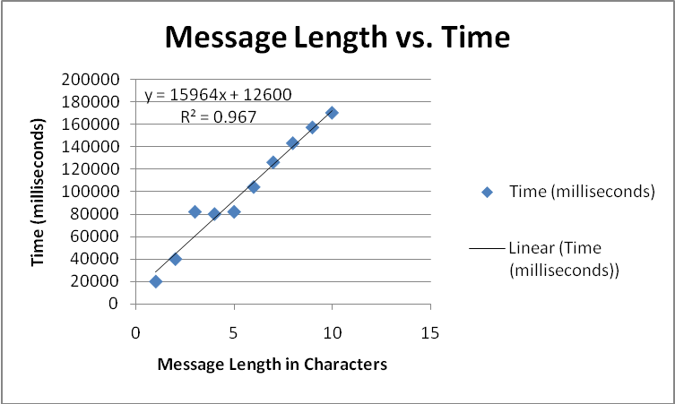

I then tested the efficacy of the encoding algorithm by varying the image size and determining its effect on the run time of the encoding algorithm.
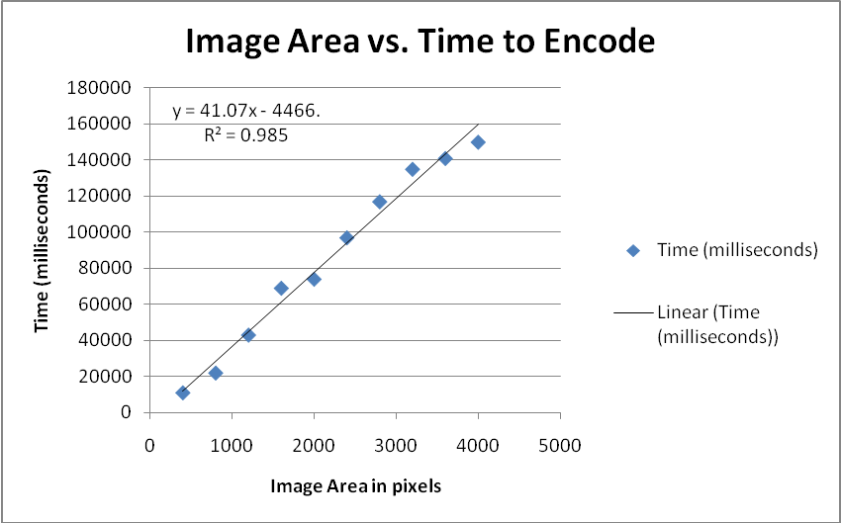

It’s intriguing that both are linearly related, thus indicating an overall big O of O(n), but that the slopes are different. The message length seems to have a larger effect on how fast the program processes the information because simply inputting a large image doesn’t take as long as traversing it and inputting the hidden message.

Since the decoding method was finished this quarter, there will be further testing on its efficiency next quarter alongside the efficacy of the program on other image formats.

- Running your project – describe what your project's program actually does in it's current stage. Include current analysis and testing you're doing. Specifically what have you done this quarter.

The program opens a directory to input the image. A text field is available in the GUI to enter the desired message. The message is then encoded into the selected image by using LSB steganography. There is another feature which attempts to decode the message hidden in a suspected image by reversing the LSB process and displaying the message in the text field.

- What is your focus for wrapping up your project for 4th quarter?
I plan on extending this project to other image formats and possibly adding another layer of resiliency by using a simple form of encryption.

