COMPUTER SYSTEMS RESEARCH
Code Writeup of your program, example report form 2009-2010
- Your name: Bharat Ponnaluri, Period: 5
- Date of this version of your program: 4/4/2010
- Project title: Design of a Real Time Strategy Game with a Genetic Algorithm
- Describe how your program runs as of this version. Include
-- files that may be needed
-- algorithms, specific procedures or methods you wrote
-Genetic Algorithms
-Dynamic mutation rate: This makes the mutation rate dependent on the standard deviation
-A visual display of the average fitness value, the highest fitness value, and the standard deviation from the beginning time

-- kinds of input your program uses
-A specified number that the algorithm will try to generate an expression for.

-- screenshots, what kinds of output does your program have

Dynamic mutation.
Red-Highest fitness
Gray-Average Fitness
Green-Standard Deviation
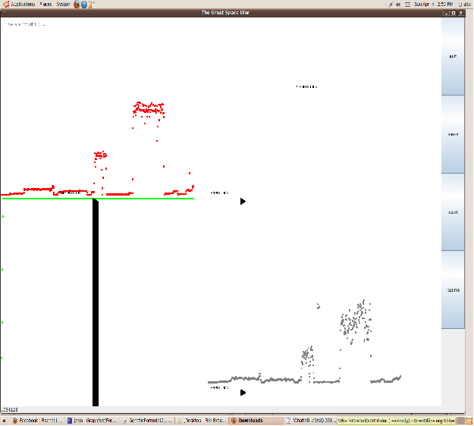

Although having a dynamic mutation rate means that the fitnesses drop after reaching a local maximum, having a dynamic mutation rate is a good idea. It shows that the genetic algorithm is behaving better than a hill climbing algorithm because it does not get stuck at local maximums.
Mutation rate of 0.05

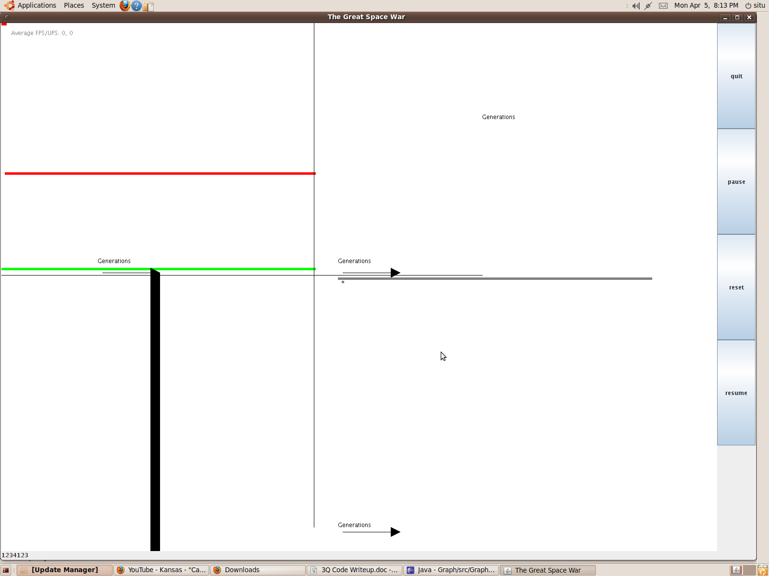

Although having a static mutation rate allows the population to rapidly improve at the beginning, it deviation eventually stagnates at a local maximum. As a result, it is the equivalent of a hill climbing algorithm with a large amount of unnecessary code.

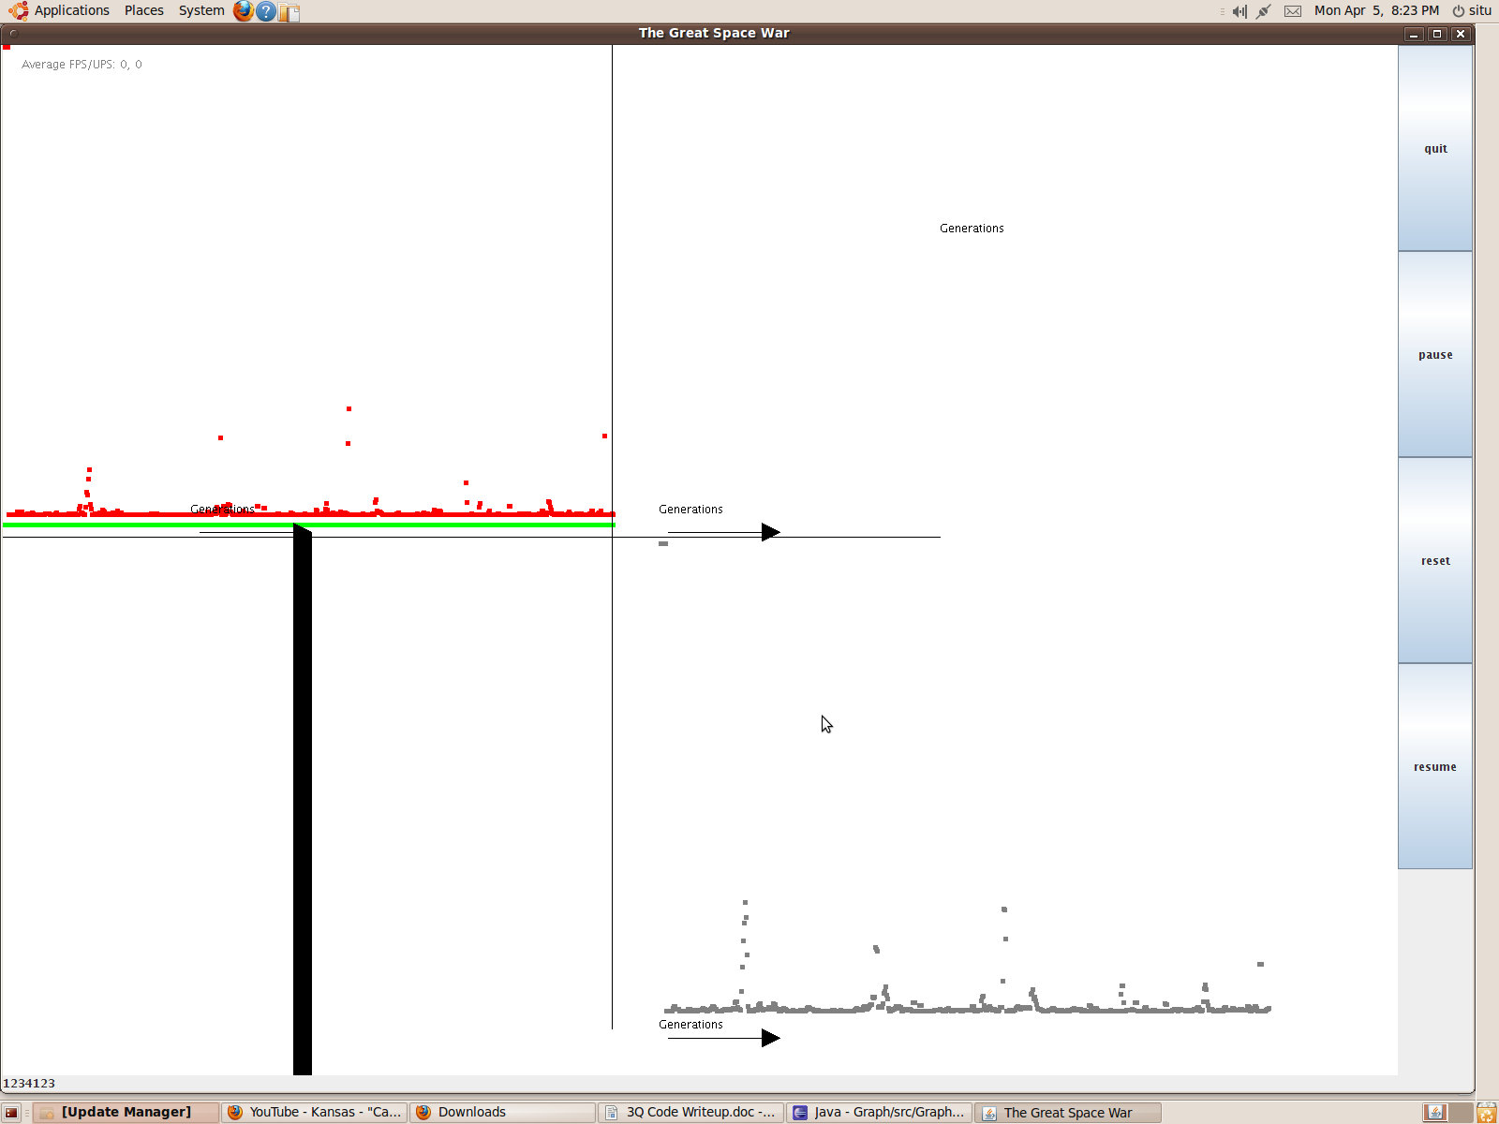

Although the population is not stagnant and has a static mutation rate, there is still less variability in the population over time, which is not good.
-- does your program handle errors, or does it crash on errors of input?
-Sometimes, there are null pointer exceptions, which crash the program. This does not happen often with normal numbers(between 1-200). However, the program crashed all four times that I tried to generate an expression for 1,000,000 with the dynamic mutation rate.

-- tests: summarize the basic analysis and testing of this version of your program.

I tested whether or not a dynamic mutation rate affected the fitness(proximity to target) of the expressions that were generated. I found that a dynamic mutation rate sometimes produces a better result than a static mutation rate, and sometimes the opposite is true. Having a dynamic mutation rate probably is not working because of its dependence on the standard deviation., which is usually 0. Both the dynamic and static mutation rates resulted in deviations of less than 1% from the target number. However, the running the genetic algorithm with a static mutation rate meant that the fitness rate eventually stagnated while the dynamic mutation rate causes random oscillations in the fitness.
Even with the dynamic mutation rate, the standard deviation eventually reaches 0. This is why there is a green line at the top of the graph. This shows a lack of diversity in the population, which is bad. It also makes the crossover method practically useless. However, the population does not stagnate, which can be seen by the high degree of variability in the trends of maximum and average fitness. The trends tend to peak at local maximums and then decline. This is a good thing since is shows that the genetic algorithm does not stagnate at local maximums.

  - mutation rate

Target number=150

((1.3927347303146886 * 0.459609238527513) / 0.009618556327199768) + ((((5.562886669798012 / 0.8976440279752964) * 7.875601052535996) / (-0.9133704835596479)) * (-0.8646457868104498)) - (0.888014311694606 / 5.748443177380818) = 112.59849(Bad)

(The fitness level plateaued)

3.516163423873376 + (((-0.12546679293851723) / 5.888617462304062) / 8.599315382204576) + ((2.11143617460612 * (-0.9941215166113628)) / 0.7683425092250671) + (6.573680892927516 / 0.04670622769266575) + 7.754730242410334 = 149.281806(Good)

Classes
FormulaGenerator:Driver program
GraphPanel:Draws the graph of the average fitness and maximum fitness. Also, it makes the genetic algorithm run periodically.

Chromsome: Represents the chromsomes/expressions

Important Methods

Remove Failures: Finds all the chromosomes with a fitness that is below average and removes them.

Crossover: Swaps data between chromosomes

Mutations: Generates a mutation rate based on the standard deviation of the fitness values and then randomly calls Chromsome's mutate() method to attempt mutations

DrawGraph: Takes the saved data for the highest fitness rate, average fitness rate, standard devation, and change of population over time and outputs the data visually(for some reason, the change of population over time is shown to be 0)

Dynamic Mutation Rate

Target Number:150

(7.749615400261505 * 1.893954933570097) - (3.9875583460158825^(-0.9745385467088737)) + 7.082406468655929 + 7.089243850554797 + 7.78377749404 + 0.9876387299051137 - (1.354066571541277 / 0.4057625712233154) = 34.0236287(Bad)

(0.8772617915988693 * 8.131497356624529 * 9.968501478288593) + 8.742134044081196 + 3.1847370985552983 + 1.7286921560738246 + 5.000178858333777 + (7.596739564554123^1.9782629628428885) + 5.032491896120176 = 150.020075(Good)

- What do you expect to work on next quarter, in relation to the goal of your project for the year?

I want spend more time making my genetic algorithm effective. In addition to making it generate an expression, the population should be diverse. Generating an AI for my game using a genetic algorithm will be significantly harder. Also, that genetic algorithm will take a lot of time,which will make it more difficult to optimize.

I will also improve the visual display of the data improved so that I can tell if the genetic algorithm is working well.

Once I am done with that, I will have the genetic algorithm generate formulas, and then use it to optimize the AI for my game.

Note on Code: To create the graphs of data, I used code(mainly variable definitions) from a game that I previously created, so some of the code is irrelevant. For now, I am keeping that code in because I do not want to accidentally delete necessary code. I will work on removing the unnecessary code later.

