COMPUTER SYSTEMS RESEARCH
Portfolio Update 3rd Quarter 2009-2010
Research Paper, Poster, Slides, Coding, Analysis and Testing of your project's program.
Name: Bharat Ponnaluri Period:5, Date: 4/07/2010
Project title or subject: Design of a Real Time Strategy Game using a Genetic Algorihtm.
Computer Language: Java

Note: Now for full credit on all assignments you must provide specific plans and work using a degree of sophistication of algorithms and data structures at or beyond the level of APCS, AI 1/2, Parallel 1/2. Using shell programs or code available on the Web or in a book is not sufficient for full credit. You must provide actual development of your own code and research, analysis and testing of this code of your own. Be sure to list specific data structures, algorithms and coding you are doing at a sufficient level of sophistication for full credit. Also for full credit, you cannot merely repeat the same algorithms/data structures week after week – your program and your learning need to be evolving at a sophisticated level.

Describe the updates you have made to your research portfolio for 3rd quarter.
- Research paper: Paste here new text you've added to your paper for 3rd quarter. Describe and include new images, screenshots, or diagrams you are using for 3rd quarter.
Specify text you've written for any of the following sections of your paper:
- Abstract: I made some edits to make it more concise.

  - Introduction or Background:
  - Genetic algorithms have been used to generate strategies for wargames
  - when the creators of the genetic algorithm did not have a precise idea of
  - the most eﬀective strategy. Two researchers used a genetic algorithm to
  - dtermine an eﬀective strategy for a a naval blockadge game that would always
  - be played diﬀerently. They also emphasized the fact that genetic algorithms
  - could generate several eﬀective strategies, which would correspond with the
  - diﬀerent AI personailities that I want to create for my game.
  - I made some edits to remove extraneous information.
Lancaster’s Square Law is a key concept to my game which will be the
basis of a heuristic. This gives the relative casualties of two armies based on
their relative strength at the end of my battle. This will be something that
it helpful for the AI to know, and it would help the AI gain an advantage
over a human player without cheating.

- Development section(s) – the work you've actually done
Instead of moving quicly to use the genetic algorithm for my AI, I will
spend more time optimizing my genetic algorithm to make sure that there is
no stagnation in the ﬁtness values of the population. I will also make sure
that my algorithm will output a graph of important statistics so that I can
analyze the sucess of my genetic algorithm and look for problems such as
stagnation or an inability to consistently produce an eﬀective result. I will
be easier to ﬁx fundamental problems with my genetic algorithm now rather
than later. Afterwards, I will modify my genetic algorithm so it takes input-
output pairs based on common functions such as quadratic polynomials and
generates a formual for the outputs based on the inputs.
Unlike I initially planned, I will not have my genetic algoritm test out
the ﬁtness values of the AI’s by having them play against each other.Having
the AI’s play against each other will take too much time. This is ﬁne if the
algorithm is only running once. However, there will inevitably be a problem,
which means that my genetic algorithm will have to run several times.
Instead, I will create a series of scenarios and precisely deﬁne the owners
of each city, and each player’s troop deployment. I will then pick a player
and deﬁne actions that would be good for it and actions that would be bad
for it. The AI’s heuristic combinations will be tested on my scenarios to
see what actions they will take. If their heuristic suggests an action that I
consider bad, they will have their ﬁtness lowered. If the heuristic suggests an
action that I consider good, their ﬁtness will increase. I will generally create
scenarios with obvious good and bad actions that an AI will take to reduce
6
any misconceptions I may have about the strategy for my game.
Currently, I have created a genetic algorithm that generates an expression
for a target number using random double values between 0 and 10, functions
on these random numbers, and several mathematical operators. I have also
implemented a dynamic mutation rate of the population based on a heuristic
evalution of how much the ﬁtness values of the population is stagnating.
While I was analyzing the eﬀectiveness of my genetic algorithm, I realized
that I was frequenly analyzing the trend of the ﬁtness values in textual form
or by converting the data into a graph manually. As a result, I decided that
I needed my program to automatically graph important parameters such as
the total ﬁtness of the population, the average ﬁtness of the population, and
the standard devation of the ﬁtness values.

5.2
Timeline
• April:
– Week 1: Modify genetic algorithm so that it consmosome’s perfor-
mance during the algorithm, a ﬁtness score is calculated for the
chromosome. Then the chromosomes with the lower scores are
eliminated. Then the chromosomes randomly mutate and have a
small portion of their data randomly modiﬁed. Then the surviv-
ing chromosomes ”mate” and swap data, then the algorithm runs
again. Genetic algorithms have a tendency to have their chro-
mosomes converge on locally optimal places. For my algorithm
this will be a good thing is long as the local optima are not too
far from the optima. This is because I would like a diverse set
of AI’s because they would have diﬀerent personalities and make
the game more exciting. Here, we propose the use of a genetic
algorithm to optimize the heuristic evaluation functions for the
AI of a strategy game.
istently works without crashing. I will also make sure that the
standard devation of the ﬁtness values does not stagnate at 0
after the beginning generations.
– Week 2: Modify genetic algorithm so that it can create formulas
for input output pairs corresponding to some function.
– Week 3: Brainstorm scenarios that I can use to test the genetic
algorithm for my games AI and save the scenarios as data that is
readable by my genetic algorithm.
• May
7
– Week 1: Create the genetic algorithm that will be used to optimze
my AI(only the scenarios, AI heuristics, and genetic algorithm will
be needed)
– Week 2: Run the genetic algorithm. While the genetic algorithm
is running, I will create a AI class for my game that runs a heuristic
created by the genetic algorithm.
– Week 3: Play against the AI and analyze its ﬂaws. Afterwards,
modify genetic algorithm and run it again. While it is running,
create several new scenarios for the AI to play out to see if it has
improved.
– Week 4: Play against AI against, analyze its ﬂaws. Afterwards,
modify and run genetic algorithm again
• June
– Week 1:Implement code so that the AI will observe the behaviour
of other AI’s and take advantage of its observations.
– Week 2: Implement diﬀerent personalities
– Week 3 and 4: Implement heuristics that allow AI to observe
patterns of other players and take advantage of them

5.8
Data Graph
Legend for graph
• Red-Highest ﬁtness
• Gray-Average Fitness
• Green-Standard Deviation
Values to the right are later values. The higher the graph, the higher the
value. The line for the standard deviation is in the middle due to a bug that
makes the standard devation converge to 0.
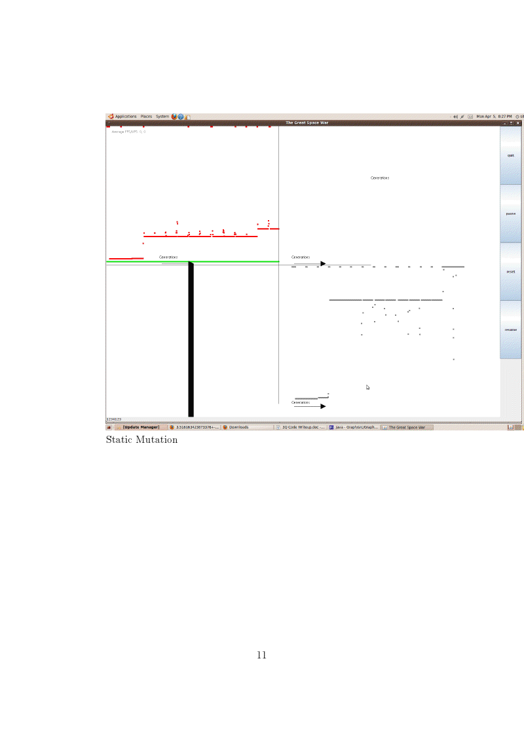

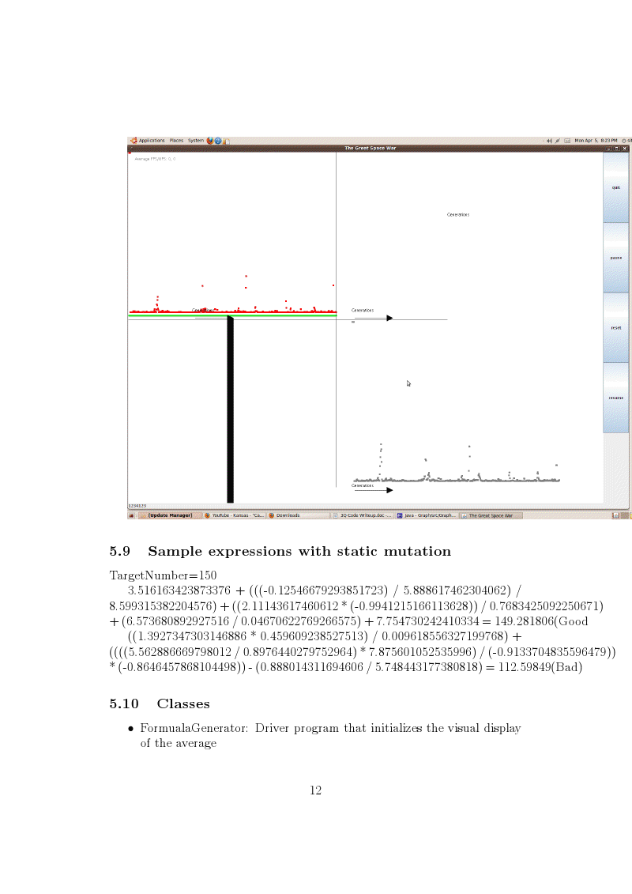

Results – if you're reaching any preliminary conclusions

- Additions to your bibliography

- images, screenshots, or diagrams in your paper

- Poster: Copy in new text you've added to your poster for 3rd quarter.
List the titles you're using for each of your subsections. Include new text you're adding
- Subsection heading: ___________________ and text:

- Subsection heading: ___________________ and text:

- Subsection heading: ___________________ and text:

- images, screenshots, or diagrams in your poster.
- Presentation slides: Provide a brief outline summarizing the main points of your presentation for 3rd quarter

- Coding: attach new code that you wrote 3rd quarter. Describe the purpose of this code in terms of your project's goal and research. Also provide clear commentary on the main sections of your code.

5. Testing, Analysis – specific listings/descriptions of the tests and analysis you've done this
quarter.

5.11
- Methods
- • createRandomExpression: Randomly creates a combination of double
- values between 1 and 10 plus functions on the numbers and operators
- • mutate: Iterates through each expression and randomly mutates a part
- based on the mutation rate.
- • calculateFitness: Evaulates expression using order of operations. The
- ﬁtness value is the absolute value of (targetNumber) divided by the
- diﬀerence between the expression value and the target number.
- • removeFailures: Finds all the chromosomes with a ﬁtness that is below
- average and removes them.I plan to modify this method so that a few
- of the unﬁt chromosomes are saved.
- • crossover: Randomly picks two chromosomes to mate data and saves
- a child. Once there are 20 children, the parents are deleted and the
- population becomes the children.
- • mutations: Generates a mutation rate based on the standard deviation
- of the ﬁtness values and then randomly calls the mutate() method to
- attempt mutations. This method will be modiﬁed
- • drawGraph: Draws a graph of the average ﬁtness of the population, the
- best ﬁtness of the population, and the standard devation. These values
- are saved for every generation, allowing the graph to be completetly
- redrawn for every iteration.

- Running your project – describe what your project's program actually does in it's current stage. Include current analysis and testing you're doing. Specifically what have you done this quarter.

My genetic algorithm works as it generates expressions for numbers somewhat accurately. However, due to a bug in my algorithm which sometimes causes all the chromosomes to be eliminated, the algorithm crashes before it finishes. While I was coding the genetic algorithm, I realized that I should have a solid genetic algorithms without problems such as long periods of stagnation or a popluation with a low standard deviation. This is because I realized that these problems would be easier to deal with when my genetic algorithm was solving a problem that is not as complex as creating a heuristic for my game. To cope with the periods of stagnation, I decided to make the mutation rate dependent on the standard deviation and the average change in the average fitness values of the population. However, the dynamic mutation rate is not working perfectly because the standard deviation of the population approaches 0 and stays there. Also, I created a visual display of the standard deviation, average fitness, and maximum fitness values because I felt that I was spending too much time trying to analyze the output(the data on the visual display) and trying to manually create graphs on the computer. In summary, I have a functioning genetic algorithm, but the population has a low standard deviation and my program ocassionally deletes all the chromsomes, leading to a null pointer exception.

(((8.59482714158532 / 0.12743034663208305) * 5.9371079519490095) / 0.0536931183605234) + (((8.930089557028241 * 8.813013817165544 * 9.282327628105781) / 0.2880566114056905) * 8.677481119426583 * 8.745399861997422) = 199 914.503
Target number is 200,000

(2.055574986563656 * 4.335029892851425 * 7.568503498458528 * 9.343999739233327) + (((1.6722547919379975 * 10.789077601745419) / 4.919120586930043) * 7.53127380275555 * (-0.5353799409737934) * 8.800371889538296) = 500.039271
Target number is 500

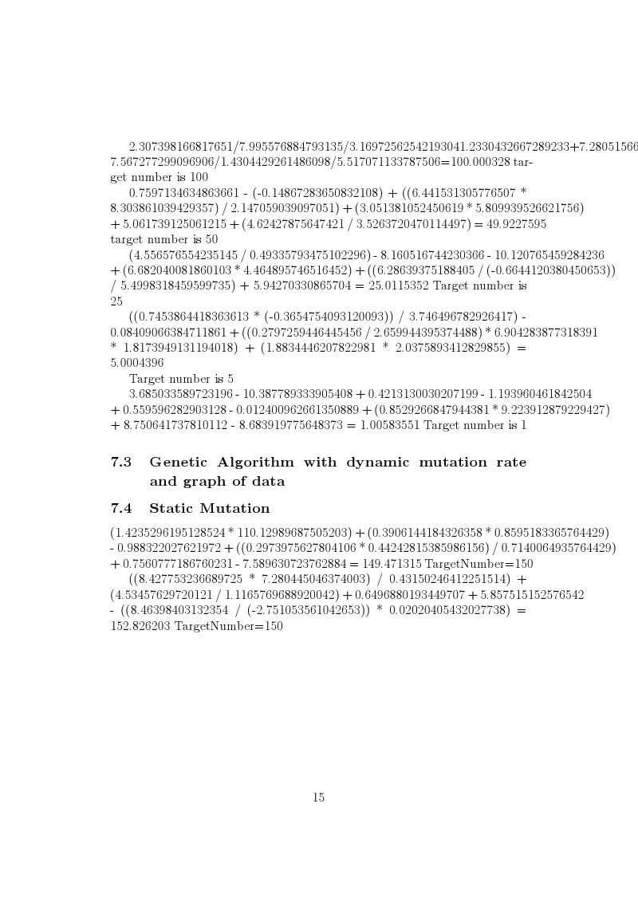

- What is your focus for wrapping up your project for 4th quarter?

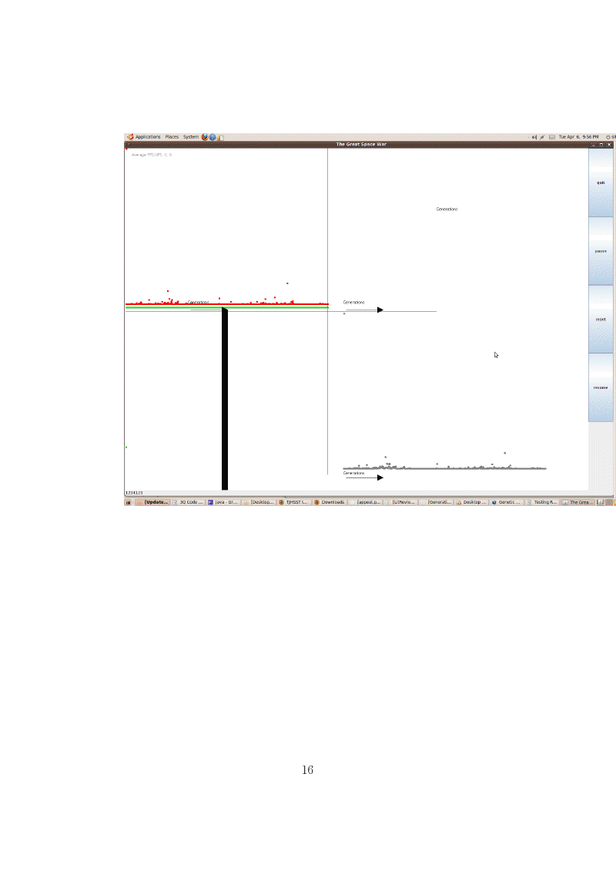

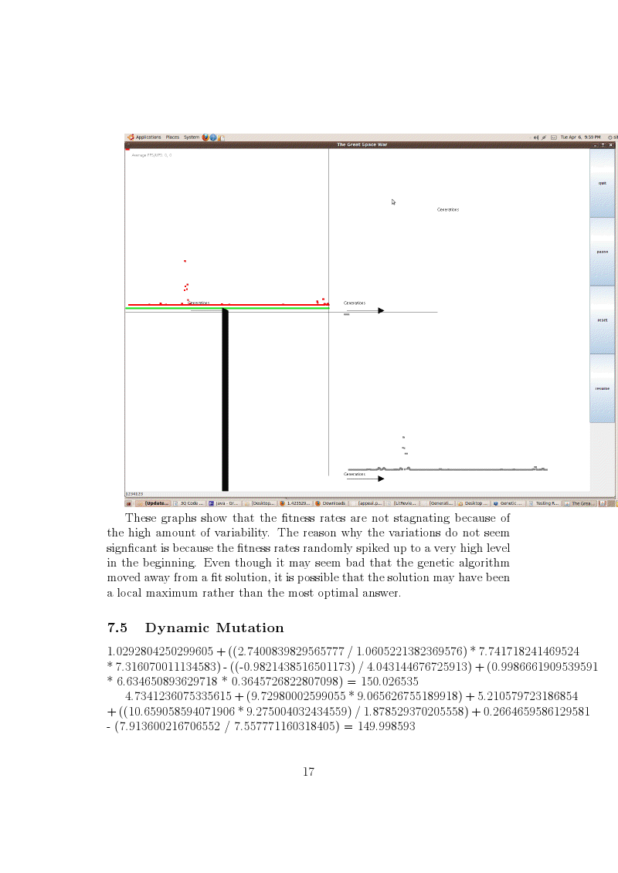

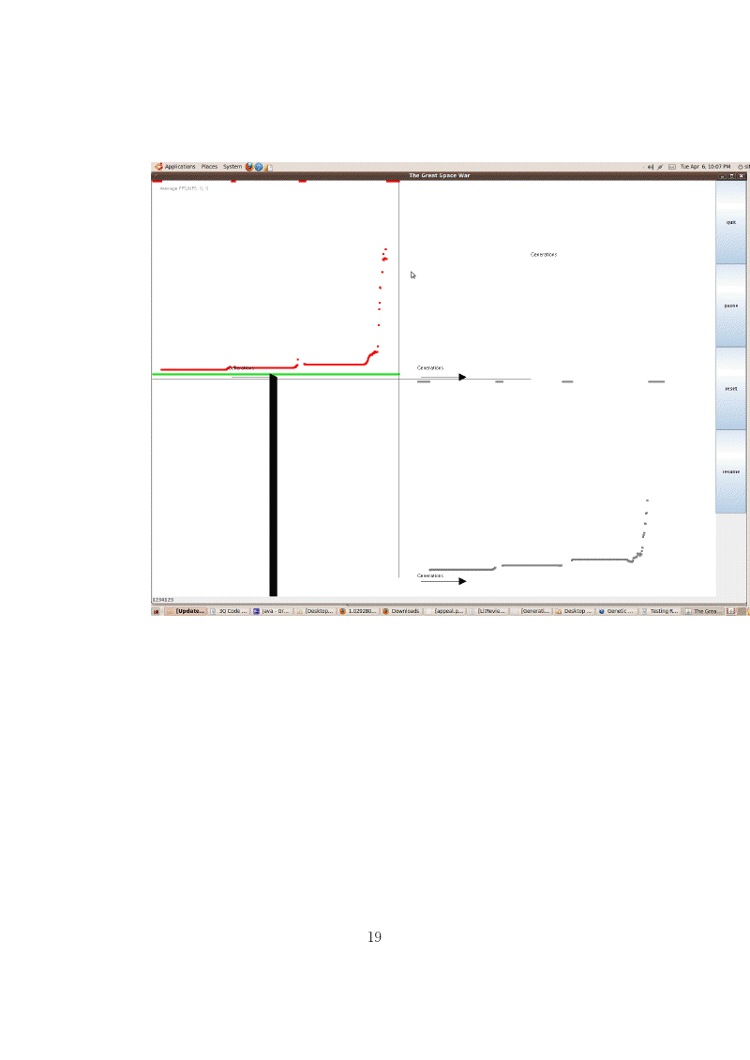

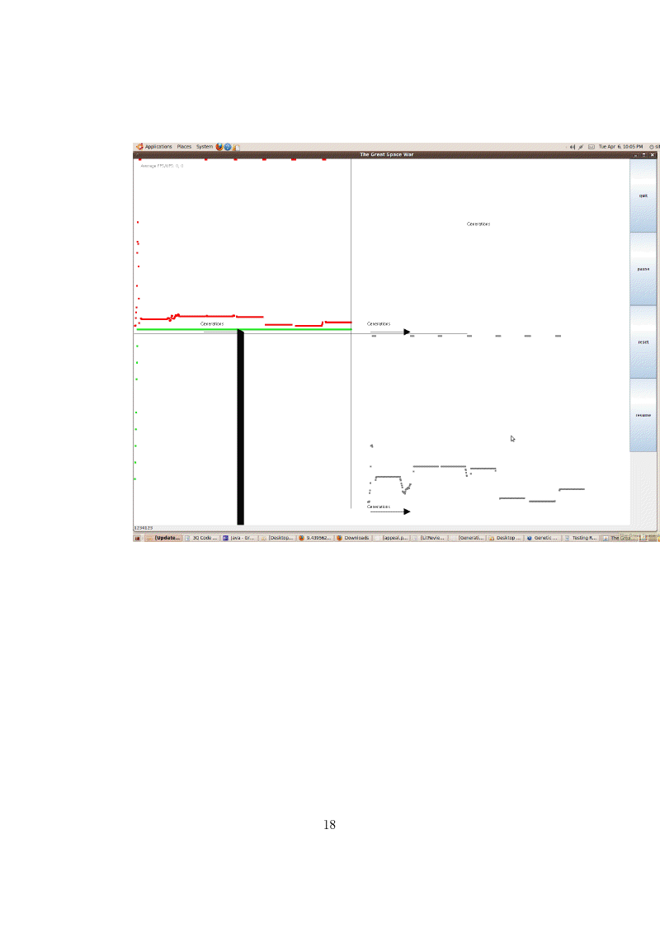

Note:The data table and the text below are old.
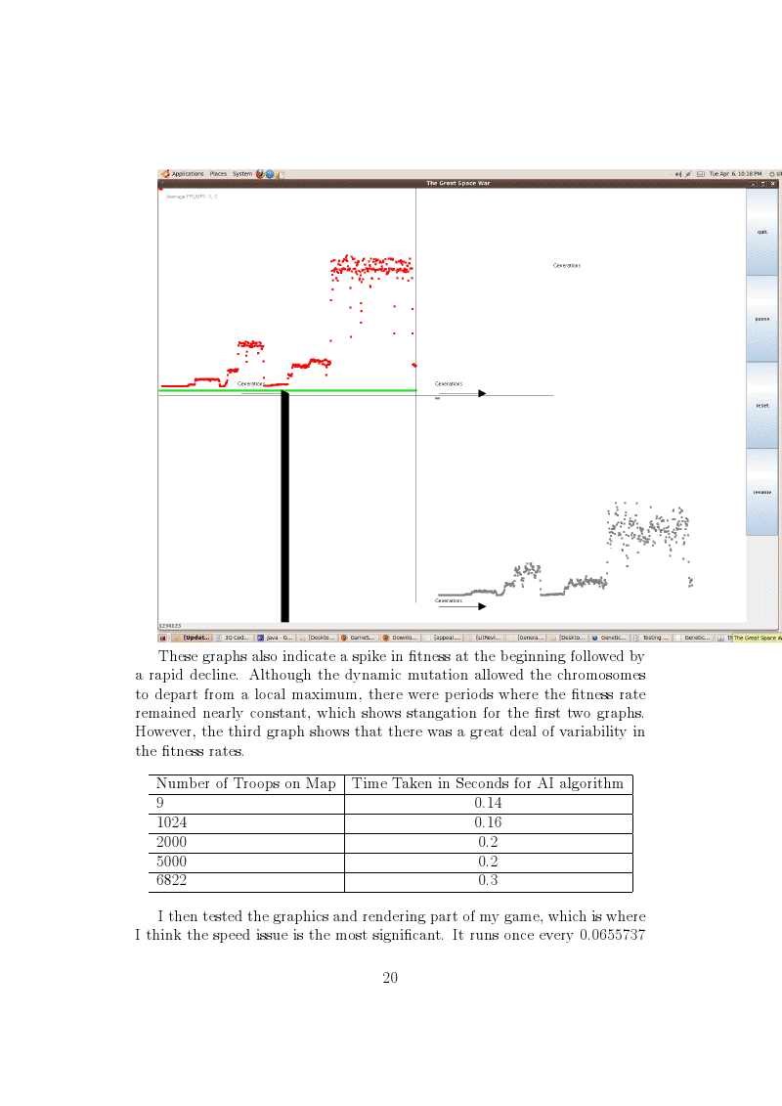
[12] Revello, Timothy.,McCartney, Robert.(2002) Generating
Game Strategies Using a Genetic Algorithm Retrieved
http://dynamics.org/ altenber

Presentation

-A list of the classes in my genetic algorithm and what they do
-A description of the important methods in my program.
-A visual display of the static fitness and dynamic mutation rates
-Sample expressions generated by the static and dynamic mutation versions of my genetic algorithm.
-Analysis of the visual displays
-What I plan to do next quarter

Poster Additions(Everthing on the right size is new)

Heading:Results

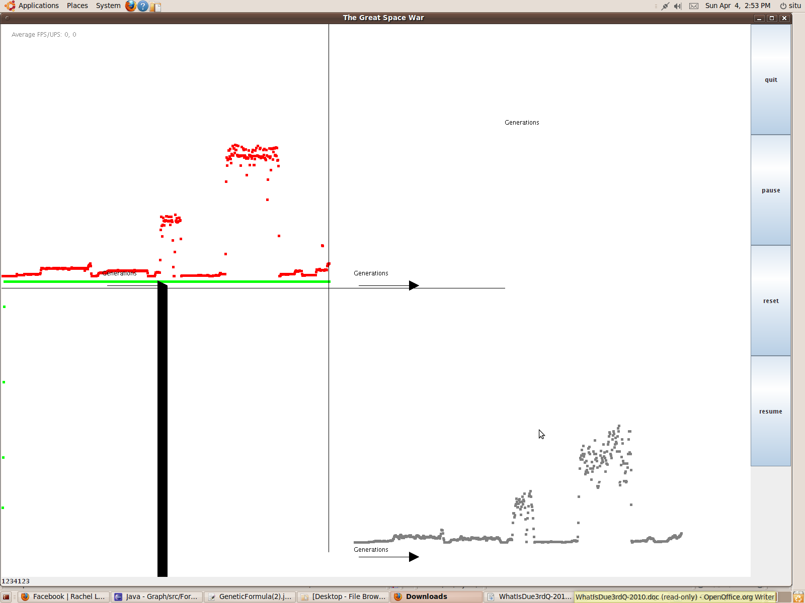

Data Table

rget Number | % devation from Target(Dynamic mutation) | % deviation from Target(0.05 mutation rate)
1 | 0.05413% | 0.1346%
100 | 0.000715% | 0.029571%
200 | 0.001976% | 0.0006975
Heading: Conclusions
I have successfully created a genetic algorithm that generates expressions for a number over a wide range. However, the standard deviation of the fitness values becomes 0 after a while,which is why there is a green line in the screenshot. The maximum and average fitness values vary significantly over time, which is good. However, the fitness values do not show long term improvement after the beginning. Once I fully optimize my genetic algorithm, I will use it for my game's AI.

Coding: Code is attached to code writeup

5-Testing,Analysis(See code writeup for more detail)
I tested whether my genetic algorihtm runs better with a dynamic mutation rate instead of a static mutation rate and I found that there was no difference. This is because the mutation rate is dependent on the standard devation.
Before implementing the dynamic muation rate, the version of the program from mid-march was able to generate expressions for any number between 1 and 10,000 on a consistent basis. Currenlty, the program is able to generate nubmers between 1 and 200 due to a bug in the dynamic mutation rate.

6. Running your project – describe what your project's program actually does in it's current stage. Include current analysis and testing you're doing. Specifically what have you done this quarter.(See code writeup for details)

Currenlty, my program generates expressions for a target number using double values, operators, and functions on the double values. Also, my program generates a visual display of the fitness values.

- What is your focus for wrapping up your project for 4th quarter?

For 4th quarter, I will improve upon the fundamentals of my genetic algorithm to make sure the population is more diverse(the standard deviation of the population is stuck at 0). Afterwards, I will make the genetic algorithm generate formulas for input-output pairs based on common formuals. Then, I will create several scenarios for my game where there are clearly good and bad decisions for the AI to make. The genetic algorithm will then create heuristics that allow the AI to recognize the goood and bad decisions for each scenario. The genetic algorithm will only need the AI heuristics from my game. Once the genetic algorithm is finished, I will play against the AI creates and apply it to new scenarios to see if it knows what to do.

