COMPUTER SYSTEMS RESEARCH
Code Writeup of your program, example report form 2009-2010
- Your name: __Anna Stapleton_________, Period: __5__
- Date of this version of your program: ___03/24/10____
- Project title: ____Input and Sharing of Infectious Disease Data at the Grassroots Level_____
- Describe how your program runs as of this version.
This quarter was focused on my NetLogo model of a meshnetoworking system based on OLPC computers. The parameters for the model were based on an article testing the networking abilities of an OLPC laptop called “Measurements in OLPC Mesh Networks” by V. Rastogi et. al. Some coding of this model were based on previously existing models in the NetLogo library, including the code which automatically links any nodes within a given distance of each other. The parts which I created on my own were the algorithms for determining the level of connection of each node, meaning how many hops were between it and the master-node. For example, if node A is connected as follows: A-->B-->C--->Master. Node A is then considered to be level 3. The code I wrote sets the color of each node based on it's level of connection. Because in NetLogo colors are stored as integers, it is inversely possible to determine the level of connection based on the color of the node. I then further wrote algorithms to calculate the likelihood of a node successfully passing its information based on its level as well as the physical distance between it and the master-node.
A typical screenshot of my program looks like this:
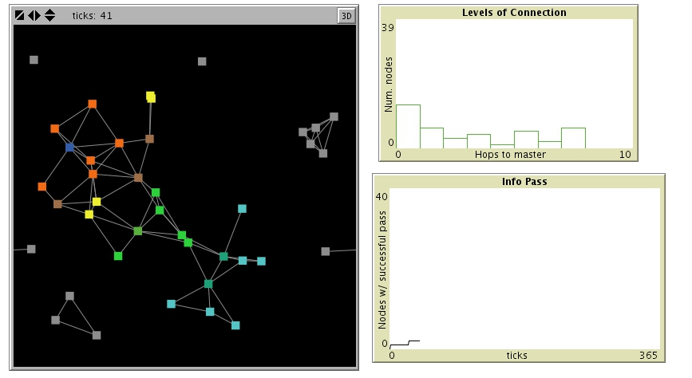
On the left is the visualization of the levels of connection. The master-node (to which all the other nodes want to pass their information) is in dark blue. Orange nodes are level 1, brown nodes are level 2, yellow nodes are level 3, etc. On the upper right is a histogram of how many nodes are at each level of connection. Below that is a graph of how many nodes have been able to successfully pass their information so far in this run.

- What do you expect to work on next quarter, in relation to the goal of your project for the year?

Next quarter I expect to simply run the model several times under different parameters, to test exactly the optimal conditions with minimal number of nodes involved. The output will be in terms of how many nodes can successfully pass their information in 365 ticks (iterations) of the model. The goal is to minimize the number of nodes while allowing 100% of the nodes to pass their information within 365 ticks.

