COMPUTER SYSTEMS RESEARCH
Code Writeup of your program, example report form 2009-2010
- Your name: Aileen Wang Period: 5
- Date of this version of your program: 04/07/2010
- Project title: Black-Scholes
- Describe how your program runs as of this version. Include
-- files that may be needed
- Internet database files: Assumed that there is access to the internet, data of the call/put values of a company to be analyzed is needed
- The model itself
-- algorithms, specific procedures or methods you wrote
- Black-Scholes model: Calculation of the call and put values
- Data extraction from internet databases
-- kinds of input your program uses
- Input data: Numerical, consists of either a call or a put with a bid-ask spread
- Output data: Numerical, consists of a value of said call or put function
-- screenshots, what kinds of output does your program have
- Sample output of calculated prices for Apple (AAPL)
- 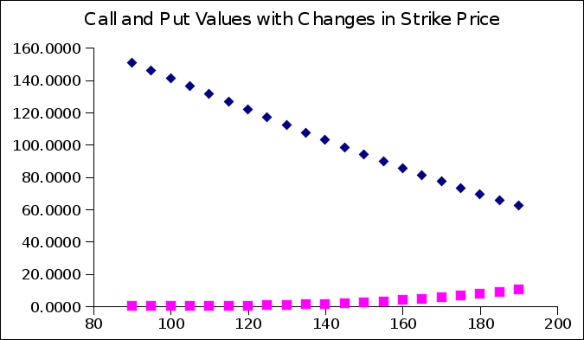
- Comparison of actual versus calculated values
- Statistical test of significance: what does the data conclude about the B-S model?

-- does your program handle errors, or does it crash on errors of input?
- Program will not run if inputs are not numerical.
-- tests: summarize the basic analysis and testing of this version of your program
- Comparing in/outputs by hand with in/out puts from extracted data to test if the extraction actually works
- Comparing output data with output data generated by established Black-Scholes calculators

- What do you expect to work on next quarter, in relation to the goal of your project for the year?

- More in-depth analysis of the significance of the disputes between actual data and calculated values
- How does this vary based on volatility and T-bond rates?
- How does this vary with industry/size/type of company?

