COMPUTER SYSTEMS RESEARCH
Portfolio Update 3rd Quarter 2009-2010
Research Paper, Poster, Slides, Coding, Analysis and Testing of your project's program.
Name: Aileen Wang, Period: 5, Date: 4/7
Project title or subject: Black Scholes
Computer Language: Java, Excel

Describe the updates you have made to your research portfolio for 3rd quarter.
- Research paper: Paste here new text you've added to your paper for 3rd quarter. Describe and include new images, screenshots, or diagrams you are using for 3rd quarter.
Specify text you've written for any of the following sections of your paper:
- Abstract
- General overview of the paper
- Objective, what the project will study and focus on
- Introduction or Background
- Introduction of B-S
- How the B-S model is used
- Formulas and input/output
- Application to the financial market
- Development section(s) – the work you've actually done
- Data extraction
- Calculation of data
- Comparison of data
- Significance
- In order to utilize the Black-Scholes model, there are several assumptions that must be applied. For the cases studied in this paper, we assume accessibility to loan cash at the risk-free interest rate. This rate will be determined by the United States Treasury Bond rate, as it is the most accurate predictor of the risk-free rate in an American market. The valuation of options follows a Geometric Brownian motionand the return is normally distributed with no limits on shorting, no arbitrage, and no transaction costs or taxes. The company is assumed to not pay dividends (this assumption is often not true, but in these cases the dividend is often not large enough to greatly sway the results). Although in real life, the shares bought is discrete data, the Black-Scholes model disregards this aspect and treats all data as continuous.
- 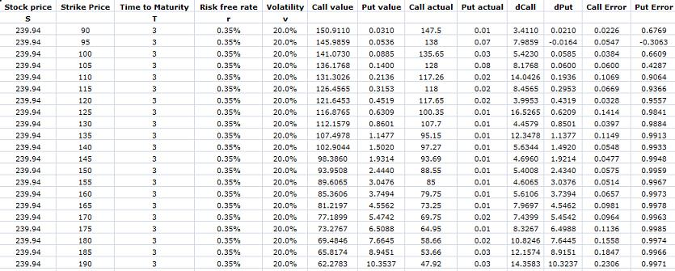
- Results – if you’re reaching any preliminary conclusions
- Analysis of Apple, Inc.
- Call values are good estimates
- Put values tend to deviate more
- Although in the future many more companies will be analyzed, Apple (NASDAQ: AAPL) was used as a preliminary subject for analysis. At a given time t, the stock price for AAPL was $239.94. APPL options used are ranged from $90.00 to $190.00 in increasing increments of $5.00. All options were calculated with three days until maturity, volatility of 20%, and a risk free rate of 0.35%.
- The table below shows the results for the analysis for AAPL. Call value and put value columns denote the calculated values of call and put using the Black-Scholes model. Call actual and put actual columns denote real life data of the call and put values. The difference between call/put actual and call/put calculated is denoted in dCall and dPut. Both columns were then made weighed by dividing dCall and dPut by their respective expected values to calculate the error in both.
- The program takes input values of real-life data for Company X and call and put option values for a fixed stock price and a variety of strike prices. Given these inputs, the program gives a series of expected call and put option values. These values are compared to actual real-life values. The deviations of expected values and actual values are found and plotted for analysis. The program is built so that the data is directly extracted from online database. For this project, the selected database is Yahoo! Finance.

- Additions to your bibliography

- images, screenshots, or diagrams in your paper
- Various output graphs
- Screenshot of the excel table of all imported and calculated values
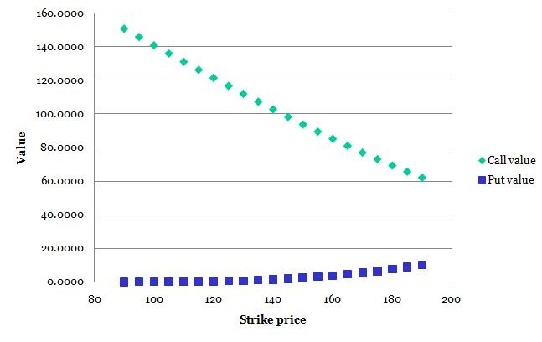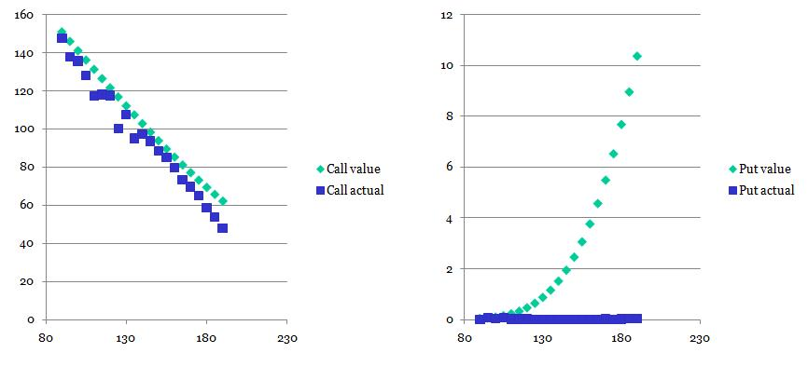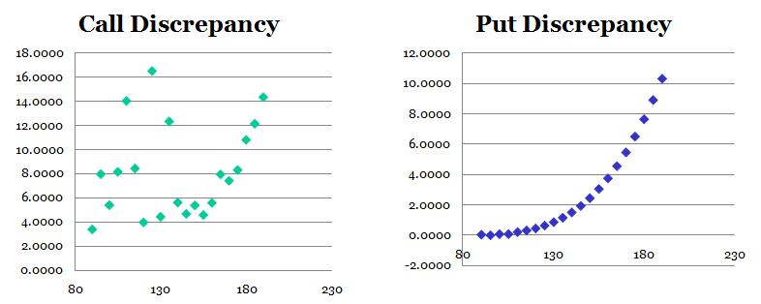
- Poster: Copy in new text you’ve added to your poster for 3rd quarter.
List the titles you’re using for each of your subsections. Include new text you’re adding
- Subsection heading: Findings and text:
- Although in the future many more companies will be analyzed, Apple (NASDAQ: AAPL) was used as a preliminary subject for analysis. At a given time t, the stock price for AAPL was $239.94. APPL options used are ranged from $90.00 to $190.00 in increasing increments of $5.00. All options were calculated with three days until maturity, volatility of 20%, and a risk free rate of 0.35%.

- Subsection heading: Modeling and text:
The Black-Scholes involves several main variables: stock price, strike price, volatility, time until maturity, and the risk-free interest rate. We assume that the valuation of options follows a Geometric Brownian motionand the return is normally distributed with no limits on shorting, no arbitrage, no dividends, and no transaction costs or taxes. The volatility is calculated through a logarithmic function from historical data; the risk free rate is estimated by the U.S. T-bond rate. The generated values are then compared with actual values.

- images, screenshots, or diagrams in your poster.
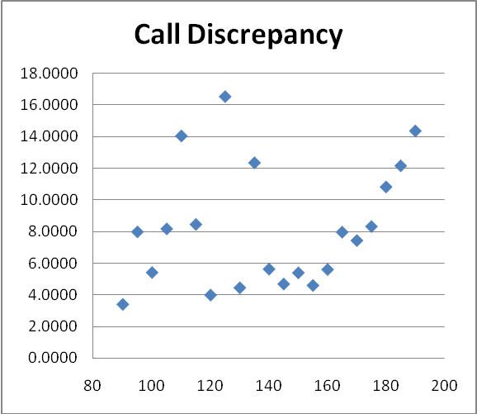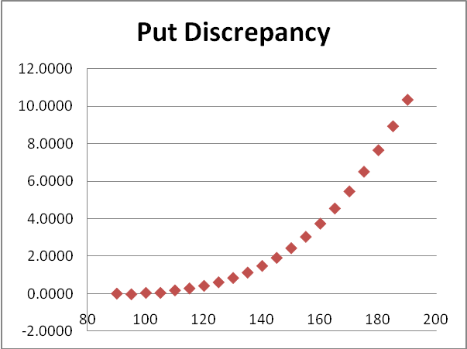
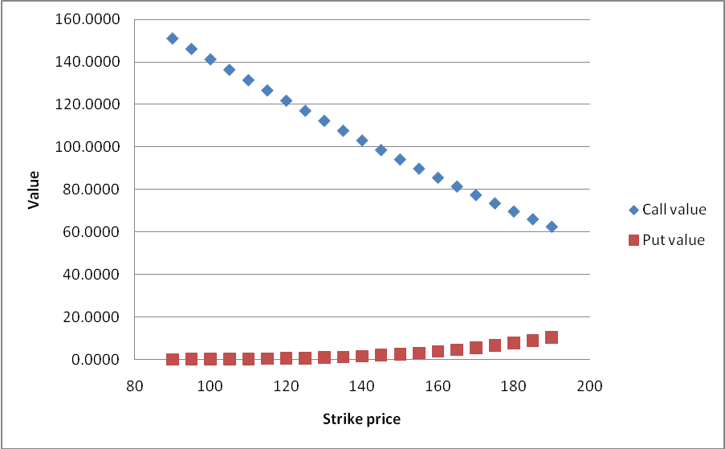
- Presentation slides: Provide a brief outline summarizing the main points of your presentation for 3rd quarter
- Analysis of AAPL:
  - Plotting the calculated values through B-S values through actual values of option trading
  - B-S as a valid estimator of call and put values
  - Deviations from the expected values

- Coding: attach new code that you wrote 3rd quarter. Describe the purpose of this code in terms of your project's goal and research. Also provide clear commentary on the main sections of your code.

5. Testing, Analysis – specific listings/descriptions of the tests and analysis you've done this
quarter.
- Experimentation
  - Using fixed data for all but one category, varying one category at a time to see the effect it has on the output values
  - Tested areas: volatility, interest rate, stock/strike price
  - Effect of time on the accuracy of the data produced

- Running your project – describe what your project's program actually does in it's current stage. Include current analysis and testing you're doing. Specifically what have you done this quarter.

- The program takes input values of real-life data for Company X and call and put option values for a fixed stock price and a variety of strike prices.
- Given these inputs, the program gives a series of expected call and put option values.
- These values are compared to actual real-life values.
- The deviations of expected values and actual values are found and plotted for analysis.
- The program is built so that the data is directly extracted from online database. For this project, the selected database is Yahoo! Finance.

- What is your focus for wrapping up your project for 4th quarter?
- Run analysis for multiple companies
- Is the model an effective way to predict options?
- Does the model affect different stocks in different sectors?
- Focus on testing the significance of the generated data from multiple companies

