COMPUTER SYSTEMS RESEARCH
Code Writeup of your program, example report form 2009-2010
- Your name: Sam Zhang , Period: 1
- Date of this version of your program: October 26th
- Project title: Dynamic word sense disambiguation with lexical ontologies in computational semantics
- Describe how your program runs as of this version. Include
-- files that may be needed
-- algorithms, specific procedures or methods you wrote
-- kinds of input your program uses
-- screenshots, what kinds of output does your program have
-- does your program handle errors, or does it crash on errors of input?
-- tests: summarize the basic analysis and testing of this version of your program

I spent the first quarter working through the NLTK tutorial to give myself a solid grounding in statistical methods of corpora analysis. A favorite graph of mine that I made using the corpora of inaugural addresses is:
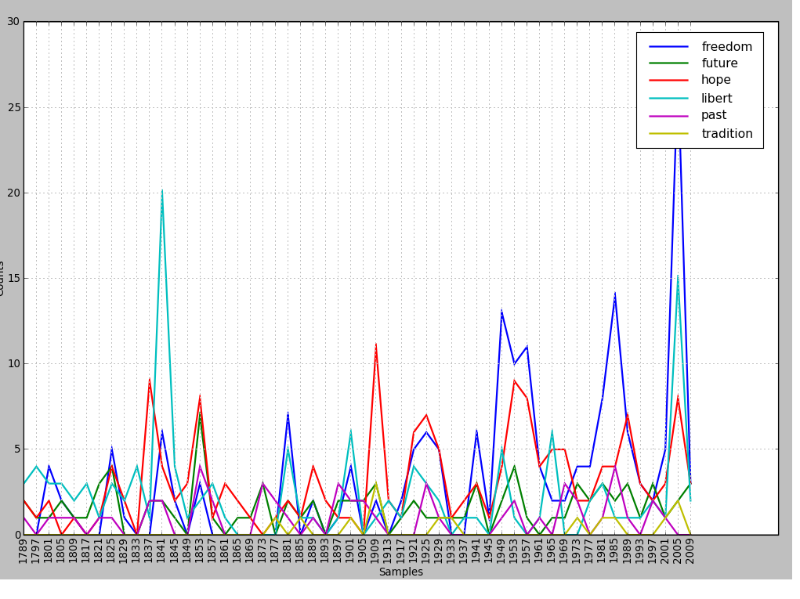
My prototyped code is to use a bidirectional search from each definition of each word to each other definition of each other word, which will be heuristically optimized, to assign a distance number, or "relevancy index" to each word. The definition with the most relevancy to the rest of the words will be assumed to be the referent, and of the referents the least relevant will be the odd one out.

- What do you expect to work on next quarter, in relation to the goal of your project for the year?

I will implement the heuristical search, implement OpenCyc to give greater relevancy to the lexical ontology, and program testing-code, especially visual aspects such as graphical output of the semantic network. I will also research the Semantic Web idea to see how my project can apply to that, for example the Ontological Web Language.

